Hidden | Universe

Lars Lindberg Christensen
Robert Fosbury
Robert Hurt

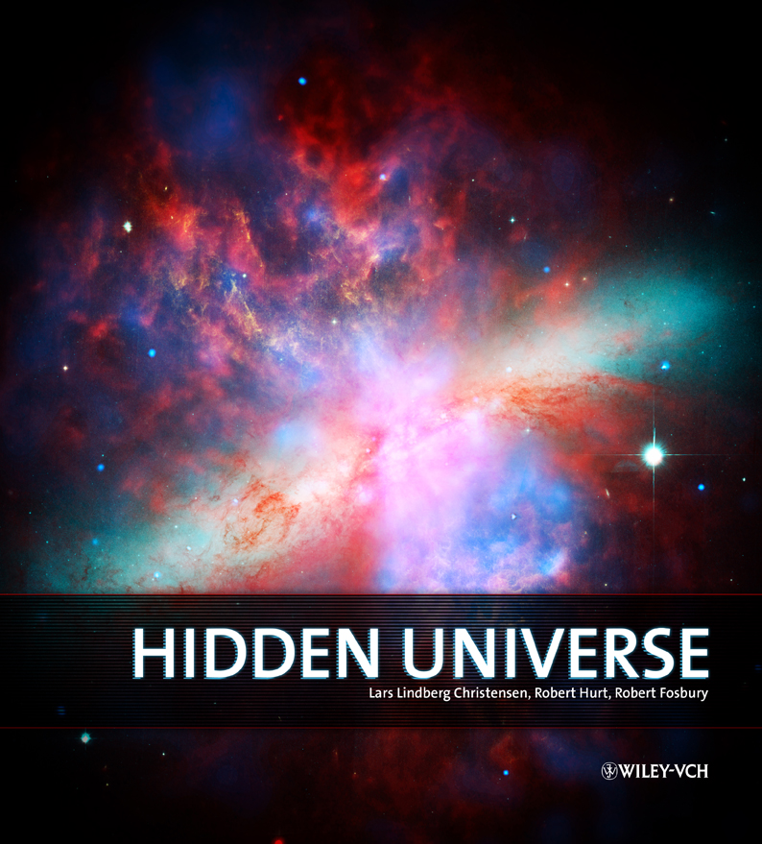

WILEY-CPH logo — IAU logo — IYA logo
Figure 1: Multiwavelength view of Cassiopeia A (inside front cover)
This stunningly colourful picture shows off the rich structure of the supernova remnant Cassiopeia A. It is composed of images using three different wavebands of light. Infrared data from the Spitzer Space Telescope are coloured red; visible data from the Hubble Space Telescope are yellow; and X-ray data from the Chandra X-ray Observatory are green and blue. Located 10,000 light-years away in the constellation Cassiopeia, Cassiopeia A is the remnant of a once massive star that died in a violent supernova explosion that would have been seen from Earth some 325 years ago had it not been behind clouds of obscuring dust. It consists of a dead star, called a neutron star, and a surrounding shell of material that was blasted off as the star imploded.

http://www.spitzer.caltech.edu/Media/releases/ssc2005-14/visuals.shtml

Contents
Foreword by Riccardo Giacconi 5
Preface 6
About the book 6
Acknowledgements 7
1. Light and Vision (Robert) 8
The eye and evolution 8
Human colour theory 9
What is light? 11
The electromagnetic spectrum 12
Seeing invisible light 14
Producing light 15
Blackbody radiation 15
Spectral line radiation 16
Non-thermal radiation 18
2. The View from the Ground 19
Atmospheric obstacles 19
Types of ground-based telescopes 21
Future ground-based observatories 22
3. Space observatories (Lars) 24
Reliability 26
What is inside? 26
Future space observatories 29
4. The Visible Universe (Lars) 31
The colours of the stars 33
Spectral lines — atomic fingerprints 36
Stellar evolution 37
Are the colours real? 38
Where the invisible becomes visible and the visible invisible 38
5. The Infrared Universe (Robert) 41
History 43
Visible-light technologies for infrared light 46
Sources of infrared light 48
Dust becomes transparent 52
6. The Ultraviolet Universe (Robert) 60
Overview 60
History 62
Sources of ultraviolet 63
Blackbody 63
Spectral lines 63
Ultraviolet telescopes 64
Ultraviolet science 65
Sun and planets 67
Star formation 68
7. The Radio Universe (Bob) 72
Bremsstrahlung 77
Radio gas 77
Cool stuff 79
Cosmic Microwave Background 80
NOT USED 82
Images/figures 82
8. The X-Ray and High Energy Universe (Bob) 83
Sources of X-rays 84
Thermal X-rays 84
Spectral line X-rays 85
Non-thermal processes 85
Observing X-rays 86
X-ray sources 86
White dwarfs, neutron stars and black holes... 86
Active galaxies 88
Clusters of galaxies 90
The Solar System 93
Pushing the limits: Gamma rays 95
Gamma-ray bursts 96
The X-ray/high energy revolution 97
9. The Multi-wavelength Universe (Lars) 101
Centaurus A in visible light 102
Centaurus A in the infrared 103
Centaurus A in the ultraviolet 105
Centaurus A in radio 106
Centaurus A in X-rays 107
A multi-wavelength view of Centaurus A 108
Post script 110
Bios 117
Glossary 119
Further reading 120
Index 121
Back 122

______ Ready for editing

______ Edited once and proofread once

____ _ Being worked on outside — DO NOT EDIT

Figure 2: Messier 81
This image of Messier 81 combines data from the Hubble Space Telescope, the Spitzer Space Telescope and the Galaxy Evolution Explorer (GALEX) missions. The GALEX ultraviolet data were from the far-UV portion of the spectrum. The Spitzer infrared data were taken with the IRAC detector. The Hubble data were taken at the blue portion of the spectrum. Also see the infrared and ultraviolet images of this object in Figure 38 and Figure 47.

Foreword by Riccardo Giacconi

Washington DC, 15 June 2008

Riccardo Giacconi
Recipient of the Nobel Prize in Physics, 2002

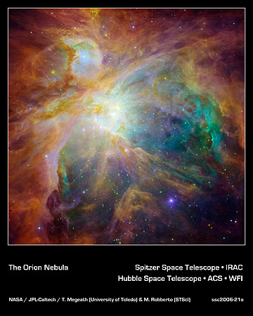

Figure 3:The Orion Nebula in infrared and visible light
Images from the Spitzer and Hubble Space Telescopes have been combined to a striking infrared and visible-light composite. Swirls of green in Hubble's ultraviolet and visible-light view reveal hydrogen and sulphur gas that have been heated and ionized by intense ultraviolet radiation. Spitzer's infrared view exposes carbon-rich molecules called polycyclic aromatic hydrocarbons in the cloud. These organic molecules are shown as wisps of red and orange.

Orion Vis/IR: http://gallery.spitzer.caltech.edu/Imagegallery/image.php?image_name=ssc2006-21a

Preface
Until 400 years ago when Galileo first turned his telescope towards the heavens, our perception of the Universe was limited by our eyes and the thoughts that sprung from considering what they could see. The huge leap in capability that even such a simple instrument could realise set us on the path of creating ever more powerful instruments to satisfy our voracious appetite for knowledge.

Nonetheless, until the mid-20th century our knowledge of the Universe was limited almost entirely to the narrow band of light that could penetrate the Earth’s atmosphere and was visible to our eyes or to sensitive photographic plates loaded at the focus of increasingly large telescopes. With these resources alone, the discoveries were still stupendous: the mapping of our Solar System, the identification of the mechanism that makes stars shine and determines how long they live, the realisation that there are a multitude of galaxies like our own Milky Way and that they constitute an expanding Universe. The profound revolution in physics during the first half of the century brought with it the understanding of how light is emitted and how to read the subtle messages it carries concerning the physical state and chemical composition of stars and nebulae.

Stimulated by the development of radar for military use, the first major expansion of our view was the result of the development of radio astronomy, leading to the realisation that the Universe could look very different to us when seen through new “eyes” tuned to a different radiation.

The launch of Sputnik in 1957 paved the way for astronomy’s escape from the absorbing and distorting effects of the Earth’s atmosphere. With truly clear skies, generations of exploratory spacecraft and orbiting observatories have produced a wondrous and often breathtakingly beautiful view of a Universe whose richness could not have been imagined. A string of new discoveries has come from this fleet of new space-based instruments and observatories, and each new insight has been firmly placed into the existing framework of understanding by astronomers. Meanwhile the impressive arsenal of today's ground-based facilities bears witness to the continuing success of the modern large and highly evolved versions of the traditional telescope.

This book will enable you to peer through these exotic new telescopes and see some of the more spectacular images that have become the icons of modern astronomy. By expanding your vision beyond the visible into an array of “colours” that span the full spectrum of light, you will be able to gain a more complete picture of the Universe than has ever been possible before in human history. These images are truly a legacy to be appreciated by everyone. Obtained using facilities built by governments and public institutions across the globe, they allow us all to better understand our place in a spectacular Universe, once hidden, but now revealed.

About the book
This book is divided into nine chapters each dealing with various aspects of the unseen Universe. The first three chapters discuss the way we perceive the Universe, through our eyes, and with telescopes on the ground and in space. The next five chapters each discuss a wavelength regime starting with the most familiar, the visible light, and then moving outwards on each side in the spectrum into the less familiar: infrared, ultraviolet, radio and X-rays. As the final chapter we attempt to gather the individual threads of the story into one, hopefully coherent, view of the totality of the multi-wavelength Universe.

When we took up the task of writing this book we knew that we were treading into unknown territory. It is no easy task to communicate unseen phenomena, and especially not issues that are caused by often unfamiliar physics far from our daily lives. We have had to use a certain arsenal of important physical terms such as “spectrum” and “blackbody radiation”, but we have kept the use of jargon to a minimum, and have explanations of the most unfamiliar terms in the glossary at the end of the book. The first occurrence of each of these glossary words in each chapter is marked with bold.

At the end of the book we have a list of literature where you may find more information. Due to the limited amount of text available in this book we can only provide a little peak into the richness of the multi-wavelength Universe.

Acknowledgements
We offer thanks to many of our colleagues working hard in the observatories and their science communication machine rooms around the world. Many of the stunning images in this book were developed using all the talents of these astronomers and graphics experts. We would like to extend an extra thank-you to the Chandra team led by Megan Watzke and Kimberly Kowal Arcand and the Spitzer team led by Gordon Squires for their frequent efforts to compare their X-ray and infrared images with other wavelengths and thereby contribute to the unveiling of the hidden Universe.

Munich 9 July 2008

Lars Lindberg Christensen
Robert Fosbury
Robert Hurt

1. Light and Vision (Robert)

Figure 4:A winter’s morning in the forest with a slight mist amongst the trees. The sunbeams radiating from our star give us the feeling that our world is flooded with light. (Photo, Bob Fosbury)

http://en.wikipedia.org/wiki/Image:Cloud_in_the_sunlight.jpg
Ours is a Universe of light…
The light we see defines the way we understand the world around us. What is solid and what is insubstantial, what is bright and what is dark, what is beautiful and what is ugly. All of these concepts derive from visual cues. But since our vision is inextricably linked to the nature of the Sun, in a real sense even our aesthetics are deeply rooted in astronomy. Perhaps it is no wonder that images of the Universe can trigger such a sense of awe. But the light from the Universe contains so much more than the light we can see for ourselves...

The eye and evolution
When a baby opens its eyes for the first time it sees a shocking blinding light. Every newborn baby is the result of 3 billion years of evolution and a demonstration of the physical connection between the human organism and the Universe. Our eyes are biological detectors shaped by evolutionary advantage to best utilise the flood of light from our nearest star, the Sun. It is no coincidence at all that our eyes see exactly the spread of colours over which our Sun radiates most brightly. It exemplifies the beauty of biological efficiency, and reminds us that if we lived near a star that shone differently, we would have formed a different concept of what constitutes “visible” light.

Human colour theory
How does our eye see colour and what makes the spectrum of colour? Our eyes are biological light detectors, allowing our brains to construct images from the signals passing down the optic nerve. Human eyes have three different types of colour-sensitive cells that allow us to differentiate three fundamental, or primary, colours of light: red, green, and blue. Combinations of these three primary hues produce the entire spectrum of colours that we can see, from pale pastels to bold, vivid tones.

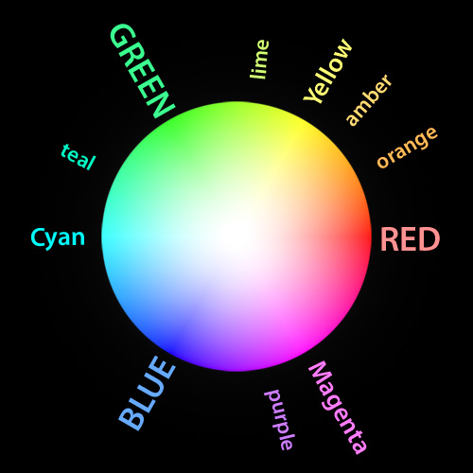
Figure 5: Colour wheel
The three fundamental colours of light, as seen by our eyes, are red, green, and blue. Combinations of these three primary hues produce the entire spectrum of colours that we can see. The secondary colours, cyan, magenta, and yellow, fall exactly between the primaries, and other hues fall at other locations. Note that our eyes are most sensitive to slight shifts between red and green, with more recognizable colours falling between them than any other two primaries.

How do the other colours relate to the primary hues of red, green, and blue? It is all in the combinations and proportions. Pairs of primary colours produce the secondary colours of light. Red and green combine to form yellow. Green and blue yield cyan, while blue and red make magenta. Other shades, like teal, orange, or purple, emerge by varying the proportions of the three primaries slightly. If red, green, and blue are all present in equal amounts, then the result is white, while black is just the complete absence of all of them. Such colour combinations are known as “additive” as they reflect the operation of the human eye as you add light of different colours.

The simplicity in this arrangement of colours makes it easy for us to record and present full colour images using digital technology. Any image we see can be broken down into three greyscale components representing red, green, and blue light. A television or computer monitor uses separate red, green, and blue elements (LEDs, backlit LCDs, or glowing phosphors) to present these images together and we see the full colour result. Likewise in print, choosing the right combination of inks can recreate an image that will reflect the right combinations of red, green, and blue into our eyes to represent the full colour image (See Box 1).

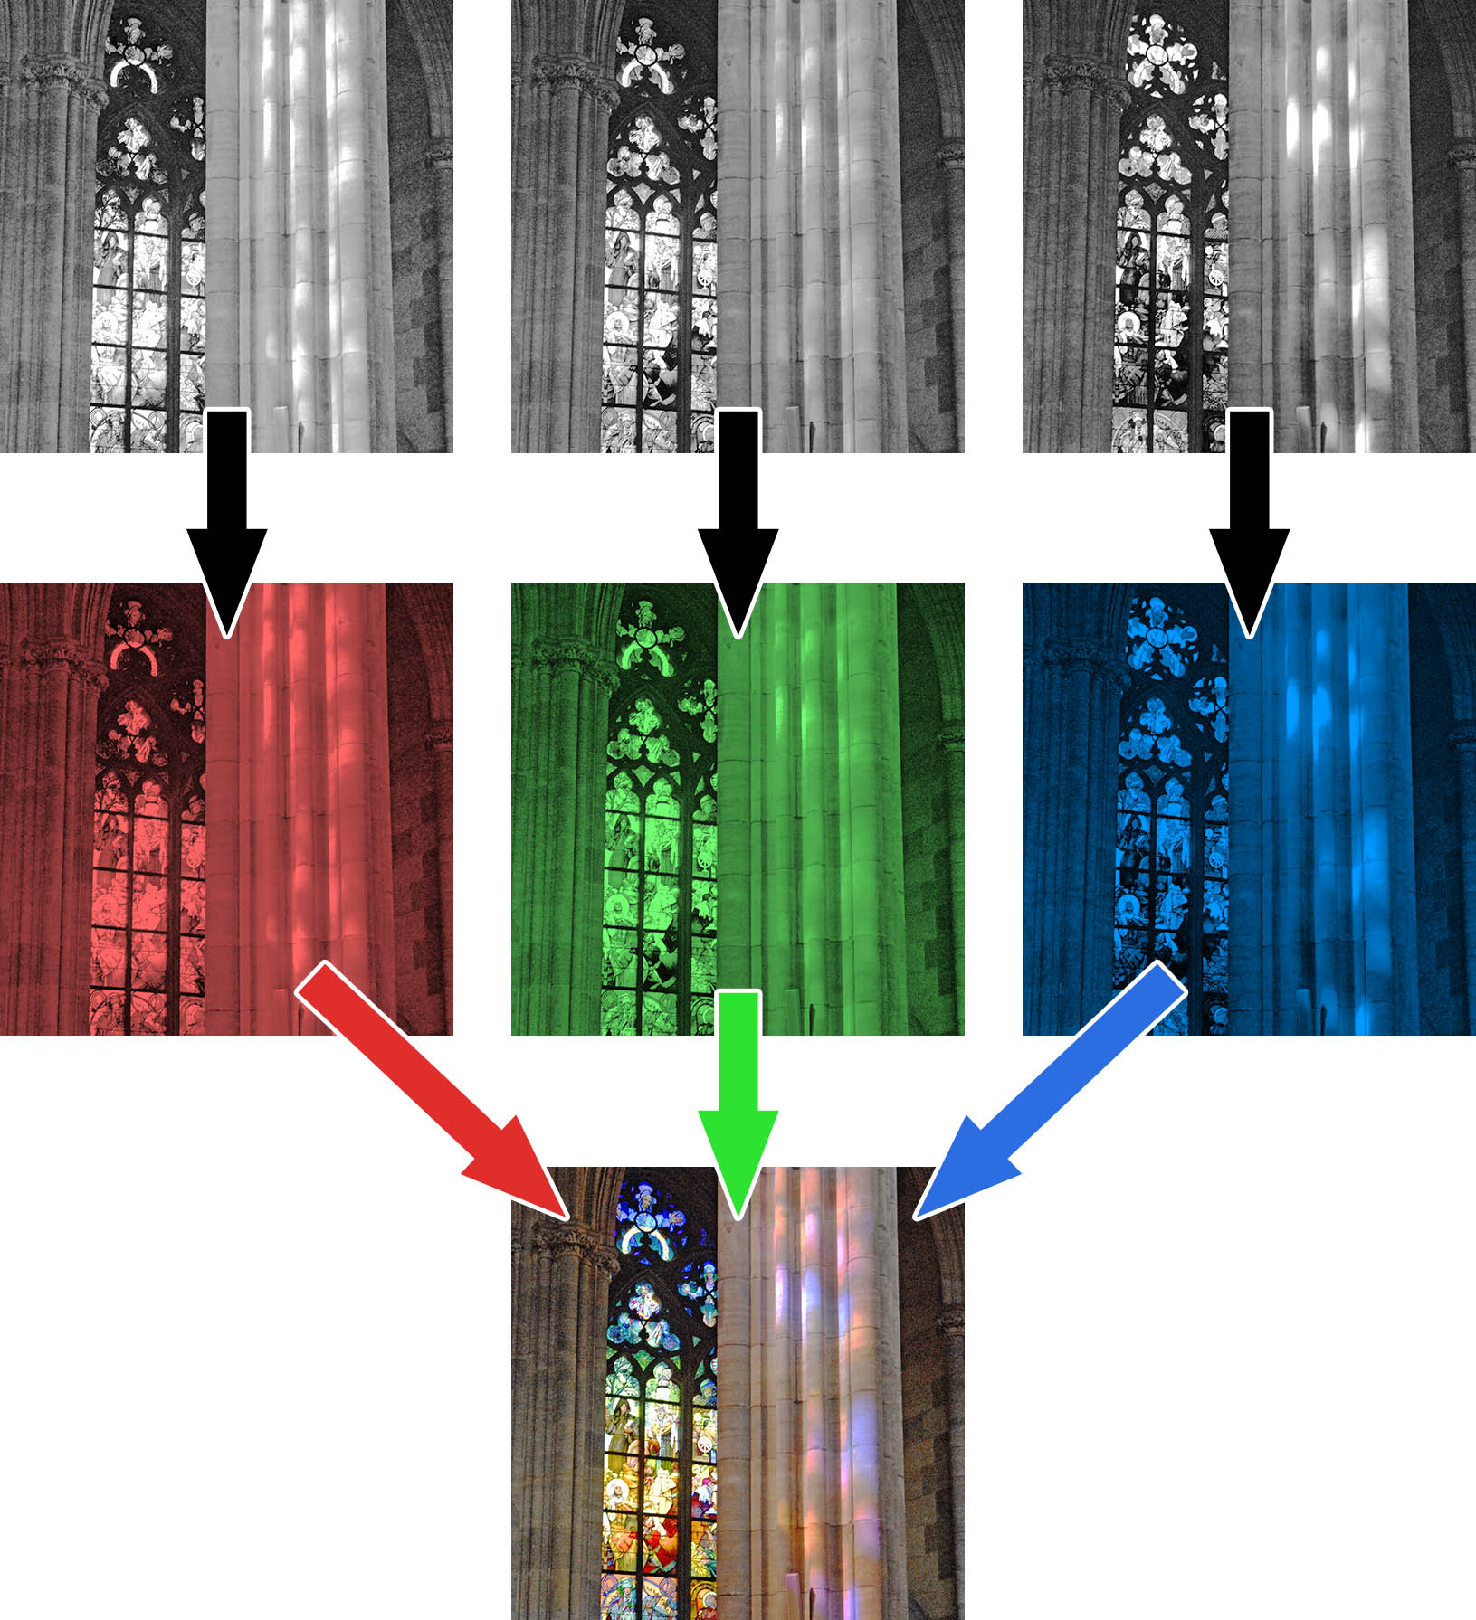
Figure 6: From greyscale to colour
Any colour image can be represented as three greyscale images capturing the red, green, and blue component. By assigning the correct primary colour to each one and combining them additively, the full colours our eye can see will emerge.

Box 1: Subtractive colours
There is often confusion in understanding the primary colours of light (red, green and blue) and how they relate to the so-called primary colours schoolchildren are taught for painting (typically, blue, red and yellow). The process our eye uses to see colour is an additive one. Light from each colour either enters the eye or it does not. If all the colours are present equally, then we see them all combine to give white.

Paints work in an opposite way, in a subtractive manner. A blank piece of paper is white, and reflects all the light that falls on it. Coloured paint subtracts out some of the colours from the light and we see only the colours that are not absorbed by the paint. For instance, a paint that absorbs only red light will have a cyan (an additive mixture of blue and green) colour, while one that absorbs only blue light will be yellow. When you mix paints together, you combine their subtractive properties. So, mixing cyan and yellow paint will subtract both red and blue from the white light leaving only green to be reflected.

Note that the true primary colours of the subtractive process, which is used in printing, are cyan, magenta and yellow. The primary subtractive colours are just the secondary additive colours, and vice versa.

It is important to note that these interpretations of colour should really be thought of as the nature of human colours. Our three-colour system is a result of evolutionary processes, but it is far from the only possible way that our eyes could have turned out. Other animals have no colour vision or can see a little way into other parts of the spectrum. If we had one additional colour receptor then we would have a significantly more complex, four-dimensional array of colours, which would be a lot harder to describe on a printed page!

What is light?
Understanding how we see colour helps us interpret our human perception of light better, but a more fundamental question remains. What is light itself?

The nature of light was a hotly debated topic throughout the early history of science. In the late 17th century Christiaan Huygens argued that light had a wave-like nature. However by the early 18th century, Isaac Newton’s competing theory that light was composed of particles had become the dominant view.

At the beginning of the 19th century, experiments by Thomas Young and Augustin-Jean Fresnel demonstrated that light clearly showed wave-like properties, producing effects similar to those seen in waves on the surface of water. It seemed that the answer was near.

But what kind of wave was light? By the late 19th century James Clerk Maxwell had formulated his revolutionary equations showing electric and magnetic fields to be two aspects of the same phenomenon. Light, it seemed, was a wave composed of alternating electric and magnetic fields.

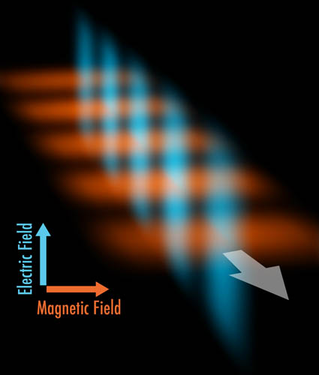
Figure 7: Light as waves of electromagnetism
The alternating weak and strong pulses of electric (blue) and magnetic (orange) fields are perpendicular to each other in space. They travel as a wave of light in the direction of the arrow, with each set of oscillating fields generating the next in the wave.

So light is understood to be an electromagnetic wave. The spacing between these alternating electric and magnetic fields is known as its wavelength, and the wavelength determines the colour of the light. Shorter wavelengths correspond to bluer colours, while longer wavelengths are redder.

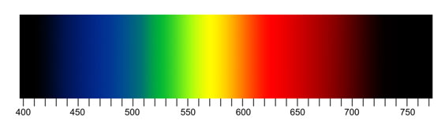
Figure 8: The wavelengths of visible light
The spacing between electromagnetic fields in the visible spectrum is tiny, measured in nanometres, or billionths of a metre. Yellow light, for instance, has a wavelength of about 570 nanometres.

Light as a wave of electromagnetism seemed irrefutable, but its particle nature was soon to reappear. In the early 20th century Albert Einstein was able to explain some confusing experimental results known as the photoelectric effect (this effect is used today as the underlying principle of solar power cells) by showing that light could posses both wave and particle properties. This bizarre notion, known as wave-particle duality would become one of the fundamentals of the emerging science of quantum mechanics. When we study light, we will often refer to its particle and wave properties independently, but it is important to remember that both are fundamentally a part of its nature.

The modern view is that electromagnetic waves are parcelled up into particle-like packets. Known as photons, these packets define the amount of energy carried within the light. A light photon’s wavelength and energy are completely interrelated — shorter wavelengths correspond to higher energies, while the longer wavelengths have lower energies. Scientists often use energy and wavelength interchangeably as they are inversely proportional.

Another fundamental result concerning the nature of light is that it moves at the same speed through space, regardless of its wavelength. It is quite fast, moving at nearly 300 000 kilometres per second. In fact, the speed of light is the ultimate “speed limit”; nothing in the Universe can travel faster.

Even so, the size of the Universe is so large that this speed limit can become quite significant. Light from our Sun still takes 8 minutes to reach us, and light from the nearest star has been travelling for 4 years before arriving at Earth. The light-year becomes a handy distance measure for astronomers, defined by how far light travels in one year.

The electromagnetic spectrum
When we think of the spectrum, usually we picture a swathe of colour running from violet to red. But the colours visible to our eyes are only a tiny slice of the entire electromagnetic spectrum of light. The full spectrum spans a variety of spectral bands that we do not necessarily think of as light, but are really another form of light, differing only by their wavelength. Scientists usually divide the electromagnetic spectrum up into seven bands: radio, microwave, infrared, visible, ultraviolet, X-ray and gamma ray. These divisions are for human convenience and are not precisely defined by physics, though they do correlate roughly with the different technologies used in each regime. Nature provides an electromagnetic spectrum that is continuous and without bounds, but humans usually prefer to divide things into pieces and name them.

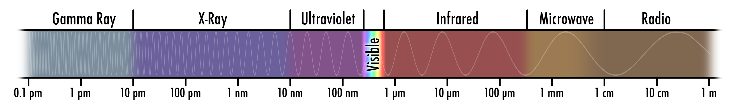
Figure 9: The electromagnetic spectrum

The wavelength of a photon of light determines its energy and where it falls in the spectrum. However, the spectrum spans an incredible range of wavelengths, from over a kilometre in the radio to less than one thousandth of one billionth of a metre for gamma rays. It is usually convenient to use different units for different parts of the spectrum. In this book we will use the following units:

- Centimetre (cm), hundredth of a metre: radio
- Millimetre (mm), thousandth of a metre: microwave
- Micrometre (microns, µm), millionth of a metre: infrared
- Nanometre (nm), billionth of a metre: X-rays, ultraviolet, visible
- Picometre (pm), trillionth of a metre: X-rays, gamma rays

Radio waves are at the lowest energy end of the spectrum and have the longest wavelengths. There is no defined longest wavelength for radio, though it becomes technologically impractical to detect anything far past the kilometre range. Radio waves are used extensively for broadcast communications, and our radio-loud civilisation does make it challenging to detect faint astronomical sources against this broadcast chatter.

Microwaves are also used for communications, including mobile phones. Microwaves are commonly divided into the millimetre and sub-millimetre bands, which in part denote differences in the detector technologies used in astronomy. They are also familiar for their use in microwave ovens. These exploit the fact that microwave radiation is strongly absorbed by water: a property that is important if we want to observe microwaves from space on the ground.

Infrared light spans the gap between visible and microwave light. Infrared light is often thought of as “heat radiation” since warm objects radiate infrared radiation that we can feel.

Visible light constitutes the spectrum that can be seen by human eyes, and it is by far the narrowest band of the spectrum, even though it is naturally the most familiar to us.

Ultraviolet light begins beyond the blue end of the spectrum. On Earth it is perhaps best known for its sun-tanning effects.

X-rays are at such high energies beyond the ultraviolet that even the name is more suggestive of its particle nature. Each photon has enough energy to penetrate many materials, making X-ray exposures a useful way of probing the internal structures of people and animals.

Gamma rays fall at the very shortest wavelengths. The energy in each photon is so high that it can have very destructive effects. Gamma rays can damage DNA and disrupt electronics, and in sufficient quantity can be lethal. Only the highest energy events in the Universe generate gamma rays.

Seeing invisible light
When we browse a book of photographs, the colours we see are a reliable constant. A clear sky will always seem blue and the leaves of a tree will always seem green. The combinations of red, green and blue seen by our eyes match the way we represent them in print or on a screen. This process can be described as showing the natural colours as our eye sees them.

But, as we have learned, the Universe of light extends well beyond the tiny slice of the visible. Colour can take on an entirely new meaning, referring to parts of the spectrum unseen by our eyes, but accessible to our technology. How can we see images from invisible bands of light?

Since our eyes can only see red, green and blue, these are our only choices available in rendering pictures from outside our range of vision. It is a simple process to take images made from any part of the spectrum and then display them in red, green and blue. The result is a colour image that vividly displays a way of seeing something our eyes alone could not perceive.

MISSING IMAGE

Figure 10: Mapping the invisible to the visible
Similar to the 3-colour image one above, only start with spectrum and indicate source of each of the 3 images from the spectrum, possibly something UV/vis/IR and how they map back into RGB; repeat twice, first for “natural” second for “representative” colour

In such images, what we see as red, green and blue no longer shows us the natural colours our eyes would see, but instead presents representative colours of the broader spectrum of light. Historically the term “false colour” has been used to describe such processing of images, but that term is misleading. “False” implies that the colours are somehow “fake” or “colourised”, as when an artist paints colours onto a black and white photograph. Representative colour images show real variations in colour from across the spectrum that have been shifted into a representation that works with our — relatively limited — eyes.

In a multi-wavelength Universe, colour becomes an unimaginably broad palette for the astronomer. Red, green and blue can now mean radically different things in different pictures as they bring the entire spectrum into view for us, and that alone provides an exotic beauty to be enjoyed.

There is even more to appreciate if we pause to consider what the colours actually represent in each case. How colour is used provides a kind of map legend, helping us to interpret the different things we see in each image. In this book, many images are presented along with colour keys that show what parts of the spectrum are represented by which colours. Knowing this mapping allows colour to become a guide, not just to our aesthetic reaction but to our scientific understanding as well. We can transcend the limits of our biological evolution and experience the full spectrum from a Universe that would otherwise be hidden!

Producing light
Our Universe is filled with light, but where does it come from? Electromagnetic radiation is produced by a surprisingly small number of phenomena which, when blended together, produce the fantastically varied Universe we see.

In the most basic sense, light is a series of oscillating electric and magnetic fields. So it should come as no surprise that light is generated from the motions and transitions of particles charged with electricity. If you take an electron or proton and shake it back and forth, you will inevitably produce light. This classical view is complicated a bit by the processes of quantum mechanics, but together they lead to a set of basic processes that together help us interpret what we see anywhere across the Universe.

Blackbody radiation
Most of the light in the world around us originates in a process curiously named “blackbody radiation”. This is a spectrum of light that depends only on the temperature of the object, whether it be a rock, a person, a star or even the entire Universe itself!

The basic idea is simple. Imagine an object that perfectly absorbs every photon of light that falls on it. Since photons carry energy, the object would have to heat up as it absorbed more and more photons. The only way such an object can be at equilibrium with its environment is if it radiates an amount of energy equal to that which it receives. Such radiation is exclusively a function of its temperature.

The physics governing blackbody radiation is known as Planck’s Law. The curve follows a consistent shape, shifting in brightness and wavelength as the temperature is changed. A blackbody radiator has a peak in brightness that shifts to shorter, bluer wavelengths as the temperature increases. The shifting peak wavelength for different temperatures is called Wien’s Displacement Law.

Our Sun, with a temperature of about 6000 °C (about 5800 K), is brightest in the yellow part of the spectrum. Hotter stars will be brightest in the ultraviolet. Even people emit blackbody radiation; with a body temperature of about 37 °C (roughly 300 K), we emit most brightly at infrared wavelengths of around 10 micrometres, but are far too cool to shine in visible colours.

Blackbody radiation is truly ubiquitous. It is the glow of the Sun, of incandescent light bulbs. It is emitted by people, planets and cold, dark clouds of interstellar dust. It is often described as thermal radiation, and it is the cosmic thermometer that astronomers use. Measuring an object’s blackbody spectrum allows us effectively to measure its temperature, even from billions of light-years away!

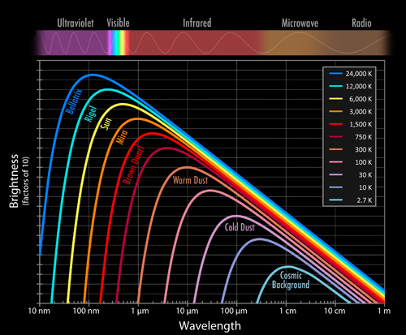
Figure 11: Blackbody radiation curves
The radiation profile of objects as a function of temperature follows a consistent shape. Note that both axes of this plot are logarithmic; each tick mark is a factor of 10 larger than its predecessor. However the peak wavelength and brightness shift dramatically with increasing temperature! For instance, our Sun has a temperature of roughly 6000 K (yellow line) and is brightest in the visible part of the spectrum around the colour yellow. If it were only half as hot at 3000 K (orange line), it would be about 100 times fainter at the colour yellow, and its peak brightness would have shifted to the infrared.

Spectral line radiation
The revolution of quantum mechanics at the start of the 20th century changed our understanding of the Universe forever, and gave us amazing tools to probe the structure of matter even from great distances. Spectral lines are specific wavelengths of light that are emitted and absorbed by every kind of atom and molecule and act as a unique fingerprint. Identifying known spectral lines in distant stars and galaxies allows us to measure chemical composition and determine physical properties like temperature, density and motions from afar.

A fundamental principle of quantum mechanics is that when we start looking at the smallest scales in the Universe, we find that energy comes only in discrete packets, or quanta. Within an atom, the electric forces that bind the negatively charged electrons that whirl around the positively charged nucleus only permit certain orbits at specific levels of energy. These levels vary, depending on the element (and how many protons are in the nucleus) and how many electrons are bound to it.

Nothing comes for free, however, and the tally of energy must always balance. An electron in a lower energy level can be bumped up to a higher level if it gobbles up a passing photon that has just the right amount of energy. Conversely, if an electron in a higher energy level drops to a lower one, it must emit a photon of an exactly matching amount of energy.

Since the energy of a photon is directly related to its wavelength, each energy transition in the atom (or molecule) corresponds to a precise wavelength of light. This light is known as a spectral “line” because of how exact the wavelength has to be; when plotted on a graph such a transition appears as a narrow line-like mark.

Spectral lines can be seen as an emission line if the electron is dropping from a high level to a low level, or as an absorption line if the electron absorbs a passing photon of the right wavelength from a background source.

Fluorescence is a common term used to describe a process where a high energy photon is absorbed by a body — which need not be hot — and gets transformed into one or more lower energy (redder) photons. This is familiar in fluorescent — or cold — lights where ultraviolet emission from an electrically-excited gas, like mercury, excites a material on the inside of the glass envelope to produce visible light. This can be a very passive process, like the use of fluorescent paints to capture blue light and radiate it as a vivid green, yellow or red. Even white writing paper contains a fluorescent dye that responds to blue/ultraviolet light and makes it glow “whiter-than-white”.

Astronomers use their knowledge of the various chemical fingerprints of known atoms and molecules to identify the composition of distant stars and nebulae.

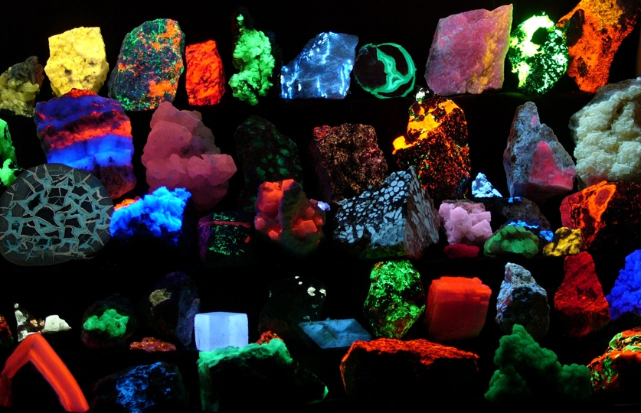

Figure 12: Examples of fluorescence
This image shows different minerals emitting visible light when exposed to (“invisible”) ultraviolet radiation. The same thing happens across the Universe as clouds of dust and gas re-emit longer wavelength light when exposed to higher energy radiation from nearby stars.

Non-thermal radiation
There are a number of other processes in the Universe that create light in more exotic ways, exotic at least compared with our day to day experience. For instance, charged electrons and protons that are passing through magnetic fields will move along oscillating spiral paths that produce electromagnetic waves (synchrotron radiation). Fast-moving charged particles that deflect one another from their electric field interactions can also generate light (bremsstrahlung radiation). Such processes are particularly evident in the radio part of the spectrum and will be discussed at greater length in Chapter 7.

2. The View from the Ground

Figure 13: The Australian Radio Telescope Array
This beautiful image shows parts of the Australia Telescope Compact Array (ATCA) near the town of Narrabri in rural New South Wales. It was taken just before sunrise with Mercury, Venus, and the Moon all appearing close together in the sky behind the array. Mercury is the highest of the three bright celestial beacons. The ATCA consists of six radio telescopes, each one larger than a house. Together they form one of the highest resolution measurement devices in the world. This is truly an astounding sight as impressive planetary conjunctions occur every few years.

Credit: Graeme L. White & Glen Cozens (James Cook University)

Astronomy is an observational science. Apart from the use of space probes in the Solar System, it is not possible to carry out experiments in situ, and information must be gleaned from light signals collected by telescopes and analysed with instruments such as cameras and spectrometers, which spread out the light into its constituent wavelengths and allow a closer study.

The telescope was invented in the early 17th century by Dutch spectacle makers and used for astronomical research for the first time by the Italian Galileo Galilei in 1609. Galileo pioneered the scientific method by thoroughly documenting all the new astronomical bodies and phenomena he saw with the telescope: craters on the Moon, Jupiter’s moons, spots on the Sun.

Since Galileo, thousands of observatories have been built around the world, and, since the 1960s, also in space. There are many advantages to be gained by observing from space (see Chapter 3), but it is expensive to launch telescopes and, with the notable exception of the Hubble Space Telescope, it is not possible to repair and upgrade them once they are there. Consequently, good sites on the ground are very attractive places to build large and powerful telescopes. These can then be continuously upgraded as new technology becomes available. Ground-based telescopes, working at visible, infrared and radio wavelengths, are forefront devices that usually work in a such a way as to complement the expensive, and usually smaller, space telescopes.

Atmospheric obstacles
Telescopes sited on the ground must cope with the distorting and absorbing/scattering effects of the atmosphere. Even at the most carefully chosen locations, the atmosphere is completely or partially opaque over large tracts of the electromagnetic spectrum (see Figure 14).

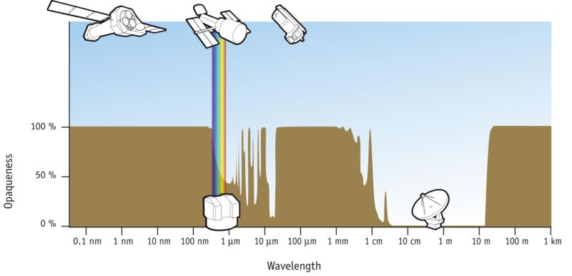

Figure 14: The opaqueness of the atmosphere
The opaqueness of the atmosphere measured on a scale from 0% to 100% (completely opaque) with some major astronomical telescopes. Three space observatories are seen at the top (from left): the XMM-Newton telescope, the Hubble Space Telescope and the Spitzer Space Telescope. At the bottom two ground-based telescopes (VLT and ALMA) are seen in two of the “windows” in the atmosphere where light can reach the Earth’s surface.

From the highest energy gamma rays, right through the X-ray region to the near-ultraviolet, at a wavelength of around 300 nm, the atmosphere completely absorbs radiation and astronomers are blind from the ground. The visible light region is relatively transparent, especially from high-altitude sites, and there are a number of useable windows in the infrared extending up to wavelengths of about 20 micrometres. Then comes a long stretch of the spectrum, covering the far-infrared, up to wavelengths just short of 1 mm where almost all radiation is again absorbed. In the so-called millimetre and sub-millimetre part of the spectrum, the principal absorber of light is water, and in this regime observations can only effectively be carried out at very high, dry sites like the 5000 metre high Chajnantor plain on the Northern Chilean altiplano, the site of ALMA. For longer radio wavelengths from around 1 centimetre upwards, the atmosphere is very transparent, although it is still capable of distorting radio “images” when conditions are not optimal. The Earth’s ionosphere finally cuts in at wavelengths of around 20 metres. As well as absorbing and scattering light, the atmosphere will radiate light during the night when it is not illuminated by the Sun. In the near-infrared, certain gas molecules, notably the combination of a single oxygen and a hydrogen atom (the so-called OH radical) emit strongly, making the sky appear quite bright. At longer infrared wavelengths, the atmosphere is bright simply because it emits heat radiation.

Not only does atmospheric transmission reduce or block the radiation coming from astronomical objects, the turbulence, all too familiar to any airline passenger, bends the incoming light through small angles that change continuously with time and position on the sky. Astronomers call this atmospheric phenomenon “seeing”. The quality of the seeing usually seriously limits the amount of fine detail that can be seen by ground-based telescopes in stars and galaxies (also known as the resolution). To compensate for some of this atmospheric distortion, modern telescopes and instruments often incorporate high-speed devices that can measure and correct for some of these distorting effects. Called “Adaptive Optics” (AO) these techniques are rapidly increasing in sophistication and can, under suitable conditions, exploit much of the intrinsic capability of large ground-based telescopes to make very sharp images (the larger a telescope is, the better resolution it has).

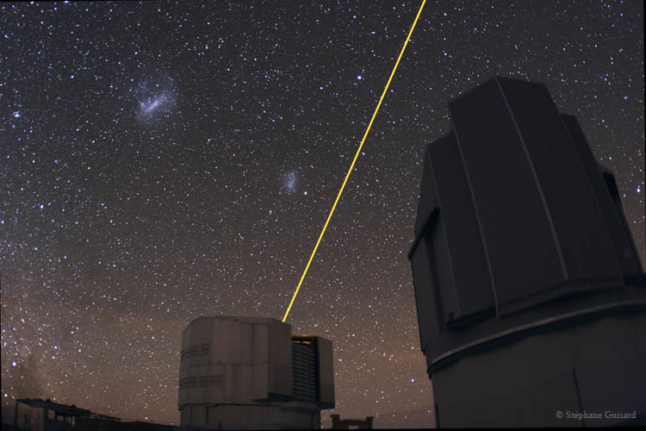
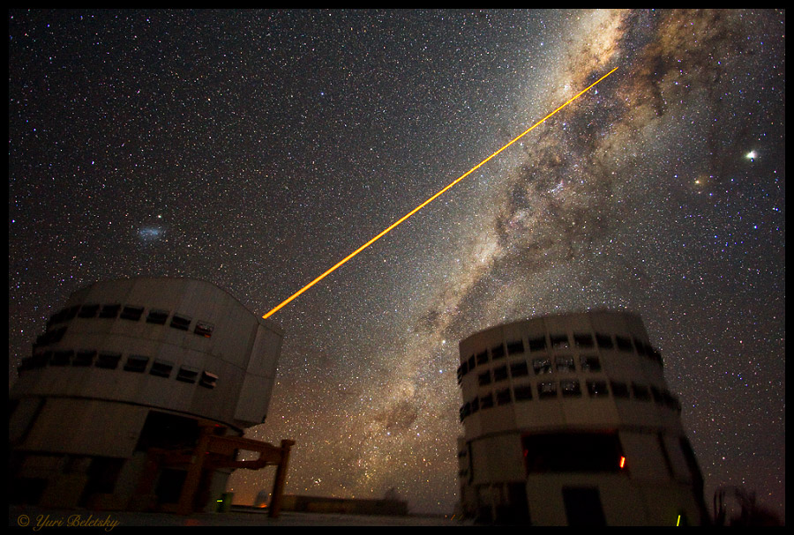

Figure 15: Adaptive Optics at work at the VLT
The Very Large Telescope in Chile with a laser used to create an artificial star in the sky to help with adaptive optics corrections.
Credit: Yuri Beletsky & ESO

To measure the changes in the atmosphere to calculate the right correction to make, AO systems need to make use of a reasonably bright star close to the object or field being observed. If a sufficiently bright star does not exist nearby, the telescope can project a laser beam into the sky to make an artificial star within the field of view (). This “star” is the result of light being reflected from a layer of sodium atoms that always is present 90 kilometres up in the upper atmosphere.

Types of ground-based telescopes
The technological development of telescopes has accelerated tremendously since the development of computers and advanced electronics. The ingenuity needed to overcome the seeing problem and to exploit the isolated gaps in the atmospheric absorption (see Figure 14) is truly outstanding. Telescopes today are often a far cry from the tube with lenses that Galileo so successfully pointed at the night sky. At the risk of over-simplifying, the many different ground-based telescopes fall roughly into seven different categories: classic visible-light reflecting (some with quite good near-infrared observing abilities) telescopes, solar telescopes, sub-millimetre telescopes, radio telescopes (often linking together in giant arrays called interferometers), cosmic-ray observatories, neutrino telescopes and gravitational-wave telescopes. For some of these instruments, the label “telescope” seems a real misnomer... Examples of all these types of telescopes are seen in Figure 16.

Future ground-based observatories
Several new ground-based observatories are being planned and/or built at the moment. In the visible-light regime the focus is on size. Three extremely large telescopes are in different phases of construction and development at the moment. The European Extremely Large Telescope (E-ELT), with a mirror diameter of 42 metres, is planned for 2017. It has a revolutionary design that includes five mirrors and advanced adaptive optics to correct for the turbulent atmosphere. The E-ELT will probably be built somewhere in northern Chile.

Two large projects are under way in the US. The Giant Magellan Telescope is planned for completion in 2016 and consists of seven 8.4-metre primary mirrors. Together they will catch as much light as a 21.5-metre mirror and provide the same resolving power as a virtual 24.5-metre giant. This huge instrument will be built at the Las Campanas Observatory in Chile, which is already home to the twin 6.5-metre Magellan Telescopes. The Californian Thirty Meter Telescope is also due to be completed in 2016 and is more like a giant version of the Keck Telescope. Almost 500 individual segments will make up one enormous 30-metre mirror. This will be able to collect ten times more light than the Keck Telescope and to see three times more detail.

The Atacama Large Millimeter/submillimeter Array (ALMA) consists of 66 millimetre-antennas and is currently under construction at Llano de Chajnantor in Chile, 5000 metres above sea level. The individual telescopes can be relocated in a variety of configurations by giant trucks to produce unsurpassed observations of the millimetre wave emissions from remote galaxies or relatively nearby star-forming regions.

The international Square Kilometer Array (SKA) is a gigantic network of dish antennas and flat receivers with a total collecting area of approximately one square kilometre that will provide astronomers with an unsurpassed view of the radio Universe. The SKA will be constructed either in Australia or in southern Africa and will be 50 times more sensitive than any other radio instrument.

Figure 16: Examples of ground-based telescopes
- The Very Large Telescope: A system of four separate visible-light telescopes each with an 8.2-metre main mirror. The VLT was built and is operated by the European Southern Observatory. It is located at the Paranal Observatory on Cerro Paranal, a 2635 m high mountain in the Atacama desert in northern Chile. The individual telescopes can form an interferometer, supplemented by smaller 1.8-metre auxiliary telescopes.
- The Keck Telescopes: Keck is a two-telescope astronomical observatory at the 4145-metre summit of Mauna Kea in Hawai'i. The primary mirrors of each of the two telescopes are composed of 36 hexagonal mirror segments and are 10 metres in diameter. The telescopes can also operate together to form a single interferometer.
- The Subaru Telescope: Subaru is the 8.2-metre telescope built by the National Astronomical Observatory of Japan and is located on Mauna Kea. It is named after the open star cluster known in English as the Pleiades.
- The Gemini Observatory: Gemini consists of two 8.1-metre telescopes, one on Mauna Kea and on Cerro Pachón in Chile.
- Swedish Solar Telescope: The Swedish Solar Telescope is a 1-metre telescope at Roque de los Muchachos Observatory, La Palma in the Canary Islands. It is the second largest refracting telescope in the world and uses a vacuum tube to create the sharpest images of the Sun with adaptive optics.
http://www.solarphysics.kva.se/NatureNov2002/images/goran/DSCN0440_turn.JPG
- The James Clerk Maxwell Telescope: JCMT is a 15-metre sub-millimetre telescope at Mauna Kea Observatory in Hawaii. It is the largest sub-millimetre telescope in the world and is used to study our Solar System, interstellar dust, and gas and distant galaxies.
- Parkes Observatory: Parkes is a 64-metre movable radio telescope near the town of Parkes, New South Wales, Australia. This telescope relayed parts of the television footage of the Apollo 11 Moon landing to the world.
- The Very Large Array: VLA consists of 27 independent antennas, each of which has a dish diameter of 25 metres. The antennas are positioned along the three arms of a Y-shape, each of which measures 21 km, and can be used for very precise interferometry.
- Major Atmospheric Gamma-ray Imaging Cherenkov Telescope: MAGIC is a 17-metre gamma-ray telescope situated at the Roque de los Muchachos Observatory on La Palma, one of the Canary Islands, at about 2200 m above sea level. It detects particle showers released by cosmic gamma rays, using Cherenkov radiation, i.e., the faint light radiated by the charged particles in the showers.
- Pierre Auger Observatory: Sixteen hundred water tanks, spread out over an area of 3000 square kilometres, make up the Pierre Auger Observatory at Pampa Amarilla in Argentina. The water tanks detect high-energy particles created when cosmic rays penetrate the Earth’s atmosphere. Named after French cosmic-ray physicist Pierre Auger, the observatory was officially inaugurated in mid-November 2008.

3. Space observatories (Lars)


Figure 17: Hubble, the most well-known space observatory
This illustration shows the NASA/ESA Hubble Space Telescope in its high orbit 600 kilometres above Earth.
Credit: European Space Agency

Astronomical observatories in space have revolutionized our knowledge of the Universe. They are one amongst many types of satellites launched since the beginning of the space age, devoted to a great variety of applications including Earth observation, communication and broadcasting, navigation and military right up to fully habitable space stations. Space observatories give access to light that is not visible from the ground and provides an undisturbed view of star and galaxy-studded sky. Expensive yes, but unbeatable in the chase for the elusive photons from the hidden Universe.

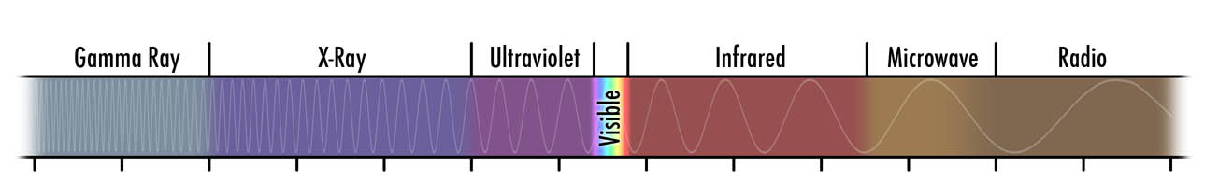
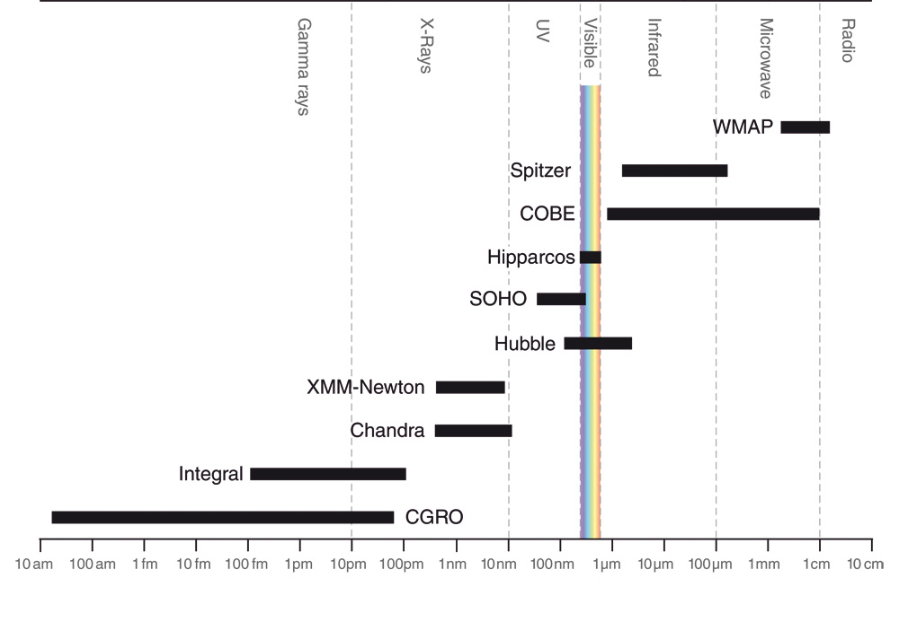
Figure 18: Ten examples of current and past space observatories
Some of the most important astronomical observatories in space and the part of the electromagnetic spectrum where they function. Short wavelengths (X-Ray, ultraviolet etc.) are on the left, long wavelengths are on the right.

The space age came into being with the launch of Sputnik by the Soviet Union in 1957. Only five years later, in 1962, NASA launched the first true astronomical research satellite, OSO-1. Since those first steps, more than 100 different astronomical observatories have been launched — some better known than others. They have contributed a wealth of information in many new fields of astronomy.

Most astronomical satellites orbit the Earth but, for some purposes, there are advantages in choosing other locations and orbits. Some are affected by the radiation belts associated with the Earth’s magnetic field which can affect sensitive detectors and electronic circuits while other spacecraft need to keep well away from the heat radiated into space by our home planet.

A sort of ‘half-way-house’ between the ground and space can be provided by high altitude balloons such as BOOMERanG which is a Cosmic Microwave Background observatory, or SOFIA, an infrared telescope flown in a converted Boeing 747 aircraft. Such experiments play an important role by avoiding many of the disadvantages of being on the ground while being considerably less expensive than spacecraft.

As mentioned in Chapter 2 there are several compelling reasons for launching telescopes into space, the most important being the escape from the absorption, emission and turbulence associated with the atmosphere. The elevated vantage point gives access to light that is not visible from the ground and provides an undisturbed view of star and galaxy-studded sky. What hinders our exploitation of the ideal space environment? High (often referred to as “astronomical”) cost is one factor, but we also have to take account of the long lead times associated with the development of these complex and remotely controlled devices and the risk that is taken when they are blasted into space atop a rocket.

These are naturally some of the reasons why observatories are still being built on the ground. On Earth it is easier to upgrade to the latest technology and to build larger telescopes that gather more light. In general space telescopes and ground-based telescopes are complimentary, but with important synergies between them. For that reason, research teams frequently make use of both space and ground-based instruments to investigate a particular phenomenon.

Reliability

When launching an observatory into space on a mission that may last years or even decades, the question of the reliability of its component parts looms large in the thoughts of the designers. With the notable exception of Hubble, which is serviced by teams of astronauts flown on the Space Shuttle, most spacecraft become inaccessible after launch.

All the mechanics and electronics have to be thoroughly tested to ensure they can endure the harsh conditions they will experience during and after launch. Severe vibration, large temperature changes and a hostile radiation environment are factors to be taken into account. As well as using well-tested and high quality components, it is usual to build in as much redundancy between systems that is reasonably possible. It usually takes years to go through this intensive space qualification. Meanwhile, technological advances continue and it becomes a race to get the best possible hardware on board before the design is “frozen in” before launch.

In addition to these considerations, some spacecraft rely on the continuing use of fuel or other consumables such as liquid or solid gas coolants that will ultimately limit their useable life.

What is inside?
Some research satellites are quite similar to the telescopes in observatories on the ground, but others are fundamentally different. Almost like a small autonomous city in space, a research satellite consists of a wide range of basic components: main mirror, telescope tube, detectors, energy supply (batteries and solar panels), communications equipment, computer, navigation equipment and hundreds or even thousands of sensors. The different parts are shown in Figure 19.

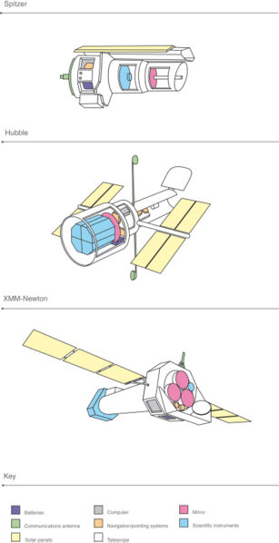

Figure 19: Inside space observatories
Sketches of three famous space observatories and their most important components: Spitzer, Hubble and XMM-Newton.

Main mirror: A common feature for most space observatories is the main mirror. The magnification is not the major criterion here, but the light-collecting area. The larger the mirror, the more light it can receive and the fainter the objects it can observe. The further away from the visible wavelengths a space observatory observes, the more specialised the mirror and the structure around it have to be.

In visible light normal mirrors are used and the light arrives almost perpendicular to the mirror (90°). In contrast, X-rays have such an enormous energy that the photons — light particles — would simply pass through the mirror if they hit it head on. Instead a series of nested cylindrical mirrors is used where the light grazes the mirror surface at an angle of only a half or one degree, and therefore is only slightly deflected by each mirror in the series to arrive eventually in focus at the detectors further down the tube (which needs to be quite long).

A gamma-ray satellite cannot use mirrors at all and the light, or radiation, falls directly onto the detector.

Telescope tube: The main purpose of the tube is to shield the mirror and detectors from unwanted light and to stabilise the observatory. The violently changing temperatures in space make the telescope “breathe” — contract when it is cold and expand when it is warm. For very precise instruments, often positioned with nanometre accuracy, this can give rise to problems. It is necessary to focus a space telescope from time to time because of these small changes. The more solid a telescope tube, the smaller the “breaths” — but at the cost of increased weight and budget. A satellite engineer has to be a ruthless packer and the master of travelling light. It is murderously expensive to construct and launch satellites (about 100 000 € per kilogramme of satellite). So all parts have to be measured and weighed — just as you would carefully select equipment and food for a week-long hike with a backpack.

Detectors: Detectors are components that receive a lot of attention from the astronomers. It is here the light is registered and translated to electrical signals. They are the eyes of the telescope. There are two main types of detectors: spectrographs and imaging detectors such as CCDs (Charge Coupled Devices, similar to those in digital cameras). The technological advances in detectors have been immense over the past 25 years.

Solar cells and batteries: The energy supply for a space observatory usually comes from the Sun via large solar cell panels that convert light to electricity, which is stored in batteries for use when the satellite is in the Earth’s shadow.

Communications equipment: Parabolic antennas are usually used to communicate back and forth with the ground. At times special relay satellites are used to pass communications back to Earth.
Computer: Onboard computers are used to calculate with the data and to store the information. As with other high-tech components in space, the computers are slightly out of date. For instance, the Hubble Space Telescope uses a 486 processor that was developed in the late 80s.

Navigation equipment: Both the direction and the position of a research satellite must be known at all times to a high precision. Gyroscopes can measure the direction of a space telescope within a fraction of a degree precision.

Sensors: Hundreds or ever thousands of sensors continuously inform the engineers about all the conditions onboard: temperature, currents, pressure etc.

Figure 20: Examples of space observatories
- Spitzer Space Telescope: Spitzer is an infrared telescope with a 0.85 metre mirror that is embedded in a sort of large thermos flask with liquid helium. It has made its mark on astronomy by being extremely sensitive and by having the highest resolution (sharpest vision) among the infrared space telescopes. Spitzer builds on the legendary work IRAS, ISO
- WMAP: In 2003 the Wilkinson Microwave Anisotropy Probe (WMAP) improved COBE’s measurements so much that many of the different cosmological parameters could be nailed down, such as the age of the Universe (13.7 billion years), the expansion velocity of the Universe (70 km/s/Mpc), and the general composition of the Universe (22% dark matter, 74% dark energy and 4% normal matter).
WMAP builds on In 1992 the COsmic Background Explorer (COBE) measured the first tiny temperature differences in the microwave radiation from Big Bang. They show the first clumps of matter that later became galaxies. This was a fundamental cosmological discovery was an immense boost to the Big Bang theory.
Credit: WMAP/NASA
- Hubble: The Hubble Space Telescope is perhaps the best-known telescope in the world. It functions as a super-sharp digital camera, delivering the clearest images so far of the objects it observes. Hubble has improved our knowledge about many areas in astronomy and has, for instance, shown that there are black holes in the centres of most galaxies.
This illustration shows the NASA/ESA Hubble Space Telescope in its high orbit, 600 kilometres above the Earth.
Credit: Hubble/NASA/ESA
- Hipparcos: Hipparcos was launched in 1989 by ESA and was the first research satellite dedicated to the measurement of the positions of the stars. Hipparcos mapped millions of stars very precisely and laid an indispensable foundation for most other branches of astronomy. Apart from establishing the general network of star positions Hipparcos also identified stars that will pass through the solar neighbourhood in the future.
Credit: ESA/Hippacos
- SOHO: The SOlar Heliospheric Observatory (SOHO) has observed the Sun almost every day since its launch in 1995 and has the most complete database of phenomena on the Sun. SOHO has found complicated currents of gas running beneath the Sun’s surface and identified thousands of new comets.
Credit: SOHO/ESA
Artist's conception of the Solar and Heliospheric Observatory (SOHO) spacecraft.
- XMM-Newton: The XMM-Newton telescope was launched by ESA in 1999 and is currently the world’s largest X-ray telescope. Its 58 nested mirrors collect the X-ray light very effectively and make it possible to measure the compositions of stars and galaxies better than any other X-ray telescope. It has helped to trace the history of a wide range of galaxy clusters by measuring X-ray radiation from otherwise invisible hot gas — at an incredible 10-100 million degrees — in the clusters.
Credit: XMM-Newton/ESA
Artist’s impression of XMM-Newton. Image courtesy of ESA.
- Chandra: The NASA Chandra X-ray Telescope has the sharpest vision of all X-ray telescopes. Among the highlights from Chandra have been the best images of supernova remnants and the best views into the lives of neutron stars and black holes.
Credit: Chandra X-Ray Observatory/NASA
- Integral: Integral is the first space observatory that can observe phenomena in gamma rays, X-rays and visible light simultaneously. It keeps a watchful eye on black holes, neutron stars and the so-called gamma-ray bursts.
http://sci.esa.int/science-e/www/object/index.cfm?fobjectid=38737
Credit: INTEGRAL/ESA
- IUE
- GALEX: The Galaxy Evolution Explorer.

Future space observatories
A wide range of groundbreaking astronomical satellites will soon be launched by NASA and the European Space Agency (ESA). By the time this book is printed ESA’s Planck and Herschel telescopes will have been launched as a double-pack. Planck will observe the microwave radiation from the Big Bang with unprecedented precision and Herschel will observe light from cold objects and distant redshifted galaxies in the infrared and sub-millimetre wavelength regions.

ESA’s GAIA will be launched in 2011 to map the precise positions of a billion of the Milky Way’s stars.

NASA’s and ESA’s successor to Hubble will be the James Webb Space Telescope, JWST, to be launched in roughly 2014. JWST will have a 6.5 metre main mirror and will observe the first stars and galaxies in the infrared.

The near future seems to be very bright astronomically speaking…

4. The Visible Universe (Lars)
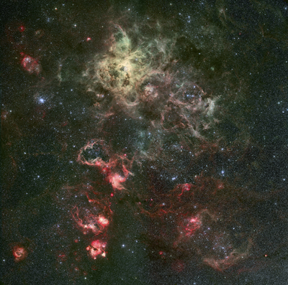

Figure 21: This beautiful one degree square mosaic of the Tarantula nebula region of the Large Magellanic Cloud was taken through four different colour filters (blue, green/yellow, oxygen [OIII in green and Hydrogen-alpha in red) with the ESO/MPG 2.2-m telescope on La Silla in Chile. The colour image was carefully constructed to maintain the full range of brightness from the dark background sky to the very centre of the greenish-yellow Tarantula nebula at the top left. The Tarantula is the youngest, most active star-forming region in our local group of galaxies and is hot enough to excite oxygen atoms to glow green. The red parts of the nebula emit light from excited hydrogen atoms, glowing with the light of somewhat older, cooler stars. The blue star clusters sprinkled over the field are even older and no longer have a surrounding nebula. The scattered remnants of the huge, dusty molecular cloud that mothered all this activity can still be seen obscuring the background stars around the periphery of the nebula.

The visible part of the electromagnetic spectrum is the astronomical base camp. This is where people first started to look at the sky many thousands of years ago and it remains the reference point for research taking place in all other wavelength domains.

Box 2: Visible light

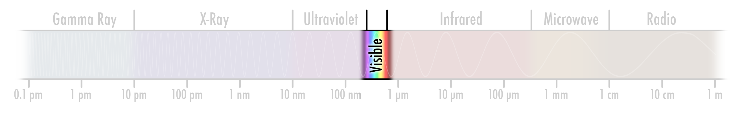

BLA BLA BLA BLA BLA BLA BLA BLA BLA
BLA BLA BLA
BLA BLA BLA
BLA BLA BLA
BLA BLA BLA

Before the first radio observations were made in the 1930s (see Chapter 7), all that was known about the Universe came from observations in the visible part of the spectrum. Scientists were not even aware of the “hidden Universe” beyond the boundaries of the visible. For many years — perhaps even persisting today — a kind of narrow-sightedness existed amongst astronomers that could perhaps be called “visible-light chauvinism” — an exaggerated focus on the processes that are visible to our eyes. For all that the visible part of the spectrum is very important and information-rich, it is just a tiny part of the full story. Although this book is about the cosmic radiation that we cannot see for ourselves, a chapter on the visible Universe is necessary to set the scene.

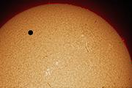

Figure 22: Our Sun
Venus in transit across the Sun as seen in Hydrogen-alpha light.
Credit: Stefan Seip
http://www.eso.org/public/outreach/eduoff/vt-2004/photos/images/vt-photo-01-stse.jpg
The visible wavelengths are called “visible” because they are the wavelengths that we can see naturally. Natural selection has forged a connection between our eyes and the Sun’s light, most of which emerges in the visible range. Our eyes are biologically tuned to be sensitive where the Sun is brightest. The Sun is a perfectly ordinary G dwarf star and many other stars emit a large part, or even the majority, of their light in the visible range.

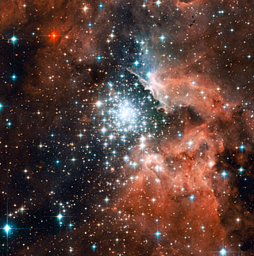
Figure 23: The star-forming region NGC 3603 — seen here imaged with the Hubble Space Telescope — contains one of the most impressive massive young star clusters in the Milky Way. Bathed in gas and dust the cluster formed in a huge surge of star formation thought to have occurred around a million years ago. The hot blue stars at the core are responsible for carving out a huge cavity in the gas seen to the right of the star cluster in NGC 3603’s centre. The red colour in the upper left may either be a colder star or a star partly obscured by dust.

The colours of the stars
When looking at the night sky it is possible, but not necessarily easy, to distinguish different colours in the stars. Aldebaran, the eye of the Bull in Taurus, is reddish, and Rigel in Orion’s right foot is bluish, but, as seen in Figure 15, the colours are subtle.

O
B
A
F
G
K
M

Rigel (B)
Aldebaran (K)
Figure 24: The colours of the stars
The seven standard stellar types O to M are seen with colours from bluish to reddish. Note that the colours are pastels and not very saturated.
Mitchell Charity’s integrated colour table. http://www.vendian.org/mncharity/dir3/starcolor/

Stars are gaseous spheres that radiate in a way that is characteristic of the temperature near their surface. This is similar, but not identical, to the important blackbody radiation described in Chapter 1. The Sun has a surface temperature of about 6000 °C and the Sun's colour is rather similar to that of a 6000 °C blackbody. Small differences arise because the radiation is escaping directly into space and is not captured inside a closed cavity, as it would be if the Sun were a true blackbody radiator.

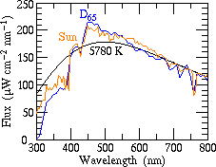
Figure 25: Our Sun, nearly a blackbody
The actual spectrum of the Sun (as seen outside the atmosphere) compared with a blackbody curve for a blackbody with the Sun’s surface temperature of 6000 °C. The general similarity is clear (and the differences can be attributed to absorption or emission from particular atoms in the Sun).
Credit: R. L. Kurucz, I. Furenlid, J. Brault & L. Testerman (1984) Solar Flux Atlas from 296 to 1300 nm. http://casa.colorado.edu/~ajsh/colour/Tspectrum.html

If the Sun’s blackbody temperature is approximated to a printed colour (although this is somewhat dependent on print-technical issues and the white point that is chosen), it looks peachy-pink, not the white or yellow that we would see if we were foolish enough to look directly at the Sun. Seen directly, the Sun’s light is simply too bright and saturates the colour-sensitive cones in our eyes. The small differences between the Sun's spectrum and a precise blackbody spectrum are due to various atomic processes that we will describe below.

Sun (G, viewed outside of atmosphere)

6000 C

Figure 26: The colour of our Sun
The Sun’s colour would look somewhat peachy-pink, if our eyes were not blinded by its bright light (NB: never look directly at the Sun with your eyes or a telescope).

The visible colour of a star depends on its temperature, which determines the wavelength of the peak of its spectrum, according to Wien’s displacement law, illustrated in Figure 14. Depending on where the peak falls, a different colour results. Only a limited range of star types have blackbody temperatures that peak in the visible range, but much of the light from all stars is visible to our eyes.

Box 3: Why are there no green stars?
Figure 14 answers a fascinating question: Why can we see no green stars in the sky or in photographs? Because the blackbody curves are relatively wide, the emission will fall across a range of different colours that will blend with the peak colour of the curve and dilute it. A hot star will, for instance, have a blackbody spectrum that peaks in the blue, and it will look bluish. A relatively cool star will have a blackbody spectrum that peaks in the red, and it will look reddish. Green lies in a narrow band squeezed between the blue and red, so a star with an intermediate temperature will have its peak in the green, but it won’t appear green. Its emission will extend out to include both blue and red colours that will blend in and make the star appear whitish.

The fact that the typical star’s spectrum peaks in the visible means that visible light photometry is very effective in distinguishing stars of different temperatures and other properties, such as size and chemical composition: so measuring both sides of the brightness peak gives the best “leverage” in determining colour.

Box 4: The colour of the Universe.
What is the colour of the Universe? This seemingly simple question has only recently been addressed by astronomers Karl Glazebrook and Ivan Baldry. It is difficult to take an accurate and complete census of all the light in the Universe. However, using the 2dF Galaxy Redshift Survey — a survey of more than 200 000 galaxies that measured the light from a large volume of the Universe — the question has finally been tackled. A “cosmic spectrum”, which represents the sum of all the energy in the local volume of the Universe emitted at different visible wavelengths of light, was constructed:

Which average colour would this give?
As for the Sun, the result actually appears almost white, perhaps with a slight pinkish tint (and again depending somewhat on printing technology):
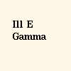

The colour of the Universe from Glazebrook & Baldry: http://www.pha.jhu.edu/%7Ekgb/cosspec/

Spectral lines — atomic fingerprints
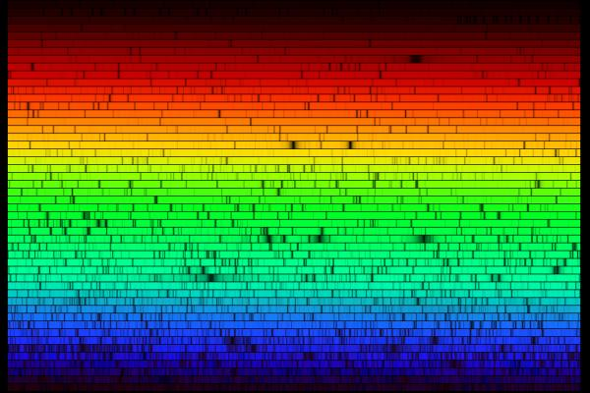
Figure 27: Solar spectrum
This amazing image shows a high resolution spectrum of the light from our Sun littered with absorption lines, each a fingerprint of a particular atomic or molecular process. The spectrum was made from digital data obtained at a solar telescope at Kitt Peak National Observatory and covers the range of visible light from 400 nm in blue to 700 nm in red. Because of the way it was obtained, the spectrum has been divided into many separate strips that are stacked one on top of another in this image. The rather broad, dark feature at the top right, red part is due to hydrogen, while the pair of strong yellow lines is produced by sodium. Credit: N.A.Sharp, NOAO/NSO/Kitt Peak FTS/AURA/NSF
http://www.noao.edu/image_gallery/html/im0600.html

As was described in Chapter 1 the spectral lines that are imprinted on the light that arrives from distant stars and galaxies is a veritable gold mine for astronomers. Many of the most important spectral lines for atoms and molecules are found in the visible-light range and they have become effective tools for astronomers, who use these lines as their principal tool for understanding the physics in the distant stars and galaxies.

The energy that eventually results in the emission of light from the outer layers of stars originates from nuclear fusion processes occurring deep in the ultra-hot stellar core. As in a hydrogen bomb, it is here that mass is converted into energy according to the Einstein’s famous equation, E = mc², as hydrogen and helium are gradually processed to heavier elements. The energy released in the deep interior does not escape from the surface very quickly — it takes some ten million years for any change in the core of the Sun to be apparent at the surface.

It is only close to the surface that the different chemical elements imprint their signature on the escaping light, allowing distant astronomers to map the stellar structure and composition, an amazing capability that was undreamt of even as late as the mid-19th century.

Stellar evolution
From a curious astronomer’s perspective, one of the interesting things about stars is that they change colour and brightness throughout their lives. Typical life-spans range from about a million years for very massive stars to tens or hundreds of billions of years for smaller stars like our Sun. The more massive a star is, the brighter it shines and the shorter its lifespan.

Around 1910, the Dane, Ejnar Hertzsprung and the American, Henry Norris Russell, made a huge leap forward in our understanding of stellar evolution, or the “lives of stars”, when they plotted stellar colour against intrinsic brightness (which astronomers call luminosity). The resulting diagram, now called the Hertzprung-Russell diagram in their honour, is an invaluable tool for stellar astronomy. Stars of the same mass (and, strictly speaking, chemical composition) trace out the same course, called an evolutionary track, through the diagram. Different masses will have different evolutionary tracks, and astronomers can extract considerable information about the mass and evolutionary status of stars from just their colour and their brightness.

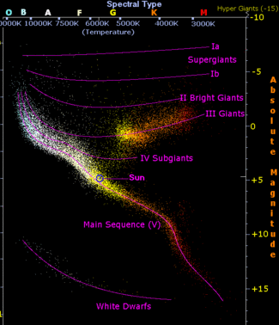
Figure 28: Hertzprung-Russell diagram
In the Hertzprung-Russell diagram the temperatures of stars are plotted against their brightnesses. The position of a star in the diagram provides information about its present evolutionary stage and its mass. Stars that fuse hydrogen into helium lie on the diagonal branch, the so-called main sequence. When a star’s fusion processes cannot continue any longer, it finally evolves into a white dwarf (bottom-left corner) or it explodes as a supernova. Which of these fates it suffers depends on its mass and whether it exists in a double-star system. Through its life, a Sun-like star will move along the trail indicated.
http://en.wikipedia.org/wiki/Hertzsprung-Russell_diagram

Are the colours real?
As Chapter 1 showed, the concept of colour is very subjective and depends both on the eyes that do the seeing and the process used to make the pictures. Many of the objects in this book would be too faint to really see very clearly even if we visited them in some fantastic future spaceship. And certainly the colours would be barely discernable or invisible, since the colour sensitive cones in our eyes work poorly under low light conditions.

Another complication is that most of the images in this book were made using light from “invisible” parts of the spectrum. For images made in X-rays, ultraviolet, infrared etc., the familiar colours are often assigned so that the “reddest” light is red and the “bluest” light is blue. With these “representative colour” images it is possible to map the invisible light to make images that we can see and appreciate.

On top of all this, some images are taken through special narrowband filters that only allow a specific wavelength to pass. These are designed to target individual atomic or molecular processes and are thus very different in “vision” from our broader red, green, blue sensitive eyes. These “enhanced colour” images are often colour-coded in a way that may not represent the proper colour, but shows the maximum amount of information. These are often beautiful demonstrations of how the science of modern astronomy mimics artistic choices.

Where the invisible becomes visible and the visible invisible
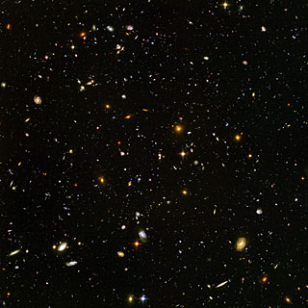
Figure 29: The Hubble Ultra Deep Field

http://www.spacetelescope.org/images/html/heic0406a.html

There is a special case where some of the “invisible” radiation from the Universe can become visible to our eyes, or at least to our visible-light cameras: ultraviolet light from very distant objects is redshifted into the visible range — the Universe expands and as a result, the more distant an object is from us, the more its light is “stretched” to longer, redder wavelengths.

But the Universe gives and takes. The redshift also shifts the redder parts of the visible part of a distant galaxy’s light into the “invisible” infrared, so we don’t really gain anything in terms of the amount of light we can see. And for the farthest galaxies that we know today, which are seen from a time when the Universe was nearly 13 billion years younger than it is today, the redshift is so extreme that the blue slope of the blackbody-like spectrum of even the hottest stars is shifted into the infrared, making them practically invisible to our eyes and to visible-light telescopes. This is one of the reasons astronomers so sorely need sensitive infrared telescopes like NASA’s Spitzer Space Telescope and, in the future, the much larger and more sensitive NASA/ESA/CSA James Webb Space Telescope — to chase the elusive redshifted visible starlight in the infrared as we observe objects from an era closer and closer to Big Bang.

A special technique using the substantial redshifts of the most distant objects has allowed astronomers to begin to map out the star formation history of the Universe from its very early stages until the present. As we observe more and more distant objects and the redshift moves their light through the visible spectrum, it turns out that at very large distances — 12-13 billion light-years — the objects suddenly disappear — or drop-out — from first the bluer and then the redder filter images. This is because hydrogen gas in the distant Universe absorbs most or all of the far-ultraviolet light from the most distant objects. Finding these “dropout galaxies” is a common and very successful method of sifting out the faint and elusive, truly distant objects from the intrinsically fainter, numerous but also closer ones. The visible become invisible, but, so doing, reveal a lot about the Universe.

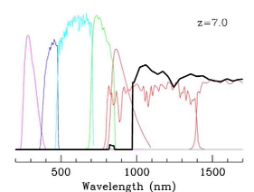

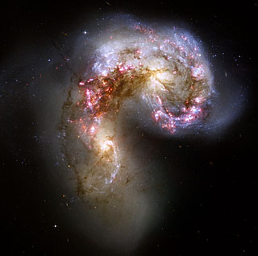
Figure 30:Tthe Antennae galaxies
This Hubble image of the Antennae galaxies is taken in visible light and is the sharpest yet of this merging pair of galaxies. As the two galaxies smash together, billions of stars are born, mostly in groups and clusters of stars. The brightest and most compact of these are called super star clusters. The image was taken through three broadband filters (shown in blue, green, red) and one narrowband filter, Hydrogen-alpha, shown in pink.
http://www.spacetelescope.org/images/html/heic0615a.html

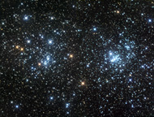
Figure 31: The Double Cluster in Perseus
This remarkable visible-light photo of the Double Cluster in perseus was taken by amateur astrophotograher Robert Gendler. The pair of open clusters resides some 7500 light-years from our Sun in the Perseus arm of the Milky Way. The clusters are among the brightest, densest, and closest of the open clusters containing moderately massive stars. Many of the stars in the two clusters are blue, hot O and B type giants, some shining 60,000 times brighter than our Sun.

http://www.robgendlerastropics.com/DoubleClusterNML.html
Credit: Rob Gendler (www.robgendlerastropics.com)

5. The Infrared Universe (Robert)

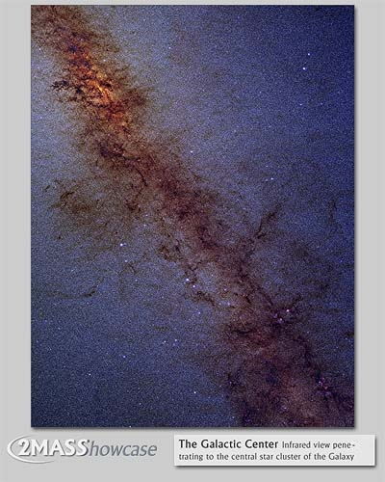

Figure 32: The Milky Way centre
The centre of our Milky Way galaxy is located in the constellation of Sagittarius. When viewed in the visible part of the spectrum, most of the stars are hidden behind thick clouds of dust. This obscuring dust becomes increasingly transparent at infrared wavelengths. This Two Micron All-Sky Survey (2MASS) image, covering a field roughly 10 x 8 degrees (about the area of your fist held out at arm's length) reveals multitudes of otherwise hidden stars, penetrating all the way to the central star cluster of the galaxy. The central core, seen in the upper left portion of the image, is about 25 000 light-years away and is thought to harbour a supermassive black hole. The reddening of the stars here and along the Galactic Plane is due to scattering by the dust; a process that is similar to the cause of the red sunset. The densest fields of dust are still opaque in this near-infrared image.

http://www.ipac.caltech.edu/2mass/gallery/showcase/galcen/index.html

The infrared regime lies just beyond the deepest red we can see. This band of the electromagnetic spectrum is a window onto a cool, dust-filled Universe. By allowing us to peer through the obscuring dust, strewn between the stars like an interstellar fog, it reveals distant reaches of our Milky Way hidden to the visible spectrum.

At longer infrared wavelengths the dust itself becomes luminous, showing us a different face of the whispy tendrils of tiny grains that drift through the vastness of space between the stars. Shrouded by these dust clouds young stars form and planets like our own are assembled.

Infrared radiation reveals the hidden, the cold and the dusty. While the term “infrared” is often synonymous with the idea of heat, in astronomy it is actually more valuable for studying objects that are cool by Earthly standards. It gives astronomers a very different view of the Universe that complements the familiar visible perspective.

The infrared spectrum starts just beyond the reddest light visible to our eyes and ranges out to wavelengths up to a hundred times longer than visible light. While the visible spectrum is confined to a narrow band between 380 and 750 nanometres (0.38 to 0.75 microns), the infrared spectrum extends out from the upper end of the visible to around 400 microns.

Box 5: Infrared regimes

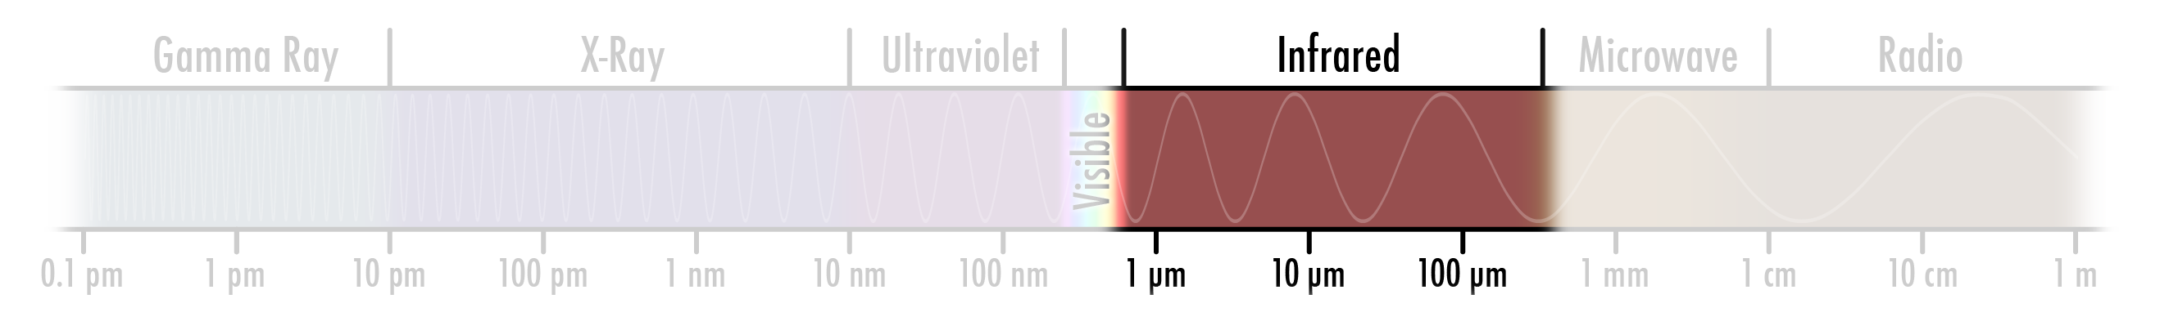

The infrared spectrum is generally divided into three regimes, the near-, mid- and far-infrared. These divisions are observational definitions and not precisely bounded, but do provide useful guidelines.
Near-infrared: 0.8–5.0 microns
The near-infrared regime begins just beyond the extreme limits of the reddest light visible to the human eye and extends out to wavelengths about ten times longer than the eye can see. The properties of near-infrared radiation are similar to those of light, and the same technologies will usually work in the near-infrared. The atmosphere is largely transparent in the near-infrared, although there are some absorption bands due to various molecules (primarily water).

Mid-infrared: 5.0–40 microns
The mid-infrared regime spans wavelengths that are roughly 10 to 100 times longer than those visible to humans. Thermal emission from objects close to room temperature, including people, peaks in this band; industrial thermal-imaging cameras typically operate at around 10 microns. The Earth’s atmosphere has a few windows of reasonable transparency, but becomes essentially opaque beyond 14 microns.

Far-infrared: 40–400 microns
Far-infrared radiation wavelengths range from about 100 to 1000 times longer than visible light. This band primarily covers thermal emission from cold objects at temperatures that can be as low as 10 degrees above absolute zero. The Earth’s atmosphere is completely opaque at these wavelengths; far-infrared telescopes must be in space and cryogenically cooled to below -263 ˚C to operate effectively.

History
Sir William Herschel could be considered to be the father of infrared astronomy. Following his discovery of the planet Uranus in 1787, his investigations led him to the discovery of the existence of infrared radiation in 1800.

Wondering how much heat came with different colours in the Sun’s spectrum, Herschel placed a series of blackened thermometers into a spectrum of sunlight refracted through a glass prism. He noted that the measured temperatures increased towards the red part of the spectrum, and when he placed a thermometer just beyond the red it showed the highest temperature of all.

Herschel’s subsequent experiments with these “calorific rays” showed them to have the same optical properties as light. This understanding eventually laid the groundwork for infrared telescope technology. Infrared detections of the Moon in the mid-1800s were followed by similar detections of Jupiter and Saturn and from some of the brightest stars in the early 1900s. By the 1960s a variety of observations from the ground, balloons and rockets had established catalogues of some of the brightest infrared sources, including star-forming regions and the centre of our Milky Way galaxy.

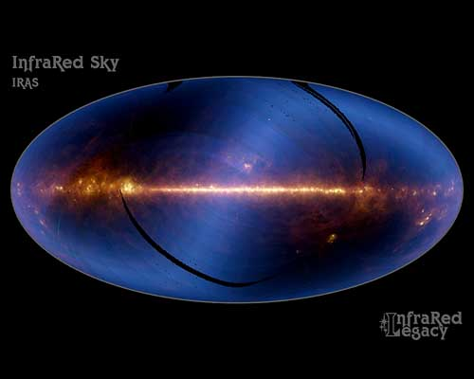
Figure 33: The infrared sky seen with IRAS
This image shows the entire sky, as seen at infrared wavelengths. It is assembled from 18 months of data from the Infrared Astronomical Satellite (IRAS), a historic mission that provided our first view of the infrared sky. The bright horizontal band is the plane of the Milky Way, with the centre of our galaxy located at the centre of the picture. As we are within it, the Milky Way dominates our view of the entire sky, as seen in this image. The colours represent infrared emission detected in three of the telescope's four wavelength bands (blue is 12 microns; yellow-green is 60 microns, and red is 100 microns). Hotter material appears blue or white while the cooler material appears red. The hazy blue, horizontal S-shaped feature that crosses the image is the glow of dust in our own Solar System which, warmed by the nearby Sun, is much warmer than interstellar dust. Black stripes are regions of the sky that were not scanned by the telescope during its mission.

http://coolcosmos.ipac.caltech.edu/image_galleries/legacy/iras_sky/index.html

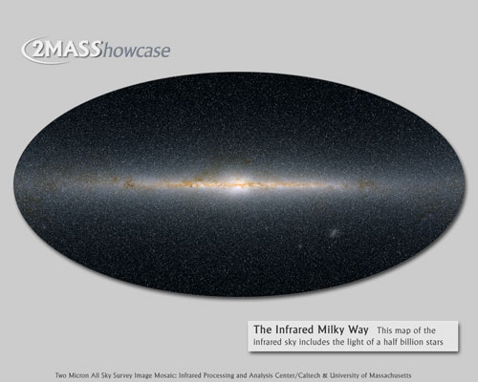
Figure 34: The infrared sky seen with 2MASS
As the previous image this is also a panoramic view of the entire sky, just as seen by the Two Micron All-Sky Survey. The measured brightnesses of half a billion stars have been combined into colours representing three distinct wavelengths of infrared light: blue at 1.2 microns, green at 1.6 microns and red at 2.2 microns. This map is not a combination of actual digital images, but has been reconstructed from a catalogue of stars that were measured from images collected over three years. This image is centred on the core of our own Milky Way galaxy, toward the constellation of Sagittarius. The reddish stars seemingly hovering in the middle of the Milky Way's disc — many of them never observed before — are partly obscured at the shortest wavelengths by the densest dust clouds in our galaxy. The two faint smudges seen in the lower right quadrant are our neighbouring galaxies, the Small and Large Magellanic Clouds.

http://www.ipac.caltech.edu/2mass/gallery/showcase/allsky_stars/index.html

The launch of the Infrared Astronomical Satellite (IRAS) in 1983 opened up a new era in infrared astronomy. From its orbital vantage point beyond an atmosphere largely opaque to infrared light, IRAS gave us our first view of the sky at far-infrared wavelengths. Among its most amazing discoveries was the “infrared cirrus”, the telltale glow of the diffuse dust clouds that are strewn throughout our galaxy.

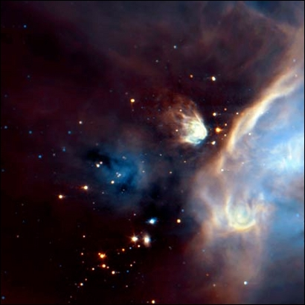
Figure 35: The Rho Ophiuchi cloud
The impressive Rho Ophiuchi cloud is one of the heavenly meeting points for astronomers in search of young stars. Located 540 light-years away in the constellation of Ophiucus, near the celestial equator, this dusty region is the nest of more than one hundred newborn stars. The image was made with ESA's Infrared Space Observatory (ISO), from a 7.7 micron infrared exposure (shown as blue), and a 14.5 micron infrared exposure (shown as red).
Credit: ESA ISO/ ISOCAM/ Alain Abergel

Space-based successors to IRAS include the European Space Agency’s Infrared Space Observatory (ISO), launched in 1995, and NASA’s Spitzer Space Telescope, launched in 2003. Each increment in technology has brought increasing sensitivity and improved resolution.

The most ambitious ground-based survey of the infrared sky to date is the Two Micron All Sky Survey (2MASS). Observations collected between 1997 and 2001 have produced a digital map of the entire sky at near-infrared wavelengths.

Visible-light technologies for infrared light
Infrared astronomy employs much the same technology as used for visible-light measurements. At a casual glance it may be difficult to tell the difference between a visible and an infrared telescope. Light reaching a polished mirror is reflected and focussed onto an instrument chamber. The detectors look much like the digital arrays found in consumer digital cameras, though the actual semiconductor technologies are different and optimised for infrared wavelengths.

Many visible-light telescopes, when equipped with suitable detectors, also function equally well in the near-infrared. While the Earth’s atmosphere is opaque at many infrared wavelengths, a few windows exist in the near- and mid-infrared bands. Even so, placing a telescope in space can be very advantageous and is essential in the far-infrared where the atmosphere is totally opaque. In the mid- and far-infrared, it is often necessary to adjust the component materials since the optical properties (transparency, reflectivity) of materials can depend strongly on wavelength.

Cryogenic cooling is a critical component of infrared telescopes. Objects at room temperature generate quite a lot infrared radiation and would flood the detectors. It would be like shining a torch onto a visible-light detector while trying to image a faint object. Near-infrared telescopes are typically cooled with liquid nitrogen at (about -195 ˚C) while mid- and far-infrared telescopes require liquid helium to reach much lower operating temperatures (-267 ˚C or even lower).

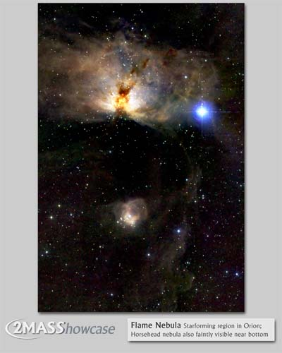
Figure 36: The Flame Nebula
NGC 2024, also known as the Flame Nebula, is located at a distance of about 1000 light-years and is part of the Orion Molecular Cloud Complex (Orion B). At near-infrared wavelengths, seen here with 2MASS, the dust in the dark lane separating the two halves of the nebula becomes more transparent, revealing a dense stellar cluster. The cluster is thought to be less than one million years old.

To the south of the Flame Nebula lies the famous Horsehead Nebula, a cloud of dust seen in visible light as a silhouette against a field of glowing gas. In the near-infrared the glowing gas is gone; only a faint trace of the Horsehead can be seen in the reflected light near the bottom right of the image (see Chapter 7).

http://www.ipac.caltech.edu/2mass/gallery/showcase/flameneb/index.html

Sources of infrared light
Infrared light is emitted through much the same processes that generate visible light, principally blackbody radiation and spectral line radiation.

Blackbody radiation (stars)
Even though infrared blackbody radiation is similar to visible light, the longer wavelengths involved present a very different Universe to the astronomer. Only the hotter stars emit the bulk of their blackbody radiation in the visible spectrum, while the blackbody emission from the far more numerous cooler stars peaks in the infrared.

As a result, our view of the visible Universe is very strongly biased towards the hottest stars, which can appear to be thousands of times brighter than their cooler counterparts. This gives us a skewed view if we are interested in the overall distribution of stars. Stars less massive than our Sun are far more numerous in the galaxy, but account for a disproportionately small amount of the visible light.

Star brightness correlates much better with star mass in the near-infrared. Since less massive stars peak in brightness in the infrared they become much easier to see and make a more representative contribution to the cosmic census.

Blackbody radiation (dust)
Starlight is of decreasing importance in the infrared spectrum as the wavelengths lengthen. Towards the mid- and far-infrared, dust clouds become the major player.

While the dust floating in interstellar space can be very cold, even matter that is at temperatures as low as -252 ˚C will still emit blackbody radiation strongly in the far-infrared. Dust that is warmed by nearby stars to -172 ˚C will be brightest in the mid-infrared. What dust lacks in brightness it makes up for in surface area. The fine particles are spread out through space, akin to the way a small piece of chalk can be ground up to cover a large area of blackboard.

Looking at the sky in mid- to far-infrared wavelengths reveals a rich Universe of dusty filaments and clouds that appear as inky black blotches in the near-infrared and the visible. Where this dust is warmed by starlight, often at the sites of current star formation, it can glow very brightly. This spectacular transformation of dust into a luminous cloud exemplifies the idea that “dark is light” in the infrared.

Spectral lines
In the visible spectrum nebulae can glow with the light of hot gasses emitting spectral lines characteristic of each element. These processes continue into the infrared. Since infrared light contains less energy than visible wavelengths, it typically takes less energy to stimulate the emission of infrared spectral lines. This can produce a wide variety of signatures of elements and molecules at cooler temperatures that are not hot enough to emit in the visible part of the spectrum.

Of particular interest in the infrared is a broad band of emission lines from organic dust molecules. These carbon-based compounds can glow brilliantly in the mid-infrared when stimulated to fluoresce by nearby stars.

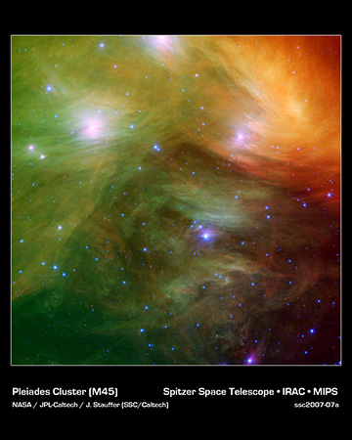
Figure 37: The Pleiades star cluster
The Seven Sisters, also known as the Pleiades star cluster, seem to float on a bed of feathers in this infrared image. Clouds of dust sweep around the stars, swaddling them in a gauzy veil. The Pleiades are located more than 400 light-years away in the constellation of Taurus. This infrared image from Spitzer highlights a spider’s web of dust filaments associated with the cloud through which the cluster is travelling, coloured yellow, green and red in this view. The densest portion of the cloud appears in yellow and red, and the more diffuse outskirts are shown in green. One of the parent stars, Atlas, can be seen at the bottom, while six of the sisters are visible at top. Additional stars in the cluster are sprinkled throughout the picture in blue.

http://sscws1.ipac.caltech.edu/Imagegallery/image.php?image_name=ssc2007-07a

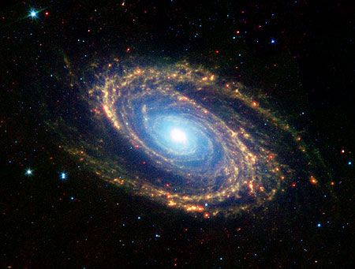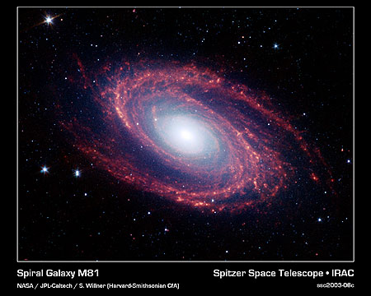
Figure 38: Messier 81 seen in the infrared

http://sscws1.ipac.caltech.edu/Imagegallery/image.php?image_name=ssc2003-06d
http://sscws1.ipac.caltech.edu/Imagegallery/image.php?image_name=ssc2003-06c

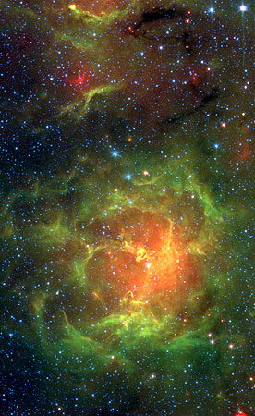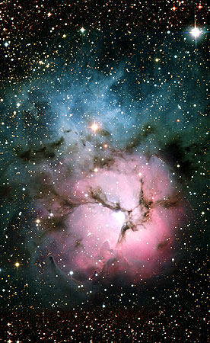
Figure 39: The Trifid Nebula
The Trifid Nebula is a giant star-forming cloud of gas and dust located 5400 light-years away in the constellation of Sagittarius. This representative-colour Spitzer Space Telescope image (left) reveals a different side of the Trifid as compared to the well-known visible-light Trifid (right). Where dark lanes of dust are visible trisecting the nebula in visible light, this dust glows brightly in the Spitzer picture. Spitzer has uncovered 30 massive embryonic stars and 120 smaller newborn stars throughout the Trifid Nebula, in both its dark lanes and in the luminous clouds. These stars are visible as yellow or red spots. The red colours in the image come from the thermal glow of warm dust, while the greens are from carbon-based dust glowing in the illumination of the nearby stars.

http://sscws1.ipac.caltech.edu/Imagegallery/image.php?image_name=ssc2005-02a

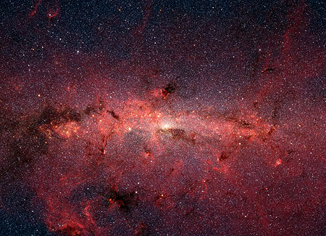

Figure 40: The centre of the Milky Way
This dazzling infrared image from Spitzer shows hundreds of thousands of stars crowded into the swirling core of our spiral Milky Way galaxy. In visible-light pictures, this region cannot be seen at all because dust lying between Earth and the Galactic Centre blocks our view.
http://gallery.spitzer.caltech.edu/Imagegallery/image.php?image_name=ssc2006-02a

Box 6: Why do infrared stars look blue in these images?

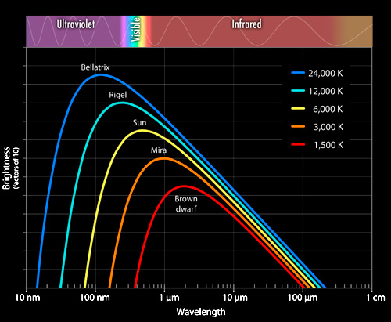

When viewed in visible light, stars have a broad range of colours ranging from red to white to blue (see the figure below). However, in images spanning the near- and mid-infrared regimes, like many shown here from the Spitzer Space Telescope, the stars all appear to be the same colour — pale blue in the colour representation usually used in these images.

In the visible, a cool star will appear red because its emission is brightest at the low energy, red end of the spectrum and drops off towards the blue. Conversely, a very hot star will be brightest in the blue or even ultraviolet and will be fainter in red light.

In an infrared image (where the shorter, higher energy wavelengths are mapped to blue and longer, lower energy wavelengths to red), almost all stars are hot enough to peak in the near-infrared or visible, so will therefore appear brightest in the wavelengths rendered as blue. Moreover, pretty much every star, whether hot or cold, has the same fall-off towards the mid-infrared, so they will all have the same colour!

The figure shows the blackbody curves of some prominent stars and of infrared emitters such as warm and cold dust as well as the cosmic microwave background for comparison (see Chapter 7).

Dust becomes transparent
In a dark, clear sky we can see a band of light stretching from horizon to horizon. Commonly known as the Milky Way, it is the only way we can see our own galaxy directly from our location inside its disc. The dark patches we see scattered across this band of light are the result of obscuring dust clouds filling the galaxy and greatly impeding our view of distant stars and nebulae. So many stars are lost to our view that even our galaxy’s centre is deeply obscured in visible light.

The infrared shows us a completely different picture. The dark, patchy obscuration is all but gone and we can see our own galaxy with clarity. Even the location of the centre of the Milky Way was a mystery for many years. In the 1920s Harlow Shapley used clever, indirect methods to determine that the centre lay towards the constellation of Sagittarius, but today a simple infrared map of the sky painlessly reveals the galactic bulge and central star cluster. In the near- to mid-infrared bands only the very densest, darkest clouds remain opaque (see Box 7).

This transparency in the infrared also allows astronomers to witness the process of star birth. Stars form at the cores of gravitationally collapsing clouds of gas and dust. These dusty cocoons prevent visible light from escaping but can be penetrated by sufficiently long wavelengths of infrared light. Filaments of dust that are so dense as to remain opaque in the infrared stand out like markers advertising the star formation within.

Infrared dust transparency can be a boon for those studying other galaxies as well. By using infrared radiation to look through the obscuring dust lanes, the underlying population of stars becomes obvious. Structural features like spiral arms, bulges, and bars become easy to discern. At longer wavelengths the dust itself becomes luminous, giving a complete picture of the dense regions that give rise to new populations of stars.

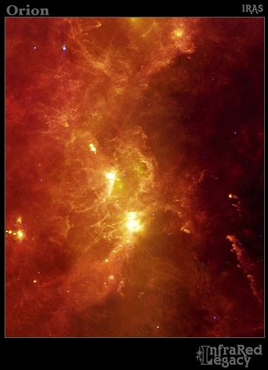
Figure 41: The constellation of Orion in the infrared
The familiar winter sky constellation of Orion takes on a spectacular guise in the infrared, as seen in this false-colour image constructed from data collected by IRAS. This picture covers an area equivalent to a magazine held at arm’s length (24 x 30 degrees). The warmest features, like stars, are brightest at 12 microns (blue). The interstellar dust is cooler and shines more brightly at 60 microns (green) and 100 microns (red). The brightest features here are all known nebulae that can be seen in visible light. The brightest yellow region is the Sword of Orion, containing the Great Orion Nebula (M42 and M43). Above it to the left is the nebulosity around the belt star Zeta Orionis, which contains the Flame Nebula (bright spot) and the Horsehead Nebula (not visible at this scale). Higher and to the left is M78, a reflection nebula. The Rosette Nebula is the brightest object near the left margin of the picture. Few of the familiar bright stars in Orion are obvious in the infrared, although Betelgeuse is obvious in the upper centre of the picture as a blue-white dot. The large ring to the right of Betelgeuse is the remnant of a supernova explosion, centred on the star Lambda Orionis (just beyond the top of the image).

http://coolcosmos.ipac.caltech.edu/image_galleries/legacy/iras_orion/index.html

Box 7: Dust transparency in the infrared
When you watch a sunset the normally white light of the Sun yellows and reddens as it sinks lower and passes through more and more layers of the atmosphere. Very small particles, such as dust grains and even gas molecules in the air, scatter blue light more than red. The same thing happens when starlight passes through interstellar dust clouds and this transparency increases even more dramatically when moving from red to infrared light.

Dust is composed of tiny particles of carbon- and silicon-derived materials. These microscopic particles can scatter and absorb photons of light. In sufficient quantities, dust clouds can render vast regions of space opaque to the transmission of light.

However, dust plays favourites when it comes to light. The bluest colours with the shortest wavelengths are blocked much more efficiently than the reddest colours. Essentially, as the wavelength of light increases beyond the size of the dust particles, the particles are less of an obstacle. The effect becomes even more pronounced in the infrared as the wavelengths grow by an order of magnitude or more. Only the very densest of dust clouds will block near- and mid-infrared light. This allows astronomers to peer into regions obscured in visible light by looking at these longer wavelengths.

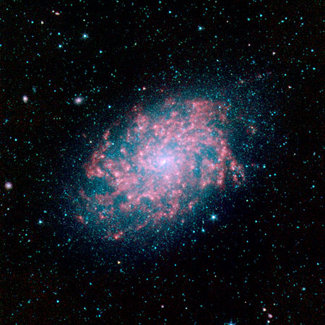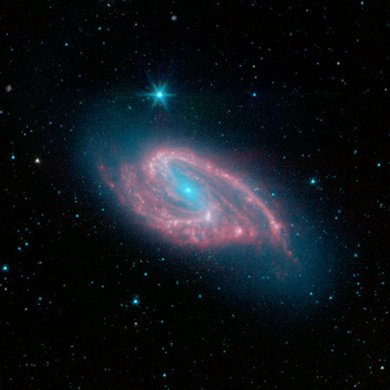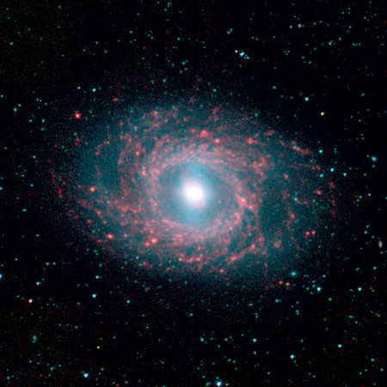
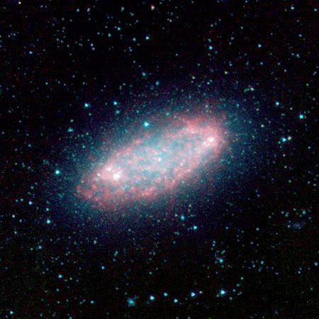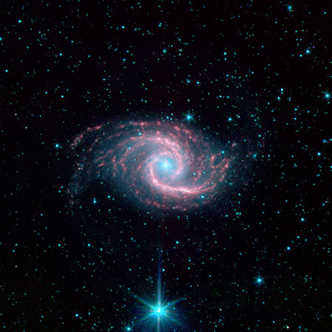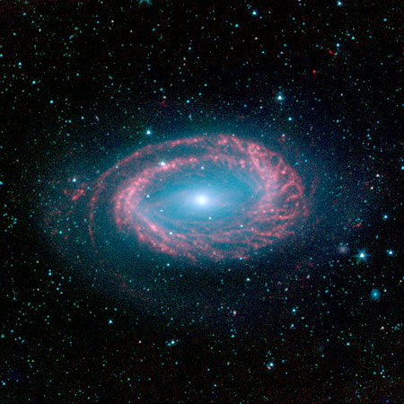
Figure 42:Assorted galaxies seen with Spitzer

http://sscws1.ipac.caltech.edu/Imagegallery/image.php?image_name=sig05-017
http://sscws1.ipac.caltech.edu/Imagegallery/image.php?image_name=sig05-016
http://sscws1.ipac.caltech.edu/Imagegallery/image.php?image_name=sig05-015
http://sscws1.ipac.caltech.edu/Imagegallery/image.php?image_name=sig05-014
http://sscws1.ipac.caltech.edu/Imagegallery/image.php?image_name=sig05-013
http://sscws1.ipac.caltech.edu/Imagegallery/image.php?image_name=sig05-011

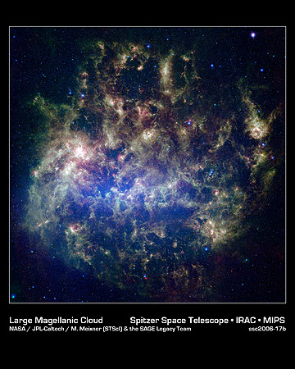
Figure 43: An untraditional view of the Large Magellanic Cloud
This vibrant image from NASA's Spitzer Space Telescope shows the Large Magellanic Cloud, a satellite galaxy to our own Milky Way. The infrared image, a mosaic of 300 000 individual tiles, offers astronomers a unique chance to study the lifecycle of stars and dust in a single galaxy. The blue colour in the picture, seen most prominently in the central bar, represents starlight from older stars. The chaotic, bright regions outside this bar are filled with hot, massive stars buried in thick blankets of dust. The red colour around these bright regions is from dust heated by stars, while the red dots scattered throughout the picture are either dusty, old stars or more distant galaxies. The greenish clouds contain cooler interstellar gas and molecular-sized dust grains illuminated by ambient starlight.

http://sscws1.ipac.caltech.edu/Imagegallery/image.php?image_name=ssc2006-17b

NOT USED:
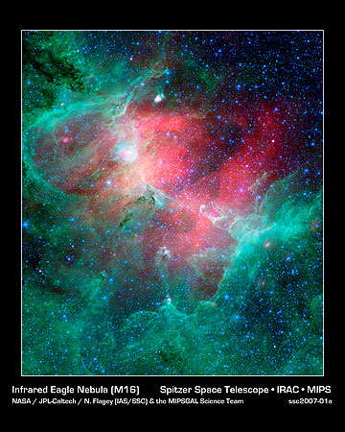
Eagle Nebula (Spitzer)
This majestic view taken by NASA's Spitzer Space Telescope tells a story of life and death in the Eagle Nebula, an industrious star-making factory located 7000 light-years away in the constellation of Serpens. The image shows the region's entire network of turbulent clouds and newborn stars in infrared light. The colour green denotes cooler towers and fields of dust, including the three famous space pillars, the "Pillars of Creation", which were photographed by NASA's Hubble Space Telescope in 1995 (located right of centre).

The pillars of the Eagle Nebula were originally sculpted by radiation and wind from about 20 or so massive stars hidden from view in the upper left portion of the image. The radiation and wind blew dust away, carving out a hollow cavity (centre) and leaving only the densest nuggets of dust and gas (tops of pillars) flanked by columns of lighter dust that lie in shadow (base of pillars). This sculpting process led to the creation of a second generation of stars inside the pillars. These stars, hidden when viewed at visible wavelengths, are revealed in this infrared image.

http://sscws1.ipac.caltech.edu/Imagegallery/image.php?image_name=ssc2007-01a

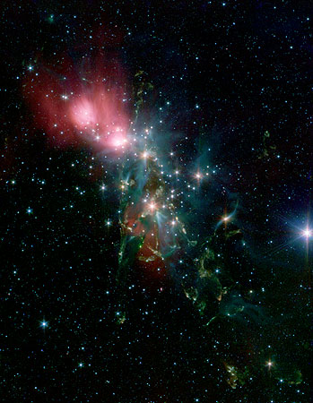
NGC 1333: Located 1000 light-years from Earth in the constellation of Perseus, the reflection nebula, NGC 1333, epitomises the beautiful chaos of a dense group of stars being born. The dense, dusty cloud in which they formed obscures most of the visible light from the young stars in this region. NASA's Spitzer Space Telescope detects the infrared light to allow scientists to gain a more detailed understanding of how stars like our Sun begin their lives and to study the warm and dusty discs of material that surround the forming stars.

The knotty yellow-green features located in the lower portion of the image are glowing shock fronts where jets of material, spewed from extremely young embryonic stars, are ploughing into the cold, dense gas nearby. The sheer number of separate jets that appear in this region is unprecedented. This leads scientists to believe that by stirring up the cold gas, the jets may contribute to the eventual dispersal of the gas cloud, preventing more stars from forming in NGC 1333.

http://sscws1.ipac.caltech.edu/Imagegallery/image.php?image_name=ssc2005-24a

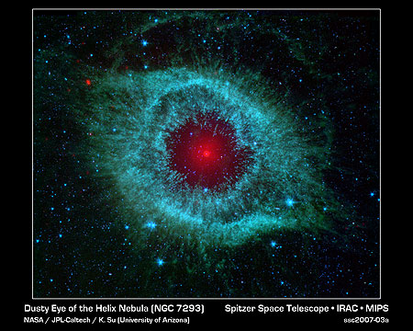
Helix Nebula: The Helix Nebula appears as an eerie eye-like orb when seen in infrared light by the Spitzer Space Telescope. Located about 700 light-years away in the constellation of Aquarius, it is a classic example of a planetary nebula. While these objects were named for their resemblance to planets like Jupiter when seen through small telescopes, they are actually the final remnants of stars like our own Sun. When Sun-like stars die, they puff out their outer gaseous layers. These layers are heated by the hot core of the dead star, called a white dwarf, and shine in both the infrared and visible parts of the spectrum.

Spitzer’s view shows the glowing gasses in near infrared light (blue-green). The mid-infrared glow of the white dwarf (red) comes from a dusty disc encircling it (the disc itself is too small to be resolved). This dust, discovered by Spitzer, was most likely kicked up by comets that survived the death of their star. The Helix Nebula is one of only a few dead-star systems in which evidence for comet survivors has been found.

http://sscws1.ipac.caltech.edu/Imagegallery/image.php?image_name=ssc2007-03a

6. The Ultraviolet Universe (Robert)
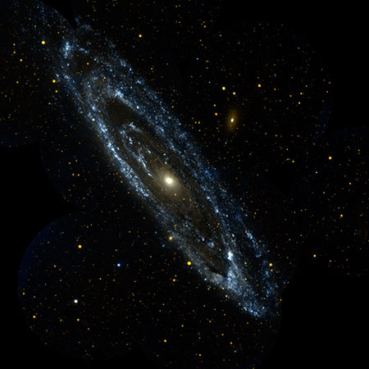
Figure 44: Andromeda in the ultraviolet
Approximately 2.5 million light-years away, the Andromeda Galaxy, or M31, is the Milky Way's largest galactic neighbour. The entire galaxy spans some 260,000 light-years— a distance so large, that 10 images from the Galaxy Evolution Explorer stitched together were needed to produce this view of the galaxy next door. The wisps of blue making up the galaxy's spiral arms are neighbourhoods that harbour hot, young, massive stars. The central orange-white ball reveals a congregation of cooler, old stars that formed long ago. Andromeda is so bright and so close that it is one of only three galaxies that can be spotted from Earth with the naked eye. This view is a two-colour composite, where blue represents far-ultraviolet light, and red is near-ultraviolet light.

http://www.galex.caltech.edu/media/glx2008-01f_img01.html

Ultraviolet light falls beyond the limits of what we can see at the blue end of the spectrum. In human terms the word ultraviolet calls to mind images of sore skin resulting from overexposure to the Sun, an indication of the high energy of this form of light.

The hottest stars in the Universe are brightest in ultraviolet light. The dusty clouds that give birth to these massive, luminous objects are in turn sculpted and shaped under the onslaught of the high-energy photons they emit. Ultraviolet light shows us where the action is in star formation — amongst the young, the massive and the hot stars.

Overview
Ultraviolet light largely originates in the glow of stars. The hottest and most massive stars glow brightest in the ultraviolet, but even our cooler Sun still produces a fair amount of light in this part of the spectrum. The ultraviolet spectrum starts just beyond blue-violet at a wavelength of 400 nm and includes wavelengths down to 10 nm at the extreme end. Remember the rule: the shorter the wavelength, the higher the energy. A single ultraviolet photon can carry as much energy as 50 or more photons of red light!

On Earth we are sheltered from much of the Sun’s ultraviolet as the ozone in our upper atmosphere filters out a great deal of the Sun’s shorter wavelength ultraviolet. Significant absorption begins beyond around 300 nm, making ground-based observations very difficult at anything other than near-ultraviolet wavelengths. While a bane to astronomers, this makes exposure to sunlight much safer for us. ultraviolet photons carry a lot more energy than visible photons, enough to do damage to our skin and even the DNA in our cells.

Paradoxically, ultraviolet light drives the very processes in our atmosphere that keep much of it from reaching the ground. Ozone, which is the primary filter against the more harmful forms of ultraviolet, is actually produced in the upper atmosphere when incoming ultraviolet photons interact with oxygen molecules.
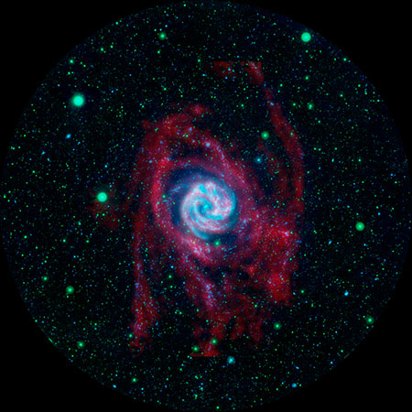

Figure 45: What lies beyond the edge of a galaxy?
This deep ultraviolet view of the Southern Pinwheel Galaxy M83 has revealed an unexpected surprise. Beyond the well-known visible disc of this classic spiral are faint but clear ultraviolet arms (rendered here in blue and green) far out beyond any that had been seen before. But these loosely wound arms of hot young stars are not alone in the outer reaches. Radio imaging of the hydrogen gas (see Chapter 7) in this galaxy shows extended gas arms that line up perfectly with the ultraviolet arms. There is an entire cycle of star formation going on far beyond what was once considered to be the disc of the galaxy!

http://www.galex.caltech.edu/media/glx2008-01r_img02.html

History
The German physicist Johann Ritter first discovered the existence of ultraviolet light in 1801, only one year after William Herschel had discovered infrared light. Inspired by Hershel’s explorations of what lay beyond the red, Ritter wanted to know if an invisible form of light extended beyond the blue as well.

Ritter’s detector was the chemical silver chloride (commonly used in black and white photographic paper), which turns black when exposed to light. Passing sunlight through a glass prism, he placed samples of silver chloride along the different colours of the spectrum. While it showed little reaction in red light, it became ever darker towards the bluer colours. Most significantly, the strongest reaction lay beyond the visible blue-violet end of the spectrum. There was indeed another kind of light hiding beyond violet!

Ritter’s discovery of these so-called “chemical” rays established the idea that the visible spectrum is embedded within a wider spectrum of light, the rest of which is invisible to our eyes. We have subsequently learnt that not all creatures are as insensitive to ultraviolet light as humans. A number of birds, bees, and other insects are known to see into the ultraviolet — an ability tapped into by some flowering plants that have ultraviolet guide-marks that are invisible to us.
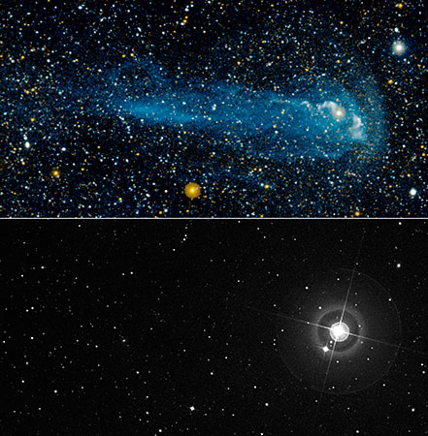

Figure 46: Surprising Mira
Mira is a well-known variable star that has been studied thoroughly for about 400 years, so how is it that until recently nobody realised that it had a vast comet-like tail? The answer is that the tail appears only in the glow of ultraviolet light (top panel) and until NASA's Galaxy Evolution Explorer caught it unexpectedly, nobody even thought to look for it! In visible light (bottom panel) the star is bright, but there is no hint of the tail. The tail is composed of the outflow of material from Mira as it ploughs rapidly through interstellar space. The shock of this passage stimulates the trailing hydrogen molecules to glow.

NASA/JPL-Caltech/POSS-II/DSS/C. Martin (Caltech)/M. Seibert (OCIW)

Sources of ultraviolet

Blackbody
Most of the ultraviolet light we see in the Universe comes from the hotter stars. Ultraviolet light comes from the short wavelength/high energy side of thermal blackbody radiation and is emitted at high temperatures. Stars with temperatures greater than 7500 °C are actually brightest in the ultraviolet. The most massive stars in the Universe can be hotter than 20 000 °C and their blackbody radiation peaks in the extreme ultraviolet. Nonetheless, even a star as cool as the Sun, at a mere 6000 °C, will still generate a significant amount of ultraviolet light.

Spectral lines
In addition to thermal blackbody radiation, there are a number of spectral lines that are found throughout the ultraviolet part of the spectrum. Many common elements including the most abundant — hydrogen and helium — have important transitions in this part of the spectrum and these are frequently observed by astronomers to study gas that can both absorb and emit these characteristic ultraviolet photons. Even the most common molecule in the Universe, molecular hydrogen, consisting of two hydrogen atoms bound to one another, has its primary emission in the ultraviolet. This, however, makes molecular hydrogen very difficult to detect, as the gas must be quite hot to stimulate the emission of this ultraviolet spectral line.

Box 8: Ultraviolet regimes

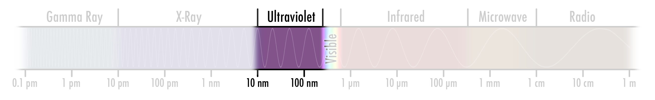

The ultraviolet spectrum can be broken down into four bands of increasing energy.

Near-ultraviolet: 400–300 nm
These wavelengths lie just beyond the limit of human vision and encompass the “black light” often used at parties to illuminate a variety of fluorescent materials such as white paper, paints, inks and even teeth and nails. Near-ultraviolet radiation from the Sun reaches the Earth most readily and can be observed from the ground.

Mid-ultraviolet: 300–200 nm
Increasingly filtered out by atmospheric ozone, mid-ultraviolet radiation from the Sun still reaches the ground in sufficient doses to cause sunburn and damage that can lead to skin cancer.

Far-ultraviolet: 200-122 nm
The atmosphere is essentially opaque to far-ultraviolet radiation, so space telescopes or high-flying rockets must be used to observe in this regime. This light is sufficiently destructive to kill bacteria easily and so can be used to sterilise objects. It also poses the greatest threat to the spread of life by panspermia — the transport of organisms through space on and near the surface of rocks that may eventually land on a planet as a meteorite.

Extreme-ultraviolet: 122–10 nm
This most energetic band of ultraviolet extends to the border of the X-ray spectrum. Extreme-ultraviolet emission is usually associated with the very hottest stars in the Universe.

Ultraviolet telescopes
As with the infrared, ultraviolet telescopes can employ many of the same optical technologies used in visible-light telescopes, particularly in the near-ultraviolet band. Detectors sensitive to visible photons are generally sensitive to ultraviolet light as well. Mirrors designed to reflect and focus ultraviolet light, however, need to be machined to greater precision due to the shorter wavelengths.

While near-ultraviolet light can be observed from the ground, the advantages of space grow rapidly at mid-ultraviolet and beyond. The Hubble Space Telescope, as well as working in the visible, has ultraviolet instruments — both cameras and spectrometers — that are sensitive down to far-ultraviolet wavelengths.

Detectors optimised for visible light do lose efficiency at shorter ultraviolet wavelengths, so the most sensitive ultraviolet telescopes have technologies designed especially for this part of the light spectrum. For instance, the Galaxy Evolution Explorer, or GALEX, uses an innovative detector that tabulates the position and time of arrival of each incoming ultraviolet photon. Computer programs can use this tabular data to build up images later, rather than generating a complete image by directly reading out from the detector array, as is common with other telescopes.

While GALEX has been designed for sensitivity to see the distant and faint sources of ultraviolet in the Universe, other telescopes like the Solar and Heliospheric Observatory (SOHO) trade sensitivity for rugged design — necessary when studying the brightest ultraviolet source in our sky: the Sun.

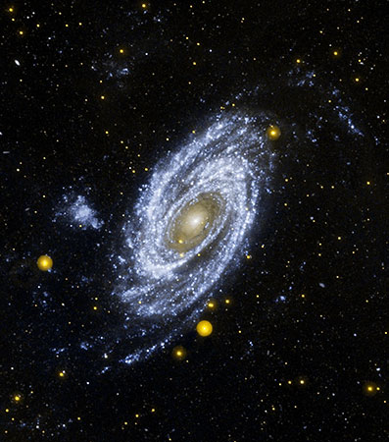
Figure 47: The ultraviolet Messier 81
The magnificent Messier 81 spiral galaxy appears in the glow of ultraviolet light in this two-colour composite. The orbiting observatory spies the galaxy's “sizzling young starlets” as wisps of bluish-white swirling around a central golden glow. The tints of gold at M81's centre come from a "senior citizen" population of smouldering stars. Far-ultraviolet light is rendered as blue, and near-ultraviolet as yellow.

http://www.galex.caltech.edu/media/glx2004-01r_img05.html
http://www.galex.caltech.edu/media/glx2007-02r_img01.html
http://www.spacetelescope.org/images/html/heic0801b.html

Ultraviolet science

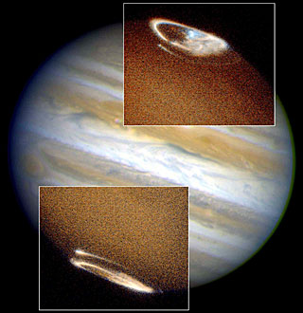
Figure 48: Aurorae on Jupiter
The Hubble Space Telescope has captured a complete view of Jupiter's northern and southern aurorae.
Images taken in ultraviolet light by the Space Telescope Imaging Spectrograph (STIS) show both aurorae, seen as bright ovals in the inset photos. Note that in the ultraviolet the aurorae are far brighter than the faint ultraviolet illumination from the Sun. In visible light they can only be seen on the dark side of the planet.

John Clarke (University of Michigan), and NASA/ESA

http://www.spacetelescope.org/images/html/opo9804a.html

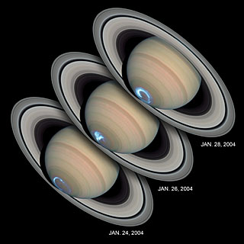
Figure 49: The changing aurorae of Saturn
These images reveal the dynamic nature of Saturn’s aurorae. Viewing the planet's southern polar region for several days, the Hubble Space Telescope snapped a series of photographs of the dynamic aurorae that change from day to day, as they do on Earth. But while Earthly aurorae come and go and may only last a few hours, on Saturn they are always bright and can last for days.

These images have overlaid the blue-tinted ultraviolet observations of the aurorae on top of visible-light images of the planet and rings for this synthetic picture. If seen only in ultraviolet, Saturn is mostly dark and is dominated by the glow of the aurorae.

NASA, ESA, J. Clarke (Boston University, USA), and Z. Levay (STScI)

http://www.spacetelescope.org/images/html/heic0504a.html

Sun and planets
The Sun is a rich laboratory for ultraviolet study since this band of the spectrum highlights the hottest gasses in the solar chromosphere and corona. The temperature of the Sun actually increases above its visible surface through the extended corona. Hot charged gas clings to the otherwise invisible magnetic fields, tracing its activity.

Looking at ultraviolet spectral line emission from trace amounts of iron in the outer solar atmosphere, the corona, it is possible to observe how the Sun’s violently active magnetic fields can actually heat the corona. Temperatures in this region can range from tens of thousands to millions of degrees centigrade, far in excess of its surface temperature of 6000 °C.

Ultraviolet light also allows us to probe the magnetic fields of other planets in the Solar System. Charged particles ejected from the solar corona can become trapped in these fields. Spiralling down towards the poles they can produce glowing discharges in the atmosphere, or aurorae. These aurorae can be especially bright in the ultraviolet, making them easy to pick out in the upper atmospheres of Jupiter and Saturn where the solar ultraviolet illumination is, by contrast, quite faint.
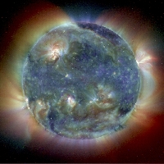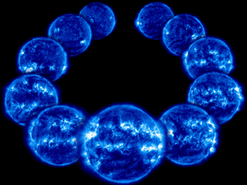

Figure 50: Sun solar cycle
The image on the left shows a composite of ultraviolet view of the Sun where three different ultraviolet wavelengths of light (17 nm, 19 nm and 28 nm) have been rendered as red, yellow, and blue. The montage on the right shows a sequence of ultraviolet images taken over the course of 11 years. During this time the Sun progressed through an entire cycle of its activity. The enhanced flare and sunspot activity at the solar maximum stand out particularly vividly in the ultraviolet, which traces the structure of the hottest gasses in the outer layers of the Sun.

http://soho.esac.esa.int/hotshots/2007_12_02/
http://soho.esac.esa.int/gallery/images/trico1.html
Credit: SOHO (ESA & NASA)

Star formation
Beyond the limits of the Solar System, the dominant source of ultraviolet is from hotter stars. Stars similar to the Sun can contribute significantly in the near-ultraviolet band, but in the far-ultraviolet the most massive stars dominate our view.

These huge stars are relatively few in number, but they make up for their lack of numbers by their brightness. A star 20 times as massive as the Sun is over 20 000 times as bright, and most of that light is emitted in the extreme-ultraviolet. The most massive stars do not live long — just a few million years — the blink of an eye in comparison to the 10 billion-year life expectancy of the Sun. So massive stars do not wander far from their birthplaces and their ultraviolet light identifies current regions of active star formation. In some galaxies this has led to the discovery of extended spiral structures far beyond the visible-light disc (see for instance Figure 47).

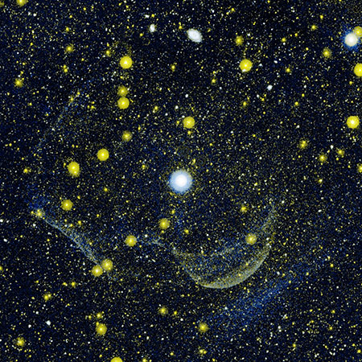
Figure 51: Traces of an ancient explosion
Looking deeply around the double star system Z Camelopardalis astronomers were surprised to find hints of a shell, seen only in ultraviolet light in this observation from NASA’s Galaxy Evolution Explorer. The shell appears to be the expanding remnant of a nova explosion from a few thousand years ago. Such an explosion would have burnt off the outer layers of a white dwarf star known to be orbiting a companion in the Z Camelopardalis system. The yellow-white traces are the only surviving evidence for this earlier explosion.
Credit: NASA/JPL-Caltech/M. Seibert (OCIW)/T. Pyle (SSC)/R. Hurt (SSC)

http://www.galex.caltech.edu/media/glx2007-01r_img02.html

Box 9: Sculpting the pillars
Massive stars have a strong influence on the star-forming regions that produced them. As soon as a massive star ignites the nuclear fusion in its core, the high temperature stimulates a torrent of ultraviolet radiation. The energy in far- and extreme-ultraviolet photons is so great that it can actually break down the surrounding dust molecules and evaporate the dust in the regions that gave birth to these stars in the first place.

Wherever these young, brilliant stars are found, there are usually massive dust clouds in the process of being destroyed by the intense light from the infant stars. The denser regions of the cloud erode more slowly under the onslaught, leaving behind impressive pillars of dust and gas. Since these regions are the densest clouds in the area, they will often harbour more baby stars in the process of formation.

Whenever massive pillars of dust are seen in visible or infrared light, they point the way to a precursor generation of newly formed stars that are still nearby.

NOT USED:
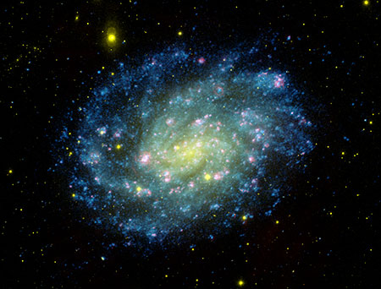
Spiral galaxy NGC 300
This colour composite image of nearby NGC 300 combines the visible-light pictures from the Carnegie Institution of Washington's 100-inch telescope at Las Campanas Observatory (coloured red and yellow), with ultraviolet views from NASA's Galaxy Evolution Explorer (coloured blue). This composite image traces star formation in progress. Young hot blue stars dominate the outer spiral arms of the galaxy, while the older stars congregate in the nuclear regions, which appear yellow-green. Gases heated by hot young stars and shocks due to winds from massive stars and supernova explosions appear in pink, as revealed by the visible-light image of the galaxy. Located nearly 7 million light-years away, NGC 300 is a member of a nearby group of galaxies known as the Sculptor Group.

http://www.galex.caltech.edu/media/glx2005-01r_img01.html

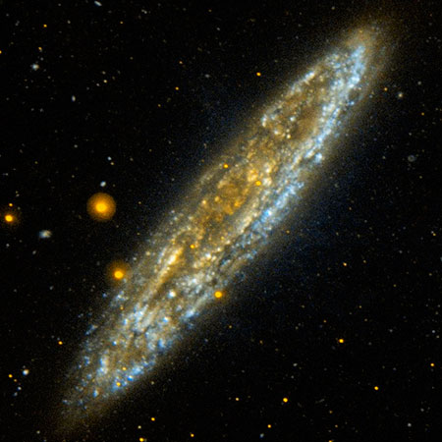
NGC 253: The Silver Dollar galaxy
Located 10 million light-years away in the southern constellation Sculptor, the Silver Dollar galaxy, or NGC 253, is one of the brightest spiral galaxies in the night sky. In this edge-on view from NASA's Galaxy Evolution Explorer, the wisps of blue represent relatively dustless areas of the galaxy that are actively forming stars. Areas of the galaxy with a soft golden glow indicate regions where the far-ultraviolet is heavily obscured by dust particles.
NASA/JPL-Caltech

http://www.galex.caltech.edu/media/glx2006-03r_img02.html

7. The Radio Universe (Bob)

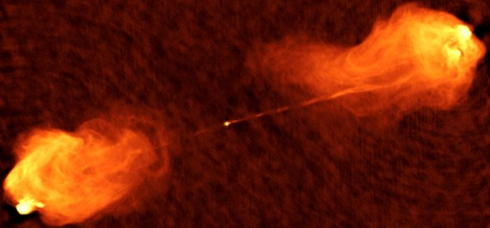
http://www.nrao.edu/imagegallery/php/level3.php?id=110

Figure 52: Radio image of Cygnus A
Cygnus A was one of the first sources of cosmic radio radiation to be identified with a visible-light object in the sky. Seen in visible light it is a nondescript elliptical galaxy, a faint smudge like multitudes of others that provides no hint that it is by far the most powerful radio source in our reasonably local neighbourhood (if you can call a distance of 800 million light-years local). This radio image was made with the Very Large Array (see Chapter 2) in New Mexico and it shows the double-lobed structure that is so characteristic of the powerful radio sources associated with some galaxies and quasars. The energy that supplies the radiation from these lobes is channelled from the nucleus of the associated galaxy along narrow jets that are clearly seen in this image. The source of all this energy is the collapse of material onto a rapidly spinning supermassive black hole in the core of the galaxy. With a mass of around a billion times the mass of the Sun (or 300 times more massive than the black hole at the centre of our own Milky Way galaxy), this Active Galactic Nucleus (AGN, see Box 13 below) will appear as a quasar when seen from some directions.

Credit: NRAO/AUI

Seen with radio telescopes, the sky is unrecognisable to a visible-light astronomer. In place of the stars in the Milky Way there are objects sprinkled throughout the entire Universe. Radio sources are rare but often intrinsically very powerful, making them detectable at very large distances. The emissions from these radio galaxies, quasars and titanic stellar explosions are the result of immensely energetic sub-atomic particles speeding through regions of twisted magnetic field. This process is quite different from that producing the heat radiation from the surfaces of stars and it leads us to the sites of some of the most violently energetic action in the Universe.

Beyond the far limits of infrared light, we move into the radio spectrum. At the shortest wavelengths (of the order of a millimetre or so) we have the region dubbed microwaves, commonly used in wireless phones. At longer wavelengths the radio spectrum spans centimetres, metres, and upwards. The radio spectrum is open and unbounded in the sense that there is no “longest” radio wavelength. However, in practical terms, low energies and extreme wavelengths beyond a kilometre or so become very difficult to generate or detect.

Initially astronomers were not very optimistic about the possibility of even seeing the objects they already knew at radio wavelengths. They could calculate the amount of radio radiation expected from stars — and it was puny. Even so, starting in 1932 and subsequently stimulated by the development of radar for military use during the Second World War, radio astronomy was mankind’s first major excursion into the Hidden Universe. The first radio observations led to the realisation that the Universe could look very different to us when seen through new “eyes” tuned to a different radiation.

Box 10: Radio regimes
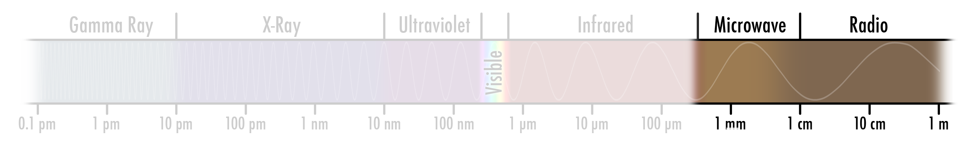
Extremely Low Frequency (ELF) radio waves with wavelengths of tens of thousands of kilometres are of little interest to Earthbound radio astronomers since they are completely absorbed by the ionosphere — the screen of charged particles that envelopes out planet. Submariners, however, rely on them to communicate with home base. By the time we reach a few tens of kilometres (VLF or Very Low Frequency), however, the sky becomes clear and remains so until the wavelength has dropped below a centimetre (SHF, Super High Frequency or microwave). The millimetre and sub-millimetre regimes are plagued by absorption from water in the atmosphere but are of great interest to astronomers since they can be used to detect and measure the huge amounts of cold material between the stars and throughout the Universe.

Although the Sun, because it is so close, was soon identified as a discrete source of radio waves, it was found that the few other bright radio sources in the sky were seen in regions where there were no very prominent stars.

The race was on to match these sources of radio radiation to objects that were already familiar to astronomers in visible light. The problem here was that early radio telescopes, despite their significant size, could not precisely locate the positions of the radio sources in the sky (see Box 11).

Box 11: Resolution of a telescope
The ability of a telescope to distinguish fine details, known as its spatial resolving power, depends in a relatively simple way on both the telescope size and the wavelength of the radiation it is imaging: the greater the number of wavelengths of light that fit across a telescope mirror or lens, the higher the resolution of the telescope. Since radio waves are typically 100,000 times longer than visible waves, a radio telescope would have to be about 240 km in diameter to achieve the same resolving power as Hubble, which has a mirror that is only 2.4 metres across.

Since it would be hard — and costly — to build a single radio telescope that would be large enough to achieve the needed resolution, telescope builders had to do some lateral thinking and figure out how to connect widely spaced antennas in a way that would allow them to act as a single, larger telescope. The resulting technique of interferometry (see Box 12) is now very widely used, especially at radio wavelengths, to enable high resolution imaging using arrays of many telescopes. By mounting some telescopes on satellites, telescopes in these arrays can even be separated by distances greater than the diameter of the Earth.

Box 12: Interferometry

[The largest single-dish radio telescope at Arecibo in Puerto Rico. http://www.naic.edu/public/about/photos/photogal.htm]

The largest single-dish radio telescope at Arecibo in Puerto Rico is an impressive 305 metres across, yet achieves nothing like the resolution achieved by even the smallest visible-light telescope. Moreover, the dish cannot be pointed and is restricted to observing a narrow band of the sky. However, following the first successful experiments in 1946 in Australia, astronomers have used the technique of interferometry to build arrays of telescopes that combine the signals in a way that achieves the resolution, if not the collecting areas, of an instrument the size of the longest antenna separation. Using interferometry astronomers can combine the light waves from two telescopes by aligning the wave crests and troughs precisely. The largest interferometric arrays combine signals from telescopes scattered across the globe, acting together as a single instrument nearly the size of the Earth, and able to ascertain the positions of sources with an extraordinary accuracy that is beyond even the largest visible-light telescopes. The earliest and most notable developments of this technique took place in Cambridge, England with Martin Ryle and Antony Hewish winning the Nobel Prize for Physics in 1974, the first time the Prize was given for astronomy.

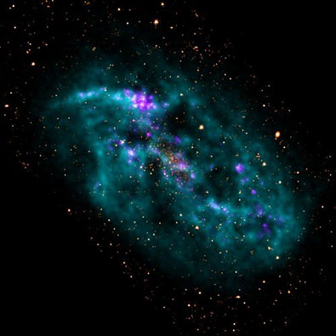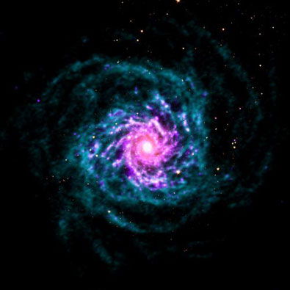

Figure 53 Dwarf galaxy IC2574, left, and spiral galaxy M74, in THINGS images.

Credit: Walter et al., NRAO/AUI/NSF
http://www.nrao.edu/pr/2008/things/

The first interferometers enabled the identification of sources that were mysteriously inconspicuous to visible-light telescopes — peculiar-looking galaxies and the apparent remnants of stellar explosions called supernovae. Why do these emit such copious amounts of radio radiation and so little visible light?

Synchrotron radiation

The glow of the radio sky stems from processes that are very different from those seen at visible, infrared and ultraviolet wavelengths. Thermal blackbody processes (see Chapter 1) are not strong in this part of the spectrum. Most bright radio sources are the sites of violently energetic events, such as black holes, where electrically charged sub-atomic particles are accelerated to very nearly the speed of light. It is the motions of these fast-moving charged particles that most commonly generate radio light.

As the term “electromagnetic radiation” hints, the effects of electric and magnetic fields are tightly interrelated. When a charged particle like an electron or proton moves through a magnetic field it is deflected and sent on a spiralling course along the magnetic field lines. This oscillating charge will give up some of its energy to the emission of radiation, particularly at radio wavelengths.

Some of the earliest particle accelerator devices built by physicists were known as “synchrotrons”. The radio waves emitted by the accelerated particles, and the associated energy loss, as the particles spiralled through the devices’ magnetic fields led to the name “synchrotron radiation” for this process. Amazingly, the Universe is filled with many cosmic synchrotrons on all scales, and the well-studied process on Earth lets us understand similar processes occurring across the Universe.

At the most energetic sites in the Universe, synchrotron radiation may be emitted across the entire electromagnetic spectrum and can also be seen with telescopes in the infrared, visible, ultraviolet and X-ray range. The synchrotron mechanism in and around black holes generally accounts for the most powerful radio sources in the sky such as Cygnus A (see Figure 52). These are not, however, the only targets for radio telescopes to examine.

Box 13: Black holes, quasars and Active Galactic Nuclei

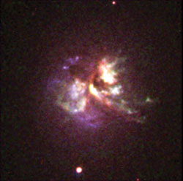
J:\HiddenUniverse\layout\images\7_agn_CygA_BVRI-O3-Ha_.tif]

An Active Galactic Nucleus, or AGN, consists of a spinning supermassive black hole at a galaxy’s core that is being fed by gas or disrupted stars coming from the surrounding galaxy. As the material falls inwards it will usually form itself into a spinning disc orbiting the black hole. A small portion of the infalling material never reaches the black hole but is spun up by surrounding magnetic fields and ejected at nearly the speed of light as oppositely directed jets perpendicular to the disc, often radiating copious amounts of radio radiation. If one of the jets points roughly towards us, we will get a relatively clear view of the regions very close to the black hole where much of the light is emitted and we see a quasar. On the other hand, if we see the disc edge-on, our view of the AGN may be obscured by the material in the disc. It is only in the last couple of decades that astronomers have begun to appreciate how the many differing types of AGN can be understood simply in terms of how their appearance will vary depending on the direction from which we view them.

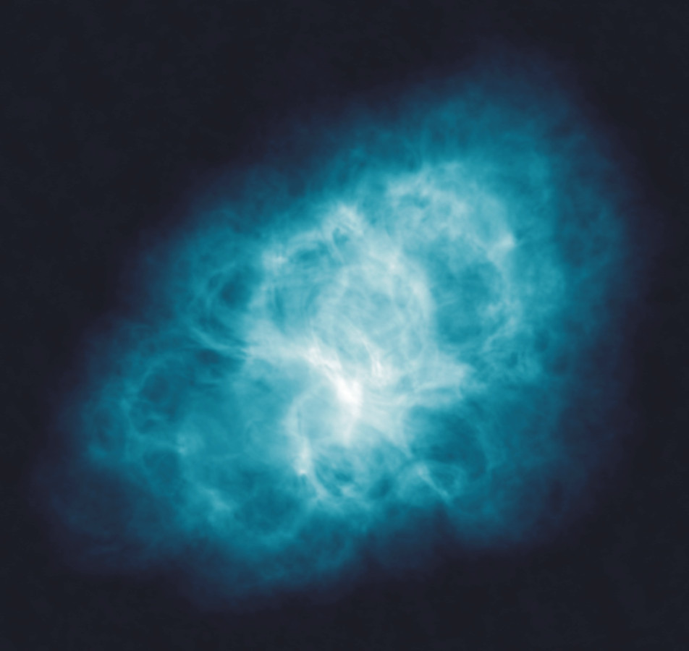
Figure 54: The Crab nebula in radio
The famous Crab nebula (object number one in Messier’s catalogue) is the remnant of a star that was seen to explode in the year 1054 by Chinese observers of the sky — an event that we now call a supernova. The extended structure that we see now, almost a thousand years later, is surprisingly similar when imaged with radio, infrared, visible-light and X-ray telescopes. This is because the radiation we see at all of these different wavelengths comes from the same mechanism: very high speed electrons (and probably also antimatter electrons, called positrons) spiralling around a tangled magnetic field. This is called synchrotron radiation (see text). The most energetic electrons and positrons radiate X-rays while the less energetic ones can radiate radio waves. Those with energies in between radiate in the visible and infrared. The origin of these energetic particles is thought to be a spinning neutron star or pulsar [see Error: Reference source not found] left behind after the star exploded.
Credit NRAO/VLA
http://www.nrao.edu/imagegallery/images/CrabNeb_RGB2001_hi.tif

Bremsstrahlung
Another radio-generating process involves direct interactions between fast-moving charged particles. The regions of glowing gas excited by hot stars, namely star-forming regions and planetary nebulae, are suffused with energetic electrons and protons that buzz around at high speed. Sometimes they come close enough to one another to be deflected by the interaction of their electrical charges. The process of deflection causes the emission of radiation that is often seen most clearly at radio and X-ray wavelengths (though it can be seen in other parts of the spectrum as well). Observations of such radiation from star-forming regions enable astronomers to learn about properties such as the temperature of the gas. This radiation from interacting particles is known as bremsstrahlung or “braking-radiation”. It is closely related to the process used to make X-rays for medical diagnosis.

Radio gas
One of the most important realisations, and subsequent discoveries, in radio astronomy was that hydrogen, by far the most common gas in the Universe, could emit and absorb radio radiation with a wavelength of 21 cm (see Box 14). Measuring this radiation with radio telescopes opened up rich opportunities for studying the motions of the gas both within and beyond the Milky Way by exploiting the Doppler effect. Astronomical “speed cameras” can measure the gas even in regions that are completely obscured from view in the visible spectrum. One of the principal applications of this study has been in the measurement of the masses of spiral galaxies. This fundamental property can be derived from the rotational speed of gas orbiting the galaxy at a given radius.

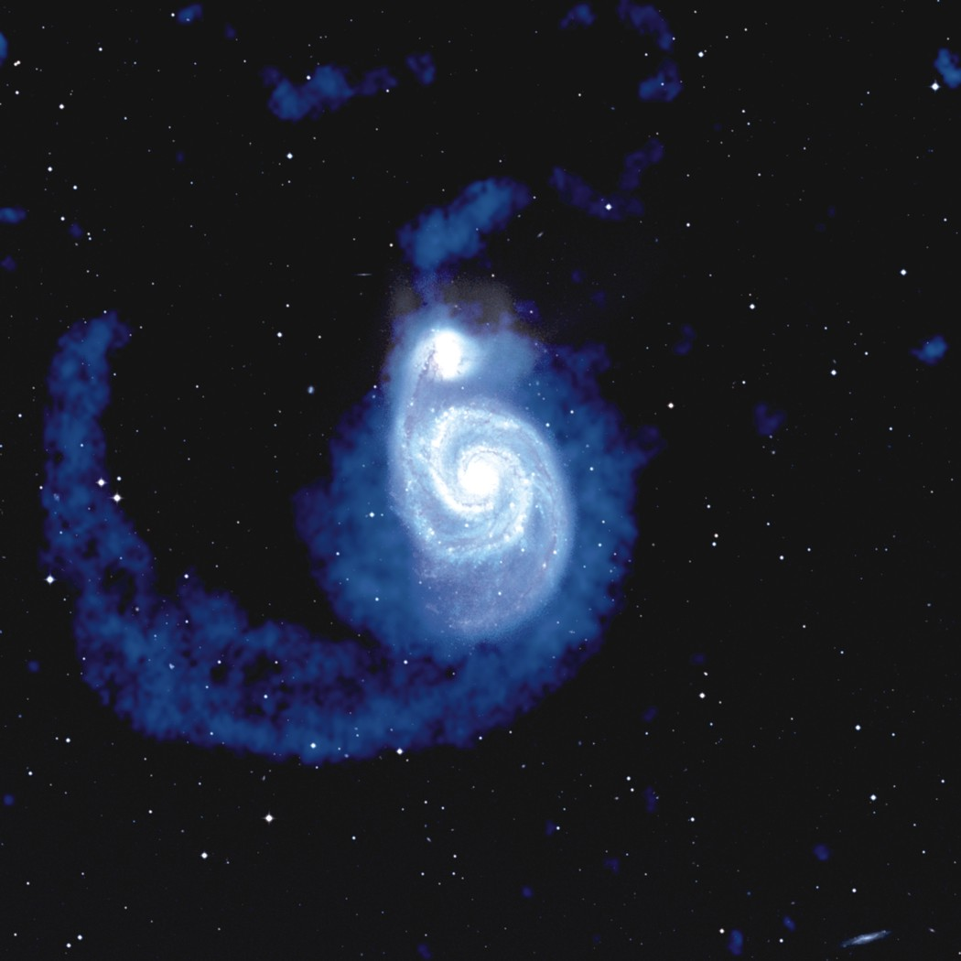

Figure 55: The Whirlpool galaxy in radio
This image of the spiral galaxy M51, also known as the Whirlpool galaxy, and its companion NGC 5195 (top) combines observations of neutral hydrogen emission (in blue) obtained with the Very Large Array with visible-light images from the Digitized Sky Survey. The visible-light data show the emission of stars in these galaxies as well as the dust; the latter can be seen as dust lanes in the spiral arms of M51 itself and in obscuring the eastern (left hand) part of the companion. They also show foreground stars in our own Milky Way galaxy as well as some background galaxies. The long tidal tail of neutral hydrogen (left) was shaken loose by the gravitational interaction of these two galaxies.
http://www.nrao.edu/imagegallery/images/m51_hi.tif

Credit: A. H. Rots, A. Bosma, J. M. van der Hulst, E. Athanassoula, P. C. Crane. Image composition: J. M. Uson.

Box 14: 21-cm radiation
Hydrogen is the simplest of all atoms and is by far the most abundant element in the Universe. The atom consists of just a single proton and a single electron, each of which has what physicists call a spin. When the atom is isolated and undisturbed — as can be the case in interstellar space — most atoms will be found with the proton and the electron having spins pointed in the opposite direction (antiparallel). Even a mild disturbance to an atom can cause the electron spin to flip to a parallel state, a tiny change in energy. The transition back to the first, or antiparallel, state would happen after some ten million years for a completely isolated atom and result in the emission of a single photon of 21-cm wavelength radio radiation. In practice, interactions with other particles can dramatically reduce this long wait, and of course there are a lot of hydrogen atoms in the Universe. So this characteristic radiation is easily seen with radio telescopes. Stimulated by Jan Oort in the Netherlands, Hendrik van de Hulst in 1944 predicted that hydrogen gas could emit this radiation and, in 1951, Ewen and Purcell at Harvard University in the USA first observed the 21-cm spectral line from space. It has since become a fundamental tool for radio astronomy.

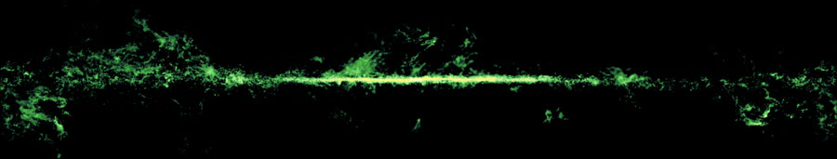
Figure 56: Carbon monoxide image of the Milky Way
This panoramic image shows a survey of carbon monoxide (CO) molecules across our Milky Way. The bright strip in the centre represents the bulk of the disc of our Milky Way, which, viewed in terms of molecules, is akin to a thin pancake: broad but very flat. The Galactic Centre is located in the middle of the image, and the edges wrap around to show the full 360° panorama. The fluffy material seen far above and below the central disc shows the very closest molecular clouds in the neighbouring spiral arms. Carbon monoxide represents only a small fraction of the mass of molecules in the Galaxy, which are mostly in the form of molecular hydrogen. However, molecular hydrogen is notoriously hard to detect directly as it tends to glow only when heated to high temperatures. CO, however, is found pretty much everywhere there is molecular hydrogen, and its easily stimulated microwave radiation can be detected even in cold clouds. As such, CO becomes a valuable way to trace the more evasive molecular hydrogen and map out the regions where stars are forming.
Ref: The Milky Way in Molecular Clouds: A New Complete CO Survey
T.M. Dame, Dap Hartmann, & P. Thaddeus ApJ, 547, 792.
CO: Wco_DHT2001.jpg

Cool stuff
Although radio astronomy was built on the study of synchrotron radiation from energetic particles, there is increasing interest in the emission of radio waves from large but very cool regions in the Universe. Sometimes called molecular clouds, these clumps of gas are cool enough to contain dust (see Chapter 5) and a brew of molecules that broadcast their identification signatures at very specific radio wavelengths as they ready themselves to give birth to new generations of stars.

Much of the heat radiation from these cool regions falls in parts of the radio spectrum — wavelengths of a few tenths of a millimetre — that are difficult or impossible to see from the ground because of absorption by the atmosphere (see Box 15). ESA’s Herschel spacecraft (see Chapter 3) is designed to make observation of these wavelengths possible.

Usually in astronomy it is easier to detect and study objects in our neighbourhood rather than strain to see faint ones in the furthest reaches of the Universe. When trying to do this kind of astronomy from the ground, however, the redshift of very distant objects can help us by moving the cool heat radiation into a part of the radio spectrum where, at least from very dry observatory sites, the atmosphere is transparent. This convenient shift allows the use of much larger microwave telescope collecting areas than can currently be launched into space and it is one of the primary justifications for building the Atacama Large Millimeter Array (ALMA, see Chapter 2).

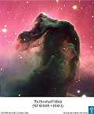
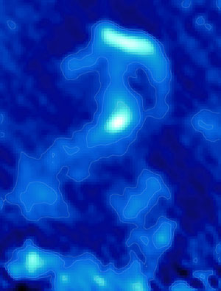
Figure 57: The Horsehead nebula in visible light and sub-millimetre radiation
An image of the famous Horsehead nebula in Orion made with the single-dish radio telescope APEX at a wavelength close to 1 millimetre (870 microns). At this wavelength, the cool dust glows rather than absorbs. The new and much larger ALMA telescope (see Chapter 2) will allow objects like this to be seen in as much detail as we can now see in the more familiar visible wavelength pictures.

Box 15 Heat from cold objects
Detecting heat radiation from cool objects does sound a bit strange. But it is a perfectly legitimate occupation for an astronomer. Black bodies emit radiation with an intensity and a spectrum that is determined uniquely by the temperature and the area of the emitting surface (see Chapter 1). A gas cloud that is really cool, say -240 °C, will radiate a blackbody spectrum peaking at a wavelength of about a tenth of a millimetre. The empty sky around the cloud will appear cooler than this and so our far-infrared telescope will see a bright patch against a darker background. In the distant Universe, at a redshift above 3 or so, the emission will become accessible to sub-millimetre telescopes like ALMA (see Chapter 2).

Cosmic Microwave Background
Objects simply glowing as black bodies, like stars, are rarely prominent targets for radio telescopes. The emitted energy falls off dramatically from the infrared into microwaves and radio. If the source has a tremendous surface area, however, the total cumulative output of radio waves can be substantial. The biggest of all bodies is the Universe itself, and, stunningly, we can see the faint remnant of the glowing fireball of the Big Bang all around us. This afterglow was discovered in 1965 and is known as the Cosmic Microwave Background radiation.

This radiation was emitted from a “surface” at about 3000 °C when the Universe was 380 000 years old and the fireball was becoming transparent. The radiation from this epoch now pervades all of space and, due to the expansion of the Universe over the last 13.7 billion years or so, has now cooled to a temperature of 2.7 K (-270 °C). At this temperature the emission peaks at a wavelength of around 2 mm in the microwave part of the radio spectrum.

How do we see this radiation now and what does it tell us about the Universe? Observations at this wavelength are difficult from the ground but can, and have been, done. High-flying balloons and spacecraft are better platforms and have been used to produce some of the most profound and remarkably precise measurements in the history of science.

When this ancient signal was discovered by Arno Penzias and Robert Wilson (who received the 1978 Nobel Prize in Physics for their discovery), they recognised — after eliminating all other possible sources of radiation including a good amount of pigeon droppings in the receiver — that the excess signal they were seeing in their microwave telescope was the echo of the Big Bang: the Cosmic Microwave Background.

The radiation is seen with microwave instruments as an extremely uniform “surface” over the entire sky. The deviations from the uniformity of the radiation temperature over the sky amount to only about one part in 100 000, but the information in these tiny temperature variations contains the “crown jewels” of modern cosmology. The data provide a wealth of fundamental information about the size, age, content and ultimate fate of the Universe.

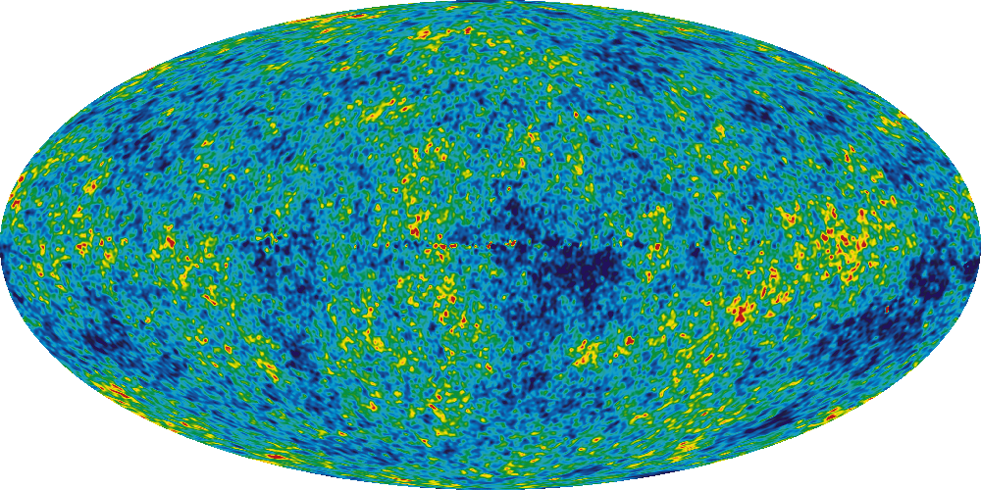

Figure 58: The cosmic microwave background
The most distant “object” we can see when we point our telescopes towards the sky is the fireball resulting from the Big Bang: the event at the origin of our Universe. About 375 000 years after the Big Bang itself, the fireball had cooled from unimaginably high temperatures to around 3000 °C (half of the temperature of the surface of the Sun). The surface of the fireball was radiating like a blackbody (see Chapter 1) as the continuing expansion made it transparent. This all-pervading radiation has remained one of the constituents of the Universe as it has continued to expand up until the present time, some 13.7 billion years later. So what does the fireball look like? As a result of the expansion, the radiation has cooled by more than a factor of a thousand from the 3000 °C when it was emitted, to -270 °C and this is seen as microwave radio radiation coming very uniformly from the entire sky. This all-sky map from NASA’s Wilkinson Microwave Anisotropy Probe spacecraft shows the measurements of the temperature of the CMB resulting from five years of measurements. The colour codes show the very small — about one part in 100 000 — temperature variations whose precise measurement is revealing an astonishingly accurate picture of the geometry, age and content of the Universe. An earlier NASA satellite experiment called COBE, designed to characterise the CMB, resulted in the 2007 Noble Prize for Physics being awarded to John Mather and George Smoot.

http://map.gsfc.nasa.gov/media/080997/080997_5yrFullSky_WMAP_4096W.tif
Credit: NASA/WMAP

NOT USED

Images/figures
- M83 UV, 21cm: http://www.galex.caltech.edu/media/glx2008-01r_img01.html
- sub-mm: http://www.roe.ac.uk/roe/workshop/2006/galactic-centre.jpg
- GMC: http://www.spacetelescope.org/images/html/opo9734m.html
- NRAO gallery: http://www.nrao.edu/imagegallery/php/level1.php
- http://www.nrao.edu/imagegallery/php/level3.php?id=562
- http://www.spacetelescope.org/images/html/heic0707d.html

Barnard 68
http://www.eso.org/public/outreach/press-rel/pr-2001/phot-02b-01-hires.jpg
http://www.eso.org/public/outreach/press-rel/pr-2001/phot-02a-01-hires.jpg

8. The X-Ray and High Energy Universe (Bob)

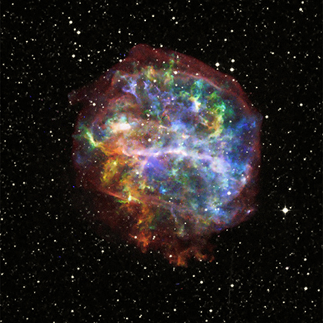
Figure 59: Supernova remnant G292.0+1.8 in X-rays
This beautiful Chandra X-ray Observatory image shows the supernova remnant G292.0+1.8. This is the aftermath of the death of a massive star. Ejected material from the supernova races outwards and slams into the surrounding gas creating intense shock waves that heat the material and make it emit X-rays. By mapping the distribution of X-rays in different energy bands, the Chandra image traces the distribution of chemical elements ejected in the supernova. The results imply that the explosion was not symmetrical. For example, blue (silicon and sulphur) and green (magnesium) are seen strongly in the upper right, while yellow and orange (oxygen) dominate the lower left. These elements light up at different temperatures, indicating that the temperature is higher in the upper right portion of G292.0+1.8.

Credit: X-ray: NASA/CXC/Penn State/S.Park et al
http://chandra.harvard.edu/photo/2007/g292/

Beyond the ultraviolet we reach the highest energies of the electromagnetic spectrum. From X-rays to the even more energetic gamma rays, the light becomes sparse and tends to be counted photon by photon. Only the most dramatic phenomena will generate light at this far end of the spectrum. Because of this, X-rays and gamma rays are our window to study cataclysmic processes such as the explosions of massive stars and the neutron stars and black holes they leave behind, as well as hot plasmas in galaxy clusters and in nearby stars.

X-rays and gamma-ray photons have wavelengths so tiny they must be measured in billionths (picometers) and trillionths (femtometers) of metres. There is no “smallest” wavelength at the gamma-ray end of the spectrum beyond the practical limits of just how much energy can be crammed into a single photon by the processes that generate them. Astronomers detect these photons on a case-by-case basis, making it challenging to build up images in the X-ray, and even more impractical in the gamma-ray regime. In fact, very few gamma-ray “images” have been constructed to date, so the focus in this chapter will largely be X-rays.

Box 16: X-ray regimes

- 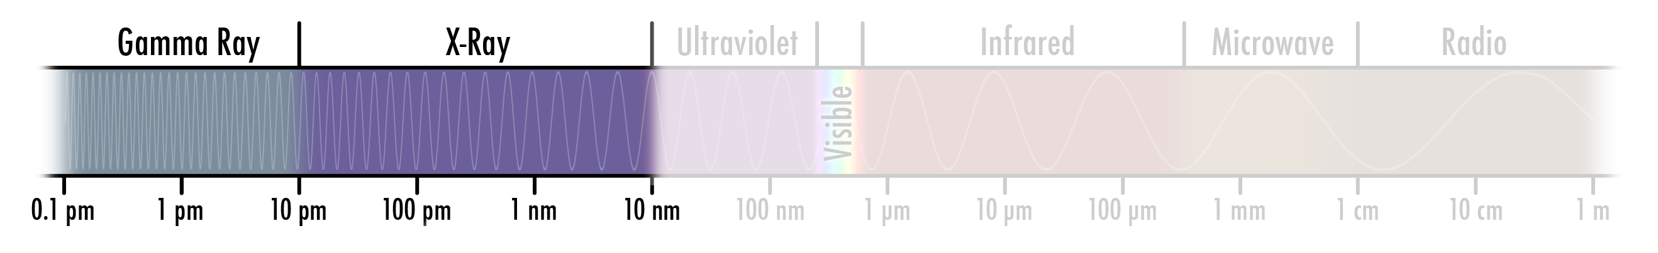Soft X-rays
- Hard X-ray

Sources of X-rays

Thermal X-rays

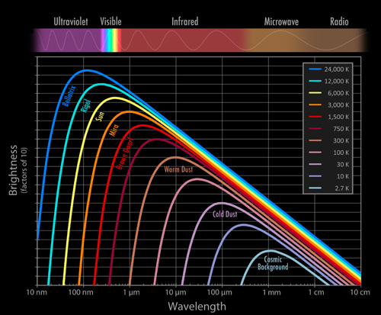
CHANGE — remove CMB, add 1 million degree curve
Figure 60: Blackbody radiation from 1 million degree warm objects

X-ray photons have energies that are thousands of times larger than the visible-light photons detected by our eyes. If these photons were purely the result of thermal, or blackbody, processes, there would have to be many objects with temperatures between about a million and a hundred million °C (See Figure 60). The discovery of some sources at these temperatures came as a surprise since even the most massive stars are not nearly this hot.

But while the stars themselves may not reach temperatures of millions of degrees, the explosion of massive stars can. As the hot debris blasted out by the explosion slams into the surrounding interstellar medium, the resulting shock waves can heat it even more. It is a kind of cosmic sonic boom, but instead of hearing it, we see the photons generated from the shock. These supernova remnants can make spectacular targets for X-ray telescopes.

However, it does not take a supernova to heat up at least some of the gas around a star. Even our Sun has an outer “atmosphere”, or corona, that can reach millions of degrees. Falling outside of what we think of as its visible surface, this sparse gas is heated by processes that puzzled the astronomers who discovered its X-ray emission. Violent phenomena on the surface — often around the darker, slightly cooler sunspots on the Sun’s surface — create waves of magnetic fields that propagate upwards into the increasingly tenuous outer atmosphere, the chromosphere and corona. As the density decreases, the waves become more and more extreme, rather like water waves breaking on a shelving beach. Eventually they become shock waves that superheat the gas.

Spectral line X-rays
We have seen that in other parts of the spectrum, changes in the electron energy state in atoms can generate “spectral line” emission at specific wavelengths. For light elements like hydrogen and helium, such lines tend to fall in visible and infrared light. However, more massive elements with larger clouds of electrons can have “inner electron” transitions of such high energies that they create X-ray spectral lines.

The temperatures required to generate X-ray spectral lines are quite high, since you never get energy out without putting it in. However, the exploding material from supernovae can easily stimulate these lines. This provides a powerful tool astronomers use to study the composition of material thrown out in such blasts.

Non-thermal processes
However, one also finds X-rays coming from sources that are not hot enough to generate them as thermal blackbody radiation. Such process are dubbed non-thermal. For instance, in some regions charged particles like electrons and protons are boosted to nearly the speed of light (sometimes slung along whirling magnetic fields, like beads on a string). When such particles are forced to change direction as they pass along these magnetic fields they emit synchrotron radiation (see chapter 7) and can be seen throughout the electromagnetic spectrum, even as X-rays.

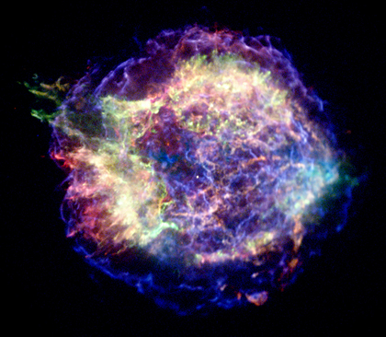
Figure 61: Cassiopeia A in X-rays
This X-ray image, taken with the Chandra satellite (see Chapter 3) shows the youngest supernova remnant in the Milky Way galaxy. Called Cassiopeia A, it is at a distance of some 11 000 light-years and — were it not for the fact that it was shrouded in a dense cocoon of dust when the massive star exploded — would have easily been seen by observers just over three centuries ago. As well as being a bright source of X-rays, Cassiopeia A is the most brilliant radio source in the sky apart from the Sun. The material blasted from the star in the explosion (seen as red and green in this image) is heated to around ten million °C. The expansion shell (blue) is moving outwards at sixteen million km/hr and is at the even higher temperature of thirty million degrees. As this shell bumps into the surrounding interstellar gas, it creates a shock wave that heats the gas to these high values. These shock regions are thought to be one of the sites where cosmic ray particles are accelerated to speeds very close to light speed. A mutliwavelength view of Cassiopeia A is seen in Figure 1.

http://chandra.harvard.edu/photo/2006/casa/casa.jpg
Credit: NASA/CXC/MIT/UMass Amherst/M.D.Stage et al.

Observing X-rays
Although a few experiments have been done from high-flying balloons, X-ray astronomy can only really be done from space. X-rays are known to penetrate objects like human bodies in hospitals and hand-baggage at airports, but they are completely absorbed by the Earth’s atmosphere. X-ray astronomy was born with the space age. Riccardo Giacconi and his collaborators detected X-rays of non-terrestrial origin during the first part of the 1960s by flying experiments in sounding rockets. The ability to construct and launch X-ray satellite observatories has since created a vibrant branch of astronomy that deals with high energy and high temperature phenomena in the Universe. In 2002, Giacconi was awarded the Nobel Prize for Physics for this work.

X-ray sources

White dwarfs, neutron stars and black holes...

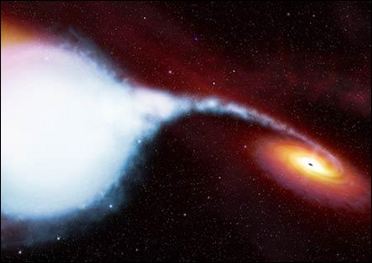
Figure 62: Cygnus X-1 (artist’s impression)
Cygnus X-1 is located about 10 000 light-years from Earth. It is one of the more violent places in our Galaxy. The black hole, Cygnus X-1, contains about five times the mass of the Sun, squeezed into a tiny sphere a few kilometres in diameter. Because of its density, it possesses an enormous gravitational field, which is pulling matter away from its companion star, HDE 226868. The companion is a massive star, known as a blue supergiant. It has an extremely hot surface temperature of 30 000 °C. As the gas spirals towards the black hole, it is heated even further and emits X-rays and gamma rays.
http://sci.esa.int/science-e/www/object/index.cfm?fobjectid=32709
Credit: ESA/Hubble

Compact sources of X-rays include white dwarf and neutron stars as well as black holes. Gas that streams into the intense gravitational attraction of these objects is heated by friction to millions of degrees during its fall. Certain types of binary stars that contain one of these ultra-compact objects and a much larger companion that can supply material to fall onto it are often bright X-ray sources. The radiation emitted by such a hot body is extremely intense so that X-rays can be seen from very small regions. Often cooler objects have to be very large to show up in telescopes as they radiate at longer and less energetic wavelengths. This ability to delve into the innermost zones of some of the most bizarre and energetic objects in the Universe is a powerful incentive to build ever larger and more sensitive X-ray telescopes.

Active galaxies
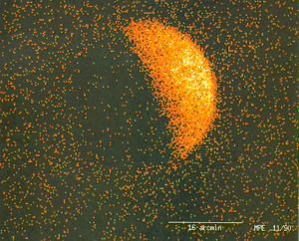
Figure 63: The X-ray shadow of the Moon
This remarkable X-ray image of the Moon was taken in 1990 by the ROSAT satellite and shows individual X-ray detections in the camera as dots. At first glance one sees the bright part of the Moon reflecting X-rays from the Sun, but if one looks closer the dark side of the Moon can be seen to shadow a background of X-ray emitting objects (the fainter signal “in front” of the dark part of the lunar disc is thought to arise in the very outer parts of the Earth’s atmosphere). This is a stunning view of the so-called X-ray background radiation that has puzzled astronomers since the very earliest days of X-ray astronomy in the 1960s. It is now realised that almost all of the X-ray background is coming from a tapestry of active galaxies radiating in the Universe’s “middle-age”.
http://chandra.harvard.edu/photo/2003/moon/more.html#rosat

Strangely enough, an X-ray image of the Moon led astronomers to understand the nature of galaxies across the Universe better. A remarkable image taken in 1990 by the ROSAT satellite clearly shows the disc of the Moon, one side illuminated by reflected X-rays from the Sun, the other seen in darkened silhouette against what appears to be a background sky bright with X-rays. For many years the question was what could be producing this cosmic X-ray background? Is it a uniform glow like the Cosmic Microwave Background seen in the radio, or does it come from multitudes of faint individual sources? This background was detected by the first rocket experiments in the early 1960s and the mystery persisted for decades.

As the resolving power of X-ray telescopes improved it became apparent that, unlike the truly diffuse Cosmic Microwave Background (see Chapter 7), the X-ray background appears to be largely composed of individual sources very uniformly distributed across the sky. If the radiation originated in our Milky Way, such uniformity would be difficult to understand and so it was assumed that the sources were at large (also called “cosmological”) distances. It has now become clear now that most of the radiation originates in active galaxies that emitted the X-rays when the Universe was middle-aged.
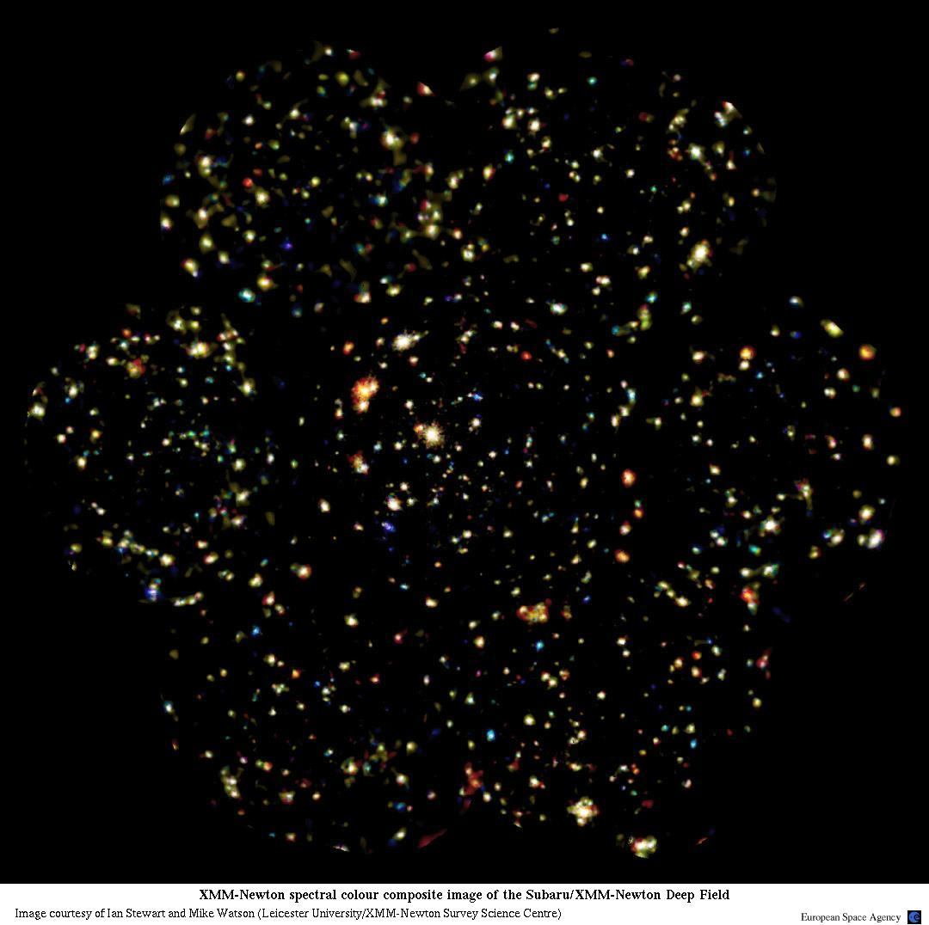
Figure 64: The Subaru/XMM-Newton Deep Field
A current, very deep view, with over one hundred hours of exposure and nearly three Moon-diameters across, of part of the X-ray sky seen by ESA’s XMM-Newton satellite. This shows how the X-ray background breaks up into discrete sources that differ from one another in “colour”. In this image, blue codes the sources that contain a high proportion of high energy (called “hard”) X-rays while red represent those dominated by the lower energy (“soft”) X-rays.

Credit: XMM-Newton/ESA/Ian Stewart and Mike Watson (Leicester University/XMM-Newton Survey Science Centre)

http://xmm.esac.esa.int/external/xmm_science/gallery/images/XSDS_20040601a.jpg

Some relatively nearby galaxies also emit large amounts of X-ray radiation. In many of them, this radiation seems to be associated with the energy release from material surrounding supermassive black holes that may reside at the centres of all galaxies. When this black hole is radiating, it is called an active galactic nucleus or AGN. Only a small fraction of nearby galaxies has active black holes at any one time. However this fraction seems to have been larger in the cosmic middle ages, as seen in the XMM-Newton Deep Field image in Figure 64. This seems to have been a special time in the history of the Universe, late enough for the central black holes to become big, yet early enough that the galaxies were still very gas-rich with fuel to power the activity. Today, the gas in galaxies is more settled and more rarely gets close enough to feed the black hole and create an AGN.

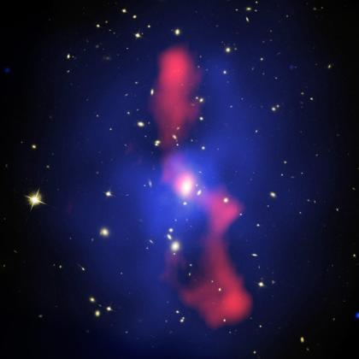

Figure 65: Hot gas in the galaxy cluster MS0735.6+7421
An image of the galaxy cluster MS0735.6+742, about 2.6 billion light-years away in the constellation Camelopardus. The visible-light view taken with Hubble in 2006 shows the cluster of galaxies (in white) together with some background galaxies and foreground stars. The Chandra observatory image (blue) shows the distribution of fifty million degree gas that pervades the cluster except for the huge cavities — nearly seven times the diameter of the Milky Way — at the top and bottom of the picture which are filled with very high speed charged particles and magnetic field: a combination that efficiently emits radio waves. The radio image (red) is from the VLA in New Mexico (see Chapter 2). The process that powers the radio emission — jets from the central supermassive black hole — has pushed aside gas weighing some trillion times the mass of the Sun.
Credit: X-ray: NASA/CXC/Univ. Waterloo/B.McNamara; Visible: NASA/ESA/STScI/Univ. Waterloo/B.McNamara; Radio: NRAO/Ohio Univ./L.Birzan et al.
http://chandra.harvard.edu/photo/2006/ms0735/index.html

Clusters of galaxies
Galaxies are not solitary, but tend to come in clusters, sometimes containing hundreds, even thousands, of members. Through cosmic history they grow by attracting individual galaxies and smaller groups of galaxies gravitationally. Such clusters are also significant sources of X-ray light. In fact, the bigger the cluster, the brighter the diffuse glow of X-rays generally appears.

Astronomers have concluded that this X-ray glow comes from vast, sparse clouds of gas that fill the apparent voids between the galaxies within a cluster. This gas, likely ejected at various times from member galaxies in the clusters, appears to be heated as it collides with the pre-existing material. It can reach temperatures between ten to a hundred million degrees, with larger clusters heating the gas more. Diffuse gas at these temperatures cools very slowly, so these clusters retain their hot halos for billions of years.

Studies of these huge X-ray halos show that they contain a significant fraction of the total observable mass in the Universe. The fact that the gas is rich in elements such as iron tells us that this hot material must have been processed by the earlier generations of stars that are the main source of the heavier elements. A recent study of X-ray halos has also helped astronomers study the nature of an even more massive “dark-matter” component to clusters that cannot be seen directly (see Box 17).

Box 17: X-Rays shine light on dark matter
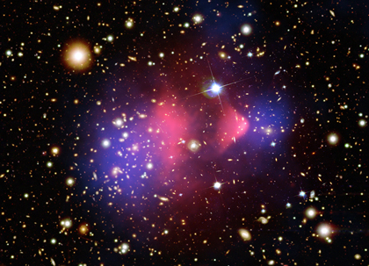
Credit: X-ray: NASA/CXC/CfA/M.Markevitch et al.; visible light: NASA/STScI; Magellan/U.Arizona/D.Clowe et al.; Lensing Map: NASA/STScI; ESO WFI; Magellan/U.Arizona/D.Clowe et al.

Sometimes it takes something you can see to help you understand something else you can’t. Such is the case with the so-called “dark matter” in galaxies and clusters. Astronomers measuring the motions of stars in galaxies, and of galaxies in clusters, calculate that there must be a lot more mass around than the matter we can see, even when using the whole electromagnetic spectrum. Thus it has been given the name “dark” — partly as we can’t see it, but perhaps more as a sign of our ignorance about its nature.

A dramatic X-ray result published in 2006, however, helped confirm the reality of dark matter and give us more insights into its properties. Astronomers assembled the composite image of the “Bullet Cluster” above. This is actually composed of two colliding clusters, many members of which can be seen in the background visible-light image. Overlaid on this are the X-ray gas emission (red) and a map of the majority of the mass of the cluster (blue). The concentration of mass is determined using the effect of gravitational lensing to indicate where light from the background galaxies behind the Bullet Cluster is distorted most by the mass of the cluster. Where the distortion is greatest, the Bullet Cluster must have the most mass.

The offset between the red X-ray gas and the blue mass measurement shows an amazing difference between the normal and the dark matter in the two clusters. The red bullet-shaped clump on the right is the hot gas from one cluster, which passed through the hot gas from the other larger cluster during the collision. Both gas clouds were slowed by a drag force, similar to air resistance, during the collision. In contrast, the dark matter was not slowed by the impact because it — apparently — does not interact directly with itself or the gas except through gravity. Therefore, during the collision the dark matter clumps from the two clusters moved ahead of the hot gas, producing the separation of the dark and normal matter seen in the image. This result is dramatic direct evidence that most of the matter in the clusters is dark, and very different from normal matter!

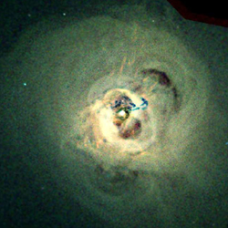
Figure 66: Centre of the Perseus Galaxy Cluster
Traditionally X-ray images of clusters of galaxies have shown relatively smooth distributions of the very hot (ten to a hundred million degrees) gas. This image of the Perseus Galaxy Cluster, taken with the sharp-eyed Chandra X-ray Observatory, tells a different story. Enormous bright loops, ripples and jet-like streaks are apparent in the image. The dark blue filaments in the centre are likely due to a galaxy that has been torn apart and is falling into the central giant galaxy NGC 1275. The hot gas pressure is assumed to be low in certain areas of the cluster because unseen bubbles of high energy particles have displaced the gas. The plumes are due to explosive venting from the vicinity of the supermassive black hole. The venting produces sound waves that heat the gas throughout the inner regions of the cluster and prevent it from cooling and making stars at a high rate. This process has slowed the growth of one of the largest galaxies in the Universe. It provides a dramatic example of how a relatively tiny, but massive, black hole at the centre of a galaxy can control the heating and cooling behaviour of gas far beyond the confines of the galaxy.

Credit: NASA/CXC/IoA/A.Fabian et al.
http://chandra.harvard.edu/photo/2005/perseus/index.html

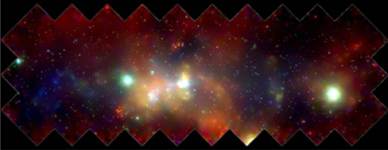
Figure 67: The X-Ray Milky Way
The mosaic from the Chandra X-ray Observatory gives a new perspective on how the turbulent centre region of the Milky Way affects the evolution of our Galaxy as a whole. Hot gas appears to be escaping from the centre into the rest of the Galaxy. The outflow of gas, chemically enriched from the frequent destruction of stars, will distribute these elements into the galactic suburbs. The bluer hues indicate X-rays at the highest energies, red at the lowest. Because it is”only” about 26 000 light-years from Earth, the centre of our Milky Way provides an excellent laboratory to learn about the wondrous phenomena taking place in the cores of galaxies.

Credit: NASA/UMass/D.Wang et al.
http://chandra.harvard.edu/photo/2002/gcenter/

The Solar System
Although the 6000 °C surface of the Sun radiates the light that illuminates and warms the Earth, the extended — but very tenuous — outer regions of its atmosphere can reach temperatures of two million degrees or so. This solar corona is heated by waves that are generated in the turbulent upper layers of the Sun and propagate outwards to deposit their energy well above the visible surface. As we go further outwards, the corona expands to become the solar wind that pervades the Solar System and, guided by magnetic fields, affects all the planets and their satellites. Astronomers can only study these energetic phenomena in the outer solar atmosphere clearly in X-rays. Such activity can include occasional super-energetic events called solar flares that can even affect us on Earth, disrupting communications and producing stunning auroral displays near the poles.

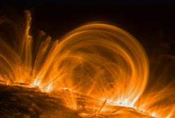
Figure 68:

Credit: TRACE/NASA, Lockheed Martin
http://trace.lmsal.com/POD/images/NAS19.tif
also http://trace.lmsal.com/POD/TRACEpodoverview.html

As noted previously, X-ray observations of the Moon have arguably helped us more in understanding active galaxies than in advancing our knowledge of Earth’s closest neighbour. In fact, the Moon was the target for one of the very first searches for X-rays beyond the Earth and the Sun by Giacconi and his collaborators in 1962. Although this rocket-launched experiment failed to find the Moon, it did find the brightest X-ray source outside the Solar System, Scorpius X-1!

However, other planets in the Solar System have been detected in X-rays. On Jupiter, auroral displays can be seen vividly near the poles. Conversely on Saturn, the fainter X-ray glow is brightest along the planet’s equator. The interactions between energetic solar radiation and atoms near the surfaces of many other objects in the Solar System have been seen as X-ray emission as well, including Mars, Venus and comets.

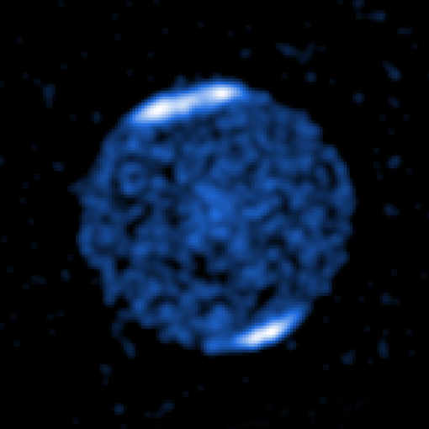
Figure 69: X-Ray auroras on Jupiter.
The strong X-ray glow of jovian auroras indicate that the particles streaming into the planet’s polar region are charged particles accelerated to high energies within the extended magnetic fields of the planet. This is a different mechanism than on Earth where solar wind particles reach the planet’s poles directly.

Credit: NASA/CXC/MSFC/R.Elsner et al.
http://chandra.harvard.edu/photo/2005/jupiter/

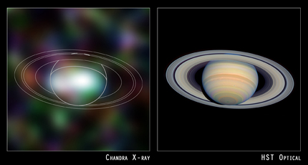
Figure 70: Saturn in X-Rays
Unlike Jupiter, Saturn is brightest near its equator in the light of X-rays. In fact the energy profile of this faint X-ray glow is very similar to that of the Sun, indicating that these X-rays are primarily just reflected sunlight. Effectively, it means the process lighting up Saturn in X-rays is much the same as in visible light.

Credit: X-ray: NASA/U. Hamburg/J.Ness et al; Visible: NASA/STScI
http://chandra.harvard.edu/photo/2004/saturn/

Pushing the limits: Gamma rays
Gamma rays fall at the highest energy end of the electromagnetic spectrum, and overlap with high energy hard X-rays. While X-rays are emitted in processes where electrons make transitions from one energy level to another gamma rays are typically emitted by transitions that take place within the atomic nucleus itself. Gamma-ray astronomy takes us directly to the edgiest, most violent physics in the Universe. But gamma rays, like X-rays, are largely absorbed by the atmosphere, so the first data came from the Explorer 11 satellite in 1961, which detected fewer than 100 gamma-ray photons, just enough to suggest the existence of a low-level gamma-ray background that scientists attributed to the interaction of high energy charged particles (cosmic rays) with interstellar gas. Individual gamma-ray sources were first seen in the 1970s, although matching them to objects seen in other wavelengths is very difficult as the resolution of the gamma-ray detectors is very poor, and even today roughly half the gamma-ray sources known remain unclassified and a mystery, despite the sterling work of veteran observatories like the Compton Gamma Ray Observatory, that logged the gamma-ray sky for almost ten years from 1991-2000.

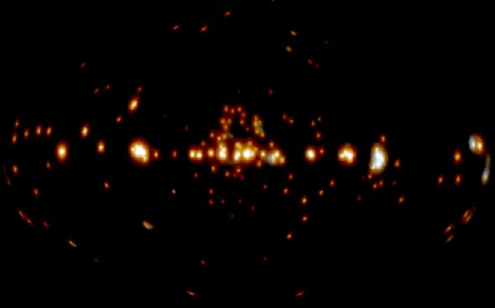
Figure 71: Gamma-ray source mystery
This all-sky map was constructed from a list of 271 sources of gamma-ray emission detected by the Compton Gamma Ray Observatory during its mission. It contains a mix of sources within the Milky Way (horizontal line of sources at the middle of the diagram) and throughout the extragalactic sky. However, the identity and nature of these sources is largely still a mystery. In large part it is due to the difficulty in identifying the location of each source precisely. Newer generations of gamma-ray telescopes, such as the Gamma Ray Large Area Space Telescope (GLAST), launched in 2008, have a much higher resolving capability and can help identify these mystery objects, and doubtless uncover more mysteries as well.

Credit: N. Gehrels, D. Macomb, D. Bertsch, D. Thompson, R. Hartman (GSFC), EGRET, NASA
http://apod.nasa.gov/apod/ap040403.html
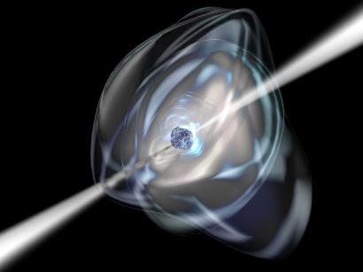

Gamma-ray bursts

Figure 72: High-energy pulsar
Artist’s impression of an anomalous X-ray pulsar — a type of neutron star first spotted pulsing low-energy X-rays into space during the 1970s by the Uhuru X-ray satellite. AXPs are extremely rare with only seven known to exist. Initially, AXPs were thought to be members of an X-ray binary system, with the X-ray emission produced by matter falling from a companion star onto the AXP.
http://sci.esa.int/science-e/www/object/index.cfm?fobjectid=39703

Brief intense bursts of gamma rays, now known to be burning more brightly than a million trillion Suns, were discovered in the late 1960s by defence satellites looking for gamma rays produced in nuclear tests. These gamma-ray bursts are surprisingly common; with events detected two or three times a week, and have been the subject of intense study. The bursts can last from milliseconds up to as long as a minute, and many of the longer bursts are now thought to be linked to very high energy supernovae — sometimes known as hypernovae — and the collapse of bright, fast-burning, short-lived stars to form black holes. The BeppoSAX satellite was successful in identifying the “afterglow” of some of these gamma-ray bursts — traces of lower energy radiation, either X-ray or even visible light that persists after the original bursts, which allowed astronomers to establish that the sources of these bursts were located outside far beyond our local group of galaxies, at distances of 8 billion light-years and more. Further advances in understanding, and perhaps some hints for the mechanism behind the very shortest — and ultra-mysterious — gamma-ray bursts have come from from NASA’s Swift satellite, launched in 2004, which is able to train X-ray and optical telescopes on a new burst within a minute — and so has been able to catch a star as it explodes.

Other instruments like the newly launched GLAST and INTEGRAL space telescopes as well as the MAGIC telescopes in the Canary Islands are ushering in a revolution in gamma-ray astronomy as their improved resolution and sensitivity will allow astronomers to probe the secrets of black holes, neutron stars and other sources of gamma rays.

The X-ray/high energy revolution

Without a doubt, our view of the Universe has changed drastically since the first observations of extraterrestrial X-rays. Thousands of X-ray sources and numerous other objects that are characterised by high energy processes have been discovered. These processes are often associated with “extreme physics” — extremely strong gravitational and magnetic fields that accelerate particles to relativistic energies, gas heated to temperatures of hundreds of millions of degrees and exotic objects such as neutron stars and black holes. Time scales are often short, indicating very compact objects. The associated high energies and short wavelengths make X-ray observations the tool of choice to probe the physics of neutron stars, the neighbourhood of black holes and the hot gas between galaxies. X-rays have allowed us to explore active stellar coronae and to pick out the very hot stars associated with the enormous regions of hot gas known as “superbubbles” that have presumably been heated by intensive stellar winds. In the hunt for black holes an enormous exotic zoo of X-ray binary stars have been discovered and explored. X-ray astronomy still provides the most promising means of studying the existence, the properties and the effects of black holes in the Universe. By looking at supernova remnants, galaxies and, not least, at the active cores of galaxies in considerable detail, evidence has accumulated that these active galaxies are driven by supermassive black holes. Other enigmas are also susceptible — X-ray studies of clusters of galaxies have found new evidence found concerning the existence of dark matter and its properties.

At the highest energy end of the electromagnetic spectrum, new space telescopes like GLAST have given gamma-ray astronomy new impetus in the quest for understanding of gamma-ray bursts and pinpointing elusive gamma-ray objects across the Universe.

X-ray and gamma-ray photons may be fewer in number than other, lower energy wavelengths, but their ability to illuminate the most exotic and bizarre objects in the Universe makes them an invaluable tool for astronomers.

NOT USED?

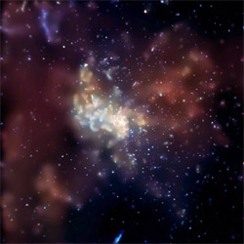
Sagittarius A*. This Chandra image of the supermassive black hole at our Galaxy's centre, a.k.a. Sagittarius A* or Sgr A*, was made from the longest X-ray exposure of that region to date. In addition to Sgr A* more than two thousand other X-ray sources were detected in the region, making this one of the richest fields ever observed.

Credit: NASA/CXC/MIT/F.K.Baganoff et al
Sgr A* http://chandra.harvard.edu/photo/2003/0203long/

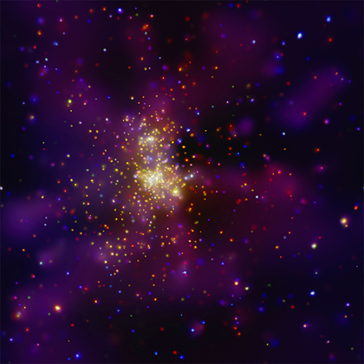
This Chandra X-ray Observatory image shows Westerlund 2, a young star cluster with an estimated age of about one or two million years. Until recently little was known about this cluster because it is heavily obscured by dust and gas. However, using infrared and X-ray observations to overcome this obscuration, Westerlund 2 has become regarded as one of the most interesting star clusters in the Milky Way galaxy. It contains some of the hottest, brightest and most massive stars known. The bluer colours correspond to higher energies.

Credit: NASA/CXC/Univ. de Liège/Y. Naze et al
Westerlund 2 http://chandra.harvard.edu/photo/2008/wd2/

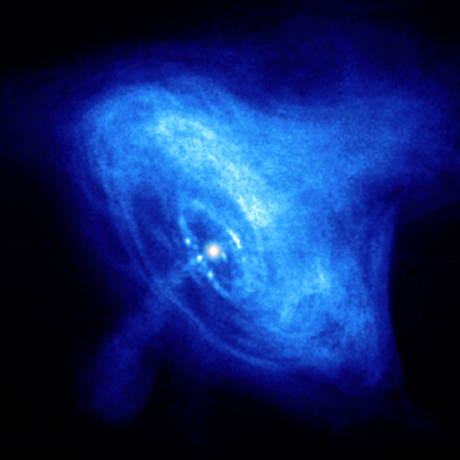
Crab Nebula. This image provides a dramatic look at the activity generated by the pulsar (white dot near the centre of the images) in the Crab Nebula. The inner X-ray ring is thought to be a shock wave that marks the boundary between the surrounding nebula and the flow of matter and antimatter particles from the pulsar. Energetic shocked particles move outward to brighten the outer ring and produce an extended X-ray glow. The jets perpendicular to the ring are due to matter and antimatter particles spewing out from the poles of the pulsar.

(Credit: NASA/CXC/ASU/J. Hester et al.)
http://chandra.harvard.edu/photo/2006/crab/more.html#0052_xray_widefield

9. The Multi-wavelength Universe (Lars)
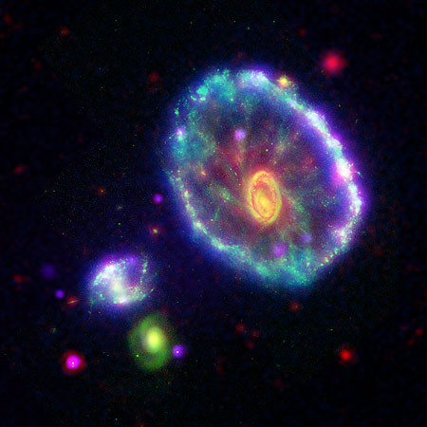
Figure 73: A multi-wavelength view of the Cartwheel galaxy
This amazing image shows a truly pan-chromatic view of the Cartwheel galaxy. In purple we see the X-rays observed with the Chandra X-ray Observatory; in blue is ultraviolet light observed by the Galaxy Evolution Explorer; in green we show the visible light from the Hubble Space Telescope and in red the infrared light captured with the Spitzer Space Telescope. A few hundred million years ago, a smaller galaxy plunged through the heart of a large spiral galaxy, creating expanding ripples of star formation. In this image, the first ripple appears as an ultraviolet-bright blue outer ring where associations of stars tens of times as massive as the Sun are forming. The clumps of pink along the outer blue ring are regions where both X-rays and ultraviolet radiation are superimposed. These X-ray point sources are very likely to be collections of binary star systems containing a black hole. The yellow-orange inner ring and nucleus at the centre of the galaxy result from the combination of visible and infrared light, which is relatively stronger towards the centre. This region of the galaxy represents the second ripple, or ring wave, created in the collision, but has much less star formation activity than the first (outer) ring The faint wisps of red spread throughout the interior of the galaxy are organic molecules in dust that have been illuminated by nearby low-level star formation. Meanwhile, the tints of green are less massive, older visible-light stars. Based on its position, velocity and apparent lack of gas, the green galaxy at the bottom left of the picture is thought to be source of the “splash”.

http://gallery.spitzer.caltech.edu/Imagegallery/image.php?image_name=sig06-005

Astronomy began as a visual science. For thousands of years, humans used little more than their eyes to observe and record the light from the stars. All this changed 400 years ago when Galileo first turned his telescope towards the heavens, dramatically expanding our ability to see and understand the Universe. Yet, for the next 350 years, the potential of this magnificent device was limited to that tiny sliver of the spectrum visible to human eyes. As we have seen in this book, a series of technological advances over the past 50 years or so has given us access to the hidden Universe: the cosmic domains of radio waves, infrared light, ultraviolet light, X-rays and gamma rays.

Layer by layer, the cosmic onion has been peeled away to reveal a richness and complexity that was unimaginable from our long-held visible perspective. We show the fundamental change in worldview brought about by expanding our perception to include the full spectrum of light.

This book is about our recently expanded multi-wavelength view of the Universe. This new perspective has made us realise that the Universe “out there” is hugely richer and more complex than our visual experience suggested. The profound change of viewpoint brought about by the development of quantum mechanics in the early 20th century launched a deep and mind-wrenching adventure into those aspects of the physical world that are not so open to our direct perception. Like nothing else at the time, quantum mechanics expanded our concept of physical reality and inspired philosophers and scientists alike. The discovery of radio waves from the cosmos in 1932 was the first of many steps in the revelation of the full electromagnetic spectrum emitted by objects beyond the Earth. Steps that slowly moved astronomy from a visual science to one governed by phenomena that stretch our imagination. Going hand in hand with the physical understanding enabled by the quantum revolution, our new view of the Universe would have been unimaginable to a scientist even a century ago.

This chapter presents the full view of the hidden Universe. By pulling all the individual wavelength regimes together — radio through gamma rays — we can try to paint a much more holistic picture of the vastness of space and its contents. This is a field of research that is in rapid development as new pieces of the jigsaw are shaped and put into place. It employs the full breadth of our scientific knowledge.

The individual images in this book so far are excerpts from this holistic view (as shown by the wavelength icon in the caption for each image). Each image is of an object or set of objects as seen through filters (either real filters, or limited by instrument sensitivity to a pre-set wavelength range). The representation of the electromagnetic spectrum is therefore confined to a small slice in each of these images. By taking one object as an example, we can make a journey through the entire electromagnetic spectrum following the same order as the chapters in this book. The active galaxy Centaurus A is both well-observed and emits over a very wide range of wavelengths. It is the nearest active galaxy (see Box 13: Black holes, quasars and Active Galactic Nuclei) to Earth, at distance of 10 million light-years, and has plenty to show us at all wavelengths.

Centaurus A in visible light

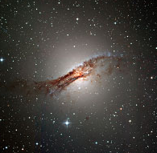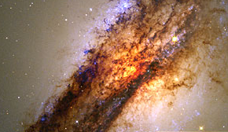
Figure 74: Centaurus A in visible light
The active radio galaxy Centaurus A seen in visible light with ESO’s 2.2-metre telescope (left) and the Hubble Space Telescope (right). An older population of stars is seen as the soft glow of yellowish-white light. A dramatic dark lane of dust girdles the galaxy. Clusters of newborn stars are seen in blue and silhouettes of dust filaments are interspersed with blazing orange-glowing gas.

http://www.eso.org/public/outreach/press-rel/pr-2003/pr-13-03.html
http://www.spacetelescope.org/images/html/opo9814c.html

The Centaurus A galaxy is one of the most studied objects in the southern sky. The British astronomer James Dunlop noticed the unique appearance of this galaxy as early as 1826, although he was unaware that its beautiful and spectacular appearance is due to an opaque dust lane that covers the central part of the galaxy (see Figure 74). This dust is likely to be the debris remaining from a cosmic merger that took place some 100 million years ago between a giant elliptical galaxy and a smaller, dust-rich spiral galaxy.

In visible light is it easy to see the soft, hazy elliptical glow of Centaurus A’s old population of red giant and red dwarf stars. Brilliant blue clusters of young hot stars lie along the edge of the dark dust lane, and the silhouettes of the dust filaments are interspersed with blazing glowing gas (seen in yellow/red).

Centaurus A in the infrared
Until quite recently, the details of the centre remained largely unknown, hidden by the dense dust lane that completely obscures the central parts of the galaxy in visible light. To peer into the centre, observations must be carried out at infrared wavelengths where the dust becomes much more transparent. (See Box 7 in Chapter 5).

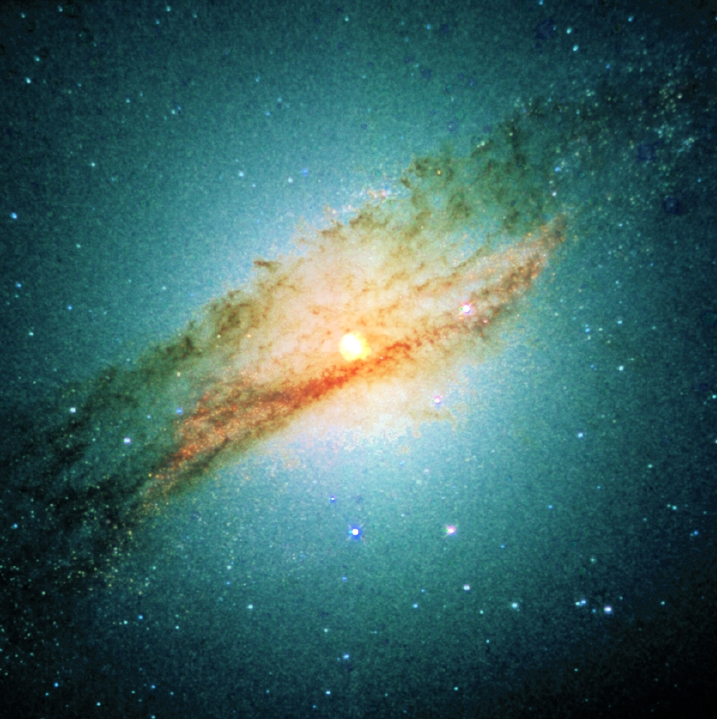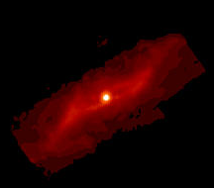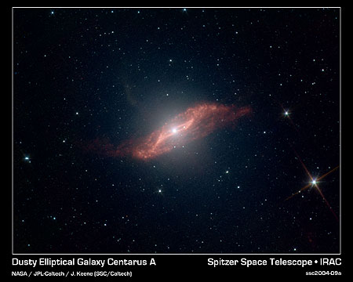
Figure 75: Centaurus A in the infrared
A near-infrared, ground-based image of Centaurus A taken with ESO’s New Technology Telescope at La Silla (left). As we move further into the infrared, the dust lane becomes more transparent, and starts to glow (shown in red). The images from ISO (middle) and Spitzer (right) show in unprecedented detail the centre of Centaurus A, which is seemingly twisted into a parallelogram-shaped structure of dust. ISO’s and Spitzer’s abilities both to see through the dust and also to see it glowing allowed the telescopes to peer into the centre of Centaurus A.

Credit: Paul van der Werf/Leiden Observatory
http://www.strw.leidenuniv.nl/~pvdwerf/research/starbursts/gif/CenA-JHKsTrueCol.jpg
http://www.spitzer.caltech.edu/Media/releases/ssc2004-09/ssc2004-09a.shtml
http://iso.esac.esa.int/images/cam/cena_lw.jpg

Observations of the dust emission in the mid-infrared spectral region were carried out in the nineties with the ISOCAM camera carried by ESA’s Infrared Space Observatory (ISO). They revealed a 15 000 light-year long, parallelogram-shaped structure of dust that appears very similar to that of the centre of a small barred galaxy. This bar may serve to funnel gas towards the nucleus of the galaxy.

Peering even closer into the centre in 1997, the near-infrared camera on the Hubble Space Telescope revealed a thin gaseous disc of material close to the centre. This looked very much like an accretion disc that was feeding material into a central black hole.

By measuring the rapid stellar motions in the centre using near-infrared spectroscopy with ESO’s Very Large Telescope, astronomers concluded that the enormous mass within the central region could not be caused by normal stars, as it would then have been much more luminous, but had to be caused by a supermassive black hole. This had already been suspected from radio observations for many years (see below).

Remarkably sharp observations with the Spitzer Space Telescope in 2004 showed the inner parallelogram-shaped structure of dust in high detail. Astronomers made a computer model that explains how such a strange geometric structure could arise. In this model, a spiral galaxy falls into an elliptical galaxy, becoming warped and twisted in the process. The folds in the warped disc, when viewed nearly edge-on, take on the appearance of a parallelogram. The model predicts that the leftover parts of the intruding galaxy will ultimately flatten into a plane before being entirely devoured by Centaurus A. Warped discs like this are the “smoking guns” of galactic cannibalism, providing proof that one galaxy once made a meal of another.

Centaurus A in the ultraviolet
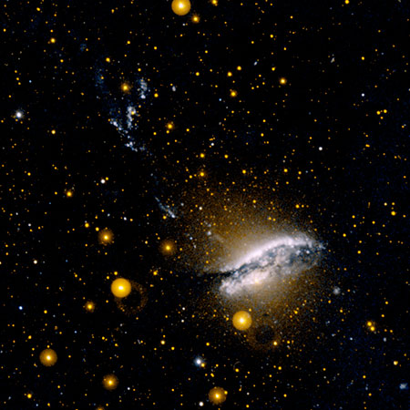
Figure 76: Centaurus A in the ultraviolet
This image was taken by GALEX in the ultraviolet and shows regions of hectic star formation associated with the dust lane. The strings of blue knots extending to the top left of the galaxy are thought to be regions influenced by the powerful jets (see Figure 77) originating from the central black hole.
http://www.galex.caltech.edu/media/glx2005-02r_img13.html

Ultraviolet observations made with GALEX show extensive ultraviolet emission in the centre from young super-star-clusters (seen in blue in the visible-light image), especially along the edge and on the upper surface of the dust lane. Most of the ultraviolet emission in the galaxy appears to result from intense star formation in the disc; none appears to be associated with the old stellar population in the main body of the galaxy, and no ultraviolet emission from the central black hole has been detected, presumably because it would all have been obscured by the dust lane.

Strings of ultraviolet light associated with the radio and X-ray jets (see Figure 77 and ) are seen extending some 130 000 light-years from the centre to the top-left. These are thought to be either gas illuminated directly by the jets or indirectly by young stars whose birth has been induced by the passage of the jets through this part of the galaxy.

Centaurus A in radio
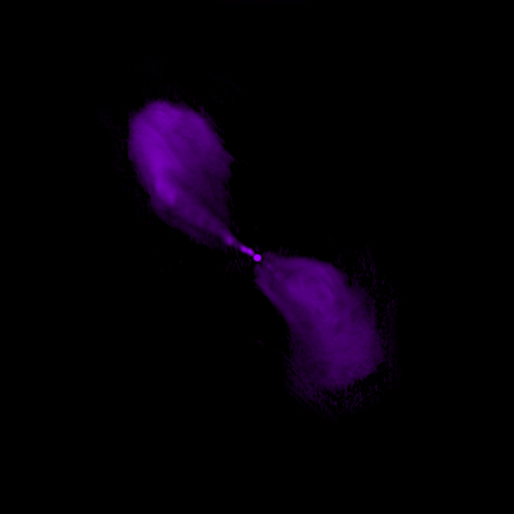
Figure 77: Centaurus A in radio
Centaurus A is one of the brightest radio sources in the sky. Most of the radio emission does not come directly from the narrow, straight supersonic jets, but from the broader “lobes” where strong shocks form near the ends of the jets. The material in the lobes is believed to have been supplied by the jets over millions of years. This image was created from observations done with the Very Large Array. Other radio observations with a single dish telescope (the Parkes 64-m telescope in Australia: featured in the movie “The Dish”) show a much larger pair of lobes from an earlier outburst of activity extending over nine degrees on the sky (eighteen times the size of the Moon)
Radio: http://chandra.harvard.edu/photo/2008/cena/more.html

Centaurus A is also spectacular when observed with radio telescopes. It is one of the brightest radio sources in the sky (its name indicates that it is the strongest radio source in the southern constellation of Centaurus). At a distance of 10 million light-years, it is also the nearest radio galaxy. The radio emission from the very compact centre exhibits strong activity (see Box 13 in Chapter 7). It has been suspected for some time that this powerful energy release is due to accretion of material onto a supermassive black hole. The most likely mass of this “central beast” is about 200 million times the mass of the Sun.

Two impressive straight and narrow jets — beams of high-energy particles —shoot many millions of light-years from the supermassive black hole in the centre of the galaxy into intergalactic space in opposite directions. These particles emit radio waves, which we can use to trace the jets and determine how much energy is being transported.

Centaurus A in X-rays
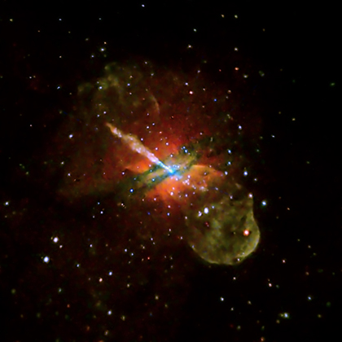

Figure 78: Centaurus A in X-rays
NGC 5128, or Centaurus A, is one of our closest active galaxies. While it is nowhere near as intrinsically powerful as Cygnus A (Chapter 7), it is much closer (at about 10 million light-years) and so appears very bright in many wavebands from X-ray to radio. This X-ray image from the Chandra Observatory shows high-energy X-rays in blue, intermediate energy in green and lower energy in red. The jet — pointing towards the top left — and the fainter counter-jet, are driven directly by the central black hole and are also seen clearly at radio wavelengths (see Figure 77). The bubbles of high-energy particles inflated by the jets are seen in green, especially in the lower part of the image. The dark green and blue bands running almost perpendicular to the jet are dust lanes that partly absorb X-rays.
Credit: NASA/CXC/CfA/R.Kraft et al
http://chandra.harvard.edu/photo/2008/cena/

Centaurus A also delivers quite a display in X-rays. In a long Chandra exposure lasting over seven days, the galaxy reveals the effects of the supermassive black hole at its centre. Opposing jets of high-energy particles can be seen extending to the outer reaches of the galaxy. These jets, which are also seen at radio wavelengths (see Figure 77), protrude dramatically from the central region. Both are driven directly by the central black hole and are thought to be important vehicles for transporting and distributing energy from the black hole across the much larger distance associated with a galaxy, possibly affecting the rate at which stars form there.

High-energy electrons spiralling around magnetic field lines produce the X-ray emission from the jet and counterjet. This emission quickly saps the energy from the electrons, so they must be continually reaccelerated or the X-rays would fade out. Knot-like features in the jets detected in the Chandra image show where the acceleration of particles to high energies is currently occurring, and provides important clues to understanding the process that accelerates the electrons to near-light speeds.

The inner part of the X-ray jet close to the black hole is dominated by these knots of X-ray emission, which probably come from shock waves — akin to sonic booms — caused by the jet. Farther from the black hole, there is more diffuse X-ray emission in the jet. The cause of particle acceleration in this part of the jet is unknown.

Hundreds of point-like sources are also seen in the Chandra image. Many of these are X-ray binaries that contain a stellar-mass black hole and a companion star in orbit around one another.

A multi-wavelength view of Centaurus A
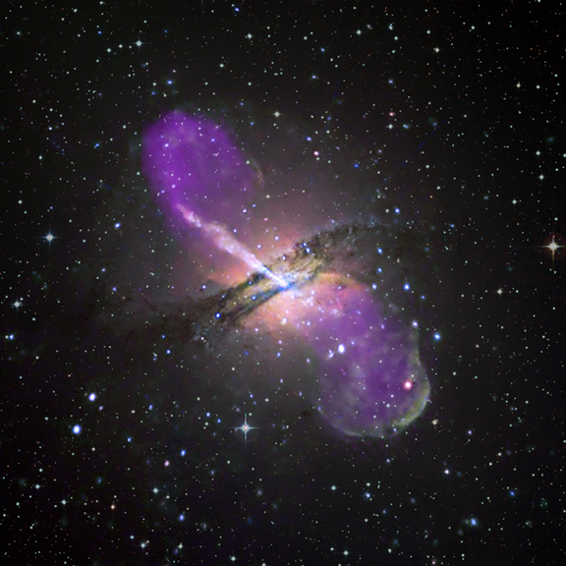
Figure 79: Combined multi-wavelength image of Centaurus A
This multi-wavelength view shows Centaurus A with X-ray, visible and radio images combined: the Chandra image, the ESO 2.2-metre visible-light image and the VLA radio image. Although this image represents a much larger part of the electromagnetic spectrum, it is still only one selected representation of the underlying physical reality.
http://chandra.harvard.edu/photo/2008/cena/more.html

We have completed our multi-wavelength journey, band by band, and will now examine how the full picture of Centaurus A comes together. Figure 79 is one representation of the full reality that shows three of the five wavelength regimes discussed in this book. Again we are hampered by being limited — by the capabilities of our eyes and the printing process — to showing only parts of the underlying complex physical reality.

This is the sense in which we can consider imaging to be a “poor man’s spectroscopy”. Where an image can only show one or several (as in the case of Figure 79) wavelength regimes, a spectrum can show the energy distribution for all wavelengths and give a more complete picture of the physical processes at work in the object.

Until now it has been rare for objects to be investigated over the full range from radio to gamma rays, but it is becoming more practical to do this. Centaurus A’s almost complete multi-wavelength spectrum is seen in Figure 80. Data in this form need special care in interpretation for two basic reasons. Firstly, it is important to know where the radiation is coming from within the object: most of the radio emission is coming from the very extended lobes while the X-ray emission is coming from the active nucleus and the associated jets and the optical light is coming from the extended, elliptical distribution of stars. Secondly, some of the emission varies substantially with time, notably the high-energy X-and gamma rays, and it may be meaningless to compare this with, say radio emission observed at a different time.

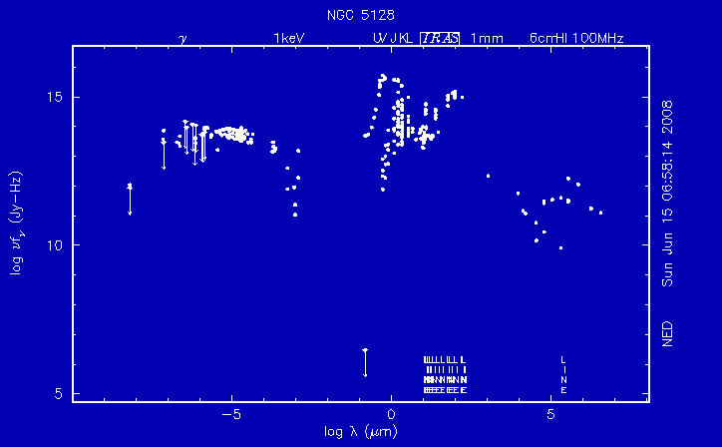

Figure 80: Multi-wavelength spectrum of Centaurus A
The complete multi-wavelength spectrum (known to connoisseurs as a Spectral Energy Distribution) of Centaurus A compiled from many different types of telescope and detector. The plot has been coded to show the origin of the radiation in different parts of the spectrum. Note that starlight dominates only in the rather narrow region around the visible spectrum. All the other emissions are driven ultimately by the gravitational collapse of matter onto the supermassive black hole at the core of the galaxy. The very high-energy gamma rays seen from this source are probably coming from very close to the black hole.

In the most general terms, a plot like this tells us something very profound about how the Universe works. The starlight in a galaxy comes from the nuclear reactions taking place deep within the cores of its stars. The energy released by the nuclear fusion that occurs at the immense temperatures and pressures at the heart of a star slowly diffuses to the surface where it is radiated away, mostly as visible, ultraviolet and near-infrared light. This energy comes from the conversion of matter to energy according to Einstein’s famous equation, E = mc², and it results in the conversion of light chemical elements, e.g. hydrogen and helium, to heavier ones: carbon, nitrogen, oxygen etc.
As more and more matter forms stars, it changes the chemical composition of the Universe. This is quite a complex story, including the role of exploding stars — supernovae — in making most of the heavy elements, but it does have profound implications for the ultimate fate of everything we can know about. The chemical endpoint of this process comes when everything is turned to iron. But that won’t happen for a very long time!

The energy coming from the supermassive black hole in the galaxy core comes, however, from a very different physical process. It comes from what astronomers call “gravitational collapse”, which occurs when “stuff” is dropped into a strong gravitational field. If you were to drop a heavy asteroid onto the Earth, it would generate copious light and heat with spectacular explosions and lots of devastation. Dropping stuff onto a black hole produces much more spectacular results! In the spectrum of Centaurus A in Figure 79, the energy may be emitted in many different ways in most of the spectral regions, but ultimately it comes from this process of dropping matter into a black hole.

When we look at an object like Centaurus A, we are bound to ask ourselves why the amount of energy arising from nuclear process in stars is even approximately the same as that coming from gravitational collapse onto a black hole. These are very different processes and it is not obvious why they should produce even remotely similar results. There must be a link between them and astronomers are just beginning to understand what it might be. It seems as if the black hole can act as a kind of “thermostat” that controls how a galaxy of stars can grow and evolve. If the galaxy tries to grow too vigorously, the central black hole is fed such a rich diet that it gets over-excited and so bright that it blows the gas and dust out of the galaxy and effectively stops the formation of new stars. This “feedback” between the central black hole and the stars in galaxies is becoming one of the core ideas in current astrophysics with profound implications for how the Universe looks and behaves.

Post script
We have come a long way in our attempt to reveal the hidden Universe. On the way we have discussed the individual mechanisms that give rise to the various flavours of light or electromagnetic radiation, such as thermal emission from blackbodies or the more exotic forms arising from fast-moving charged particles. As we cross the finishing line we show an example (Figure 80) of the comprehensive multi-wavelength spectrum that represents our state-of-the-art view of one of the most exotic of objects in the Universe. Needless to say, we have only covered part of the full story.

In March 2008 Science magazine published some of the first results from the Pierre Auger Observatory in Argentina that observes cosmic rays. Following observations between January 2004 and August 2007, the Pierre Auger Collaboration announced the detection of 21 amazing particles from space with “wavelengths” below 2 x 10⁻²⁶ m (above 5.7 x 10¹⁹ electron volts). Two of these cosmic rays are likely to have come from Centaurus A — which would make it first time high-energy cosmic rays can be traced back to an individual galaxy. This result has triggered a surge in theoretical papers explaining why Centaurus A’s black hole has to be a source of high-energy cosmic rays. In Figure 80 this result would have to be plotted XX cm outside the figure on the left! The highest energy cosmic ray yet detected had about the same energy as a tennis ball moving at 150 kilometres per hour.

So, electromagnetic radiation, as we have focused on in this book, is not the sole window we have on the visible and the hidden Universe, there are other messengers reaching us from space and we are scrambling to decode the story they have to tell. What are these messengers and what kind of telescopes do we need to catch them?

The high energy cosmic rays, mostly consisting of protons (hydrogen nuclei) but also helium nuclei (alpha particles), electrons and the occasional nucleus of a heavier element, interact with particles in the Earth’s atmosphere creating flashes of blue light and showers of other particles that can be seen by detectors on the ground. The cosmic ray “telescopes” can have devices to image both the light flashes from the upper atmosphere and the showers of secondary particles triggered by the original particle.

Other cosmic particle messengers include the elusive neutrino that is so shy of detection that it can travel through a block of lead the size of the Solar System without noticeable hindrance. Neutrinos coming from the hot core of the Sun are so numerous that some 50 trillion of them pass through your body every second — and you don't feel a thing! Needless to say, it is very difficult to build a “neutrino telescope”. But it can be done and astronomers have detected these particles from the Sun and also from Supernova 1987A in the Large Magellanic Cloud that was seen to explode on the 23 February 1987.

Space-time itself can be made to oscillate and such disturbances would be seen as yet another kind of messenger from space — gravitational waves. Although none have been detected directly, there is powerful indirect evidence for the phenomenon. Russell Alan Hulse and Joseph Hooton Taylor, Jr. from Princeton University observed radio pulses from pulsar PSR B1913+16 that arrived at Earth sometimes a little earlier and at others a little later than expected. These irregularities were traced to a companion star whose orbit was evolving in a way that was precisely predicted by the application of Einstein's General Theory of Relativity, and which can be used to calculate the emission of gravitational radiation from the system. Hulse and Taylor were awarded the 1993 Nobel Prize for Physics for their work. A number of gravitational wave telescopes are now operating, under construction or planned.

The development of this range of “non-light” telescopes is already having a major impact on astrophysics and will spawn very exciting areas of research in the future. One of the consequences is that high energy physicists and astronomers are learning one another's languages and jargon, stimulating a cooperation that will bring new perspectives to our quest to understand the world we inhabit.

New windows are being opened on hidden parts of the Universe. As has happened repeatedly through history, our perception of the physical reality, and with it our world view, is changing. One can only wonder how much more is hiding out there...

Extra multi-wavelength images:

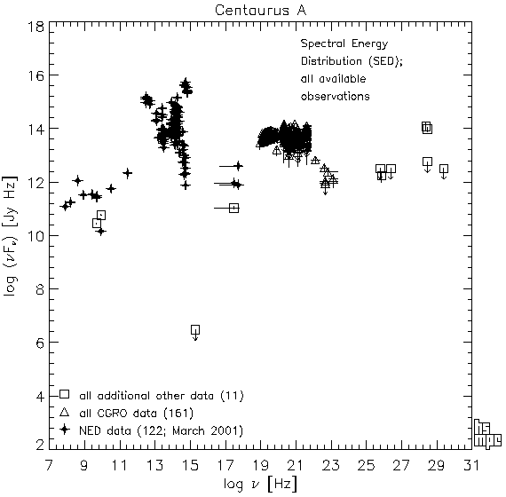
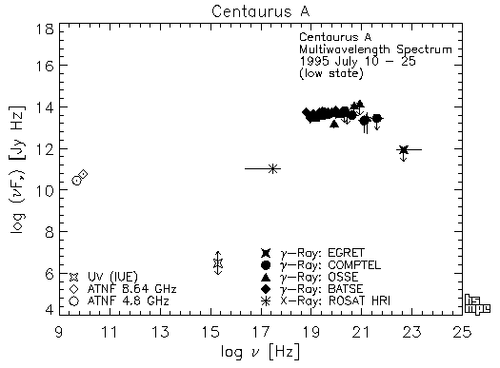
http://www.mpe.mpg.de/~hcs/Cen-A/cen-a-facts.html

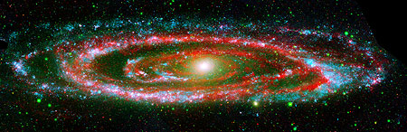
M31 (Galex/Spitzer)
http://sscws1.ipac.caltech.edu/Imagegallery/image.php?image_name=sig06-024

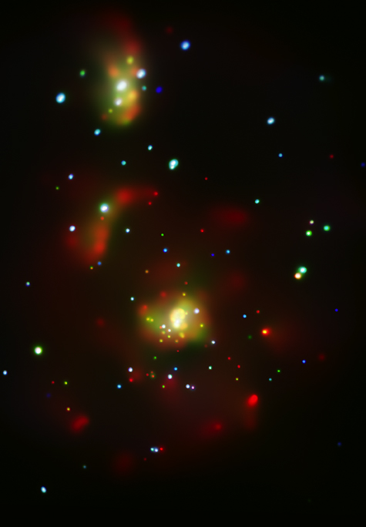
X-Ray: http://chandra.harvard.edu/photo/2007/m51/more.html

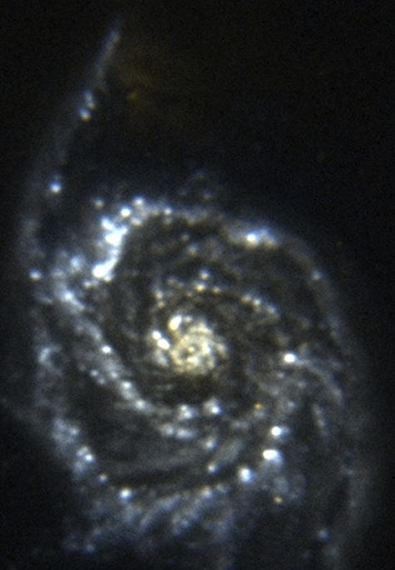
ultraviolet: http://chandra.harvard.edu/photo/2007/m51/more.html
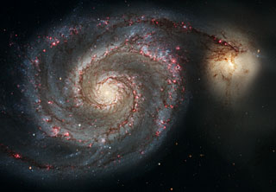
VIS:http://www.spacetelescope.org/images/html/heic0506a.html

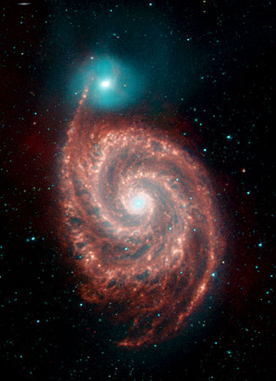
IR: http://www.spitzer.caltech.edu/Media/releases/ssc2004-19/ssc2004-19a.shtml

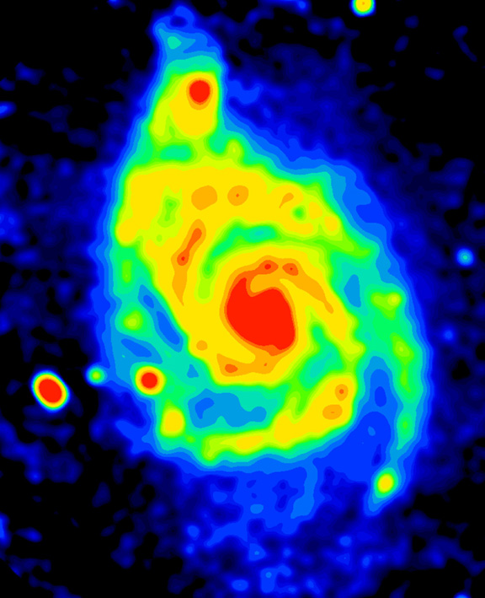
Radio:

Multi-wavelength images:
- MILKY WAY: http://homepage.mac.com/rarendt/dirbe_qtvr/b123.html
- CRAB NEBULA:

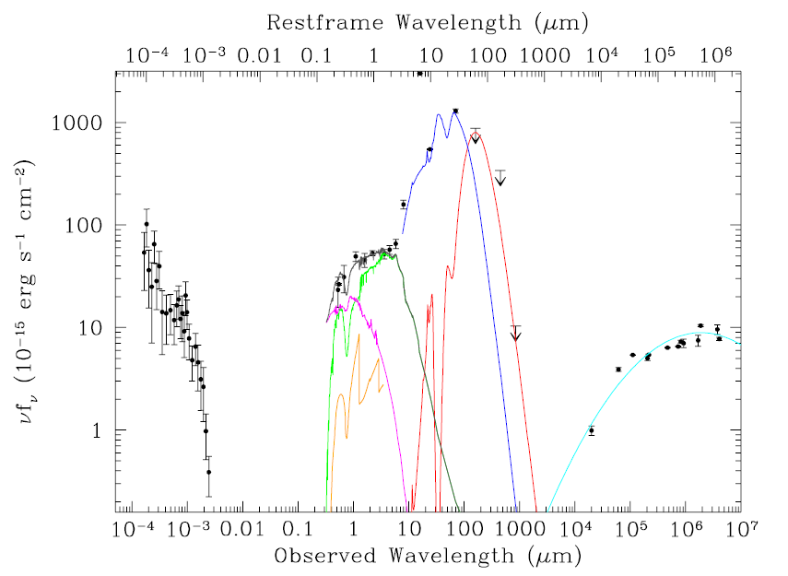
X-ray to radio spectral energy distribution (SED) of the z=2.483 radio galaxy 4C+23.56 (De Breuck et al. in preparation). All data points are observed flux densities, except for the J, H and K-band fluxes, which have been corrected for strong emission lines. Coloured lines show the decomposition of the SED into different intimately related components. The accretion onto the supermassive black hole creates very energetic X-ray and ultraviolet emission and powerful synchrotron radio jets and lobes. In this typical radio loud, type 2 AGN, the direct view to the nucleus is blocked by an obscuring torus absorbing the soft X-ray radiation that is re-emitted as hot thermal dust emission (blue). Radiation escaping through the torus opening is scattered toward the observer providing a unique periscopic view of the nucleus (magenta). It also ionises the ISM producing nebular continuum emission (orange) and, of course, line emission (which is not shown). The massive stellar host galaxy is seen directly in the rest-frame near-IR (green), while an obscured starburst is revealed by sub-mm cool dust re-emission (red). The radio synchrotron fit is in cyan. The bolometric contributions from the accretion onto the supermassive black hole and the stellar nucleosynthesis are remarkably similar.

Bios
Lars Lindberg Christensen
Lars is a science communication specialist heading the Hubble European Space Agency Information Centre group in Munich, Germany, where he is responsible for public outreach and education for the NASA/ESA Hubble Space Telescope in Europe.

He obtained his Master’s Degree in physics and astronomy from the University of Copenhagen, Denmark. Before assuming his current position, he spent a decade working as a science communicator and technical specialist for the Tycho Brahe Planetarium in Copenhagen.

Lars has more than 100 publications to his credit, most of them in popular science communication and its theory. His other productive interests cover several major areas of communication, including graphical, written, technical and scientific communication. He has written a number of books, notably The Hands-On Guide for Science Communicators (Springer, 2007) and Hubble — 15 Years of Discovery (Springer, 2006). His books have been translated to Finnish, Portuguese, Danish, German and Chinese.

He has produced material for a multitude of different media from star shows, laser shows and slide shows, to web, print, television and radio. His methodology is focussed on devising and implementing innovative strategies for the production of efficient science communication and educational material. This work involves collaborations with highly skilled graphics professionals and technicians. Some of the products of these collaborations are visible at: http://www.spacetelescope.org.

Lars is Press Officer for the International Astronomical Union (IAU), a founding member and secretary of the IAU Commission 55 Communicating Astronomy with the Public (http://www.communicatingastronomy.org), manager of the ESA/ESO/NASA Photoshop FITS Liberator project, executive editor of the peer-reviewed Communicating Astronomy with the Public journal, director of the Hubblecast video podcast, manager of the IAU International Year of Astronomy Secretariat and the Executive producer and director of the science documentary Hubble — 15 Years of Discovery. In 2005 Lars was the youngest recipient so far of the Tycho Brahe Medal for his achievements in science communication.

Robert (Bob) Fosbury
Bob works for the European Space Agency as part of ESA's collaboration with NASA on the Hubble project. Carried out in collaboration with the European Southern Observatory (ESO) near Munich in Germany, this work benefits greatly from the unique scientific environment that ESO provides. He started doing this in 1985, five years before launch. During the latter part of this period, Bob served on NASA's Ad Hoc Science Working Group and ESA's Study Science Team as they developed the instrument concepts for the James Webb Space Telescope, the next generation of space observatory.
Bob has published over two hundred scientific papers on topics ranging from the outer atmospheres of stars, the nature of quasars and active galaxies to the physics of forming galaxies in the most distant reaches of the Universe. He started his career at the Royal Greenwich Observatory (RGO) in Herstmonceux, England in 1969 and was awarded his DPhil by the nearby University of Sussex in 1973. He then became one of the first Research Fellows at the newly constructed Anglo Australian Observatory 4-metre telescope in New South Wales, Australia before going on to ESO, then based at CERN in Geneva, Switzerland. This was followed by a spell of seven years as a staff member at the RGO, working on instruments for the new observatory on La Palma in the Canary Islands and on the pioneering Starlink astronomical computer network.
Bob was temporarily head of the ESO Public Affairs Department in 2008. He maintains a lifelong interest in the study of natural phenomena of all kinds and is particularly interested in atmospheric optics and the origin of natural colour. He is an enthusiastic photographer and likes to develop innovative techniques for infrared, ultraviolet and stereo imaging.
Robert Hurt
Robert Hurt is the visualisation scientist for the Spitzer Space Telescope, the infrared component of NASA’s Great Observatory programme. Receiving his Ph.D. from UCLA for radio studies of starburst galaxies, his research has combined radio and infrared studies of star formation in the Milky Way and beyond.

His backgrounds in astronomy, photography and digital art all contribute to his role as visualisation scientist for Spitzer. In addition to rendering astronomical datasets and illustrating science topics, he also produces the Hidden Universe video podcast. His other current projects include the ESA/ESO/NASA FITS Liberator (a free tool for importing and processing astronomy data in Adobe®Photoshop®) and metadata standards for the Virtual Astronomy Multimedia Project (www.virtualastronomy.org). Robert lives in Los Angeles, California, USA, near Venice Beach.

Glossary
Absorption bands??
Absorption line
Additive colours
Blackbody radiation
Bremsstrahlung radiation
Doppler effect
Dust re-emission
Electromagnetic wave
Electromagnetic spectrum
Emission line
Fluorescence
Light-year
Luminosity
Nanometres, microns
Natural colours
Non-thermal radiation
Photoelectric effect
Photometry
Photons
Planck’s Law
Primary colours
Radiation
Redshift
Relation between wavelength and energy
Representative colours
Resolution
Secondary colours
Spectral line
Spectral line radiation
Spectroscopy
Subtractive colours
Synchrotron radiation
Thermal radiation
Wavelength
Wave-particle duality
Wien’s displacement law

Further reading
Chapter 1

Chapter 2

Chapter 3
- Christensen, L.L. og Fosbury, R.: Hubble — 15 Years of Discovery
- Schilling & Christensen, Eyes on the Skies
- http://en.wikipedia.org/wiki/Satellite
- http://en.wikipedia.org/wiki/Space_observatory

Chapter 4

Chapter 5

Chapter 6

Chapter 7

Chapter 8
X-ray astronomy on Wikipedia: http://en.wikipedia.org/wiki/X-ray_astronomy

In-depth information about the birth of X-ray astronomy from the Nobel Prize foundation: http://nobelprize.org/nobel_prizes/physics/laureates/2002/adv.html

Riccardo Giacconi’s Nobel Prize Lecture: http://nobelprize.org/nobel_prizes/physics/laureates/2002/giacconi-lecture.pdf

Chapter 9

A wonderful press release page from Chandra with lots of additional information and multi-wavelength images of Centaurus A: http://chandra.harvard.edu/photo/2008/cena/

http://www.spacetelescope.org/images/html/opo9814c.html

Spitzer: http://www.spitzer.caltech.edu/Media/releases/ssc2004-09/ssc2004-09a.shtml

Radio: http://chandra.harvard.edu/photo/2002/0157/

Other: http://apod.nasa.gov/apod/ap020812.html

A very comprehensive web site about Centaurus A: http://www.mpe.mpg.de/~hcs/Cen-A/cen-a-pictures.html

Energy — Wavelength converter: http://heasarc.gsfc.nasa.gov/cgi-bin/Tools/energyconv/energyConv.pl

Index
No index entries found.

Figure 81: (inside back cover)

Back
Astronomy was for many years a visual science. For thousands of years man used little but their eyes to observe and record the light from the stars. This changed dramatically 400 years ago when Galileo first turned his telescope towards the heavens, expanding our ability to see and understand the Universe. Yet for the next 350 years, the potential of this magnificent device was limited merely to the tiny sliver of the spectrum visible to human eyes. Only in the last 50 years or so have a series of technological advances given us access to the hidden Universe: the cosmic domains of radio waves, infrared light, ultraviolet light, X-rays...

Layer by layer the cosmic onion has been peeled away to reveal a reality stunningly different from what we thought we knew about a merely visible Universe. This book shows the fundamental change in worldview brought on by expanding our perceptions to cover the full spectrum of light.

Hidden Universe is lavishly illustrated. The striking images are hand-picked and partly created by the authors themselves.

Boxes and illustrations give an understandable overview of processes, telescopes and backgrounds.

The authors’ unique skills involve science and science communication at the highest level.

ESA logo?

