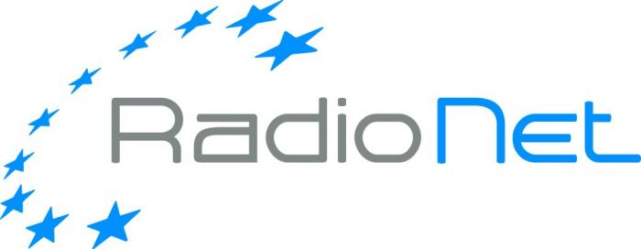

Request for RadioNet support for
training events

- Call text
- The application form to be used
RadioNet support for training events
Call

RadioNet is an EC funded project, which brings together the premier radio astronomical facilities in Europe to serve a growing research community across all of Europe and beyond. RadioNet is devoted among others to equipping scientists and engineers with the essential skills to take maximal advantage of existing and future radio astronomical infrastructures.
It will enable radio astronomers to take advantage of global best practices and research opportunities and help newcomers to radio astronomy to learn current state-of-the-art techniques, and encourage them to stay in the field. This ensures that there will be sufficient experts in the market to support their communities in making use of new opportunities (ALMA, EHT and SKA, and the other rapidly-evolving RadioNet facilities).
RadioNet seeks hosts for major radio astronomy-related training events such as ERIS and hands-on single-dish schools. In addition, RadioNet provides modest support for the training aspects of events, covering any subject of radio astronomy. Please apply as early as possible, communicate the requested amount of funding and, if possible, give alternate dates in case of clashes. You are welcome to contact the Training activity leader – Dr. Anita Richards (a.m.s.richards@manchester.ac.uk) for more information about the RadioNet training programme.

We are inviting organisers of training events to respond to this call using the application form.
The financial support will subsidise travel costs for selected participants (early career, from less well-funded institutes or invited lecturers and tutors) and the organisational cost. Organisers will be encouraged to ensure the gender balance and diversity of attendees, both among participants and tutors.

Please send the duly filled in application form as PDF file to RadioNet@mpifr.de
Deadline: February 15th, 2017, 5pm

The duly submitted applications will be evaluated and selected by the Selection Committee, the results will be announced within 3 weeks after the submission deadline.
The event organizers and supported participants are expected to acknowledge the RadioNet support at all event advertisement media. The organizers must provide an assessment report within 1 month after the event. Please note that the travel claims should be completed within 3 months after the event, and upon the submission of the assessment report.
Do not hesitate to contact the RadioNet office (RadioNet@mpifr.de) for any assistance.

Sincerely,

RadioNet Management

Funding principles:
- Cost must be actually incurred in connection with the RadioNet action and necessary for its implementation
- Cost must be identifiable and verifiable, in particular recorded in the accounts in accordance with the accounting standards. Cost must comply with the applicable national law on taxes, labour and social security
- Travel costs and related subsistence allowances (including related duties, taxes and charges such as non-deductible value added tax (VAT) paid by the beneficiary) are eligible if they are in line with the beneficiary’s usual practices on travel.
- Cost must be reasonable, justified and must comply with the principle of sound financial management, in particular regarding economy and efficiency (i.e. in line with a good housekeeping practice when spending public money, avoiding monetary excesses).
‘Economy’ means minimising the costs of resources used for an activity (input), while maximising quality; ‘efficiency’ is the relationship between outputs and the resources used to produce them.

Examples:
1. The beneficiary may NOT increase the remuneration of its personnel, upgrade its travel policy or its purchasing rules because of the European Commission support.
2. Entertainment or hospitality expenses (including gifts, special meals and dinners) are in principle not eligible.
3. Tips, which are not obligatory, are not eligible. By contrast, in some countries the invoice of the restaurant includes a certain mandatory amount as payment for the ‘service’. In this case, the amount may be considered eligible — if the other eligibility conditions are fulfilled.
4. Cost of cancelled trips/events cannot be reimbursed.

Eligibility for funding:
Researchers throughout the world can participate in the Horizon 2020 projects - though they are not always eligible for H2020 funding. Regarding funding, we can distinguish between countries that are automatically eligible for funding and those that are not. For more information click here: http://ec.europa.eu/research/participants/docs/h2020-funding-guide/cross-cutting-issues/international-cooperation_en.htm

RadioNet support for training events
Application form
Event Information
Title
Place
Organiser
Date
No. of participants
Total event cost
Other sources of funding | Please specify the other sources of funding and their level
REQUEST (max. 2 pages)
Requested contribution | Please specify the level of the requested RadioNet support [EURO]
Use of the RadioNet contribution | Please specify the use of the RadioNet contribution, e.g. approximately how many people will be supported, is this students, tutors, etc.? Which other costs exist? What is the overall budget for the event? How will this event contribute to RadioNet goals?
Impact of training | Please outline the anticipated impact of the event e.g. on knowledge transfer to the next generation of scientists and engineers.
Accessibility | Please specify the selection criteria for attendees
Ethics | Please explain how you will encourage ethical issues such as gender, ethnic diversity, reaching new communities, as relevant.

For more information about the RadioNet training programme please contact the Training activity leader – Dr. Anita Richards (a.m.s.richards@manchester.ac.uk).

